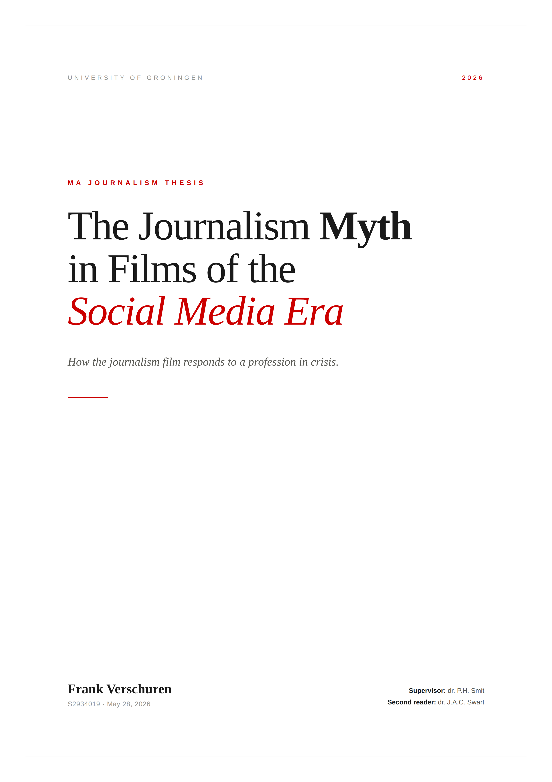

Abstract
This thesis examines the state of the journalism myth in popular film of the social media era. The myth of journalism as an objective, truth-seeking fourth estate arose more than a century ago and has been deeply naturalized through decades of repetition and cultural reinforcement. The convergence of journalism and social media in reality, however, has thrown the institution into a crisis, and scholars have predicted several possible futures for the myth that sustains it: decline into irrelevance, survival as a genre anchored in the past, or migration from the traditional journalist to a new kind of figure. This thesis tests those predictions against a corpus of 31 recent popular films.
The analysis reveals that the journalism myth has not declined. It has proliferated, and it has done so mainly while refusing to recognize the new figures and conditions that now define the journalistic reality. The journalism film has largely retreated into the past, and within it, the journalist is portrayed more heroically than in earlier decades, most often now as a woman rather than the traditional man. The villainy once carried by the corrupt journalist has instead been moved onto the social media figure. Where the myth does adapt, it proves far more willing to change the face of its hero than to question the modern realities of the profession.

Contents
Abstract 2
CHAPTER 1: Introduction 1
CHAPTER 2: Theoretical Framework 7
2.1 The Journalism Myth 7
2.2 What the Myth Conceals: Herman and Chomsky's Five-Filter Model 11
2.3 Archetypes, the Persona/Shadow, and McNair 13
2.4 Organic Crisis: How the Mask Slips 17
2.4.1 The Current Organic Crisis 18
2.5 The Journalism Myth in Film 28
2.5.1 Film as the Vehicle for the Journalism Myth 28
2.5.2 The Study of Journalism in Film 29
2.6 A Myth in Crisis 36
2.7 Social Media and Journalism: Real-World Convergence 38
CHAPTER 3: Methodology 44
3.1 Formalism and Narratology 44
3.1.1 Archetypes as Functions 44
3.1.2 The Actantial Model 45
3.1.3 A Two-Order Actantial Model 46
3.1.4 Reception Theory 48
3.2 Neoformalism 50
3.2.1 Cognitive Schemas 51
3.2.2 Cues: Narrative and Stylistic 52
Mis-en-scene 53
Cinematography 54
Editing 54
Sound 55
3.2.3 Style, Schemata, and This Thesis 57
3.3 Qualitative Analysis 57
3.3.1 Textual Analysis 58
3.3.2 The Corpus 59
Inclusion Criteria: Popularity 60
Weighted Popularity Score and Popularity Discrepancy Score 61
Inclusion Criteria: Content 65
3.3.3 Limitations 65
3.4 Coding Scheme 68
3.4.1 Table A1: Journalist Demographics 68
3.4.2 Table A2: Journalistic Professional Roles 69
3.4.3 Table A3: Journalistic Archetypes and Moral Behavior. 69
3.4.4 Table A4: Journalistic Platforms 69
3.4.5 Table A5: Journalist Career Stability and Motivation 70
3.4.6 Table A6: Social Media Impact on Journalists, Institutions, and Public 70
3.4.7 Table A7: On-Screen Depiction of Social Media 70
CHAPTER 4: Findings 71
4.1 Journalism-centered Films 71
4.1.1 The Retreat into the Past 71
4.1.2 Distribution, Popularity, and Hegemonic Reach 73
4.1.3 Demographics 73
Gender 73
Age and Seniority 74
Ethnicity 75
Sexuality 76
4.1.4 Narrative 76
4.1.5 Archetypes 78
The Heroine as the New Face of the Journalistic Myth 79
The Watchdog and the Witness 83
The Repentant Sinner 83
The Gender-Swapped Lovable Rogue 84
The Migration of the Reptile 85
The Exception 85
4.1.6 Professional Roles 86
4.1.7 Mythological Signs 86
4.1.8 Social Media: a Glaring Absence 91
4.2 Social-media-centered films 96
4.2.1 Distribution and Popularity 96
4.2.2 Demographics 98
Gender 98
Age 99
Ethnicity 100
Sexuality 100
4.2.3 Genre and the Punishment of the Influencer 100
4.2.4 Archetypes 103
4.2.5 Professional Roles 105
4.2.6 The Diegetic Audience as Actant 105
4.2.7 Social Media as Institution: Hegemony Without a Myth 107
4.2.8 Mythological Signs of the Social Media Influencer 109
4.2.9 Social Media On-Screen 111
4.3 Convergence Films 113
CHAPTER 5: Close Analysis 116
5.1 The Post 116
5.2 Not Okay 127
5.3 Dumb Money 141
Conclusion 154
References 160
Appendix A: Coding Scheme 169
Table A1: Journalist Demographics 169
Table A2: Journalistic Professional Roles 169
Table A3: Journalist Archetype / Moral Alignment 170
Table A4: Journalistic Platforms 171
Table A5: Journalist Career Stability & Well-Being 171
Table A6: Social Media Impact 172
Table A7: On-Screen Depiction of Social Media 173
Appendix B: Corpus of Films 176
Appendix C: Coded Data 180
Films 1–8 180
Films 9–16 184
Films 17–24 188
Films 25–31 191

The movies have portrayed journalists both as upstanding citizens and heroes and as scruffy outsiders and villains. Either way, Hollywood has reproduced myths in which the press is always at the heart of things and always makes a difference. The films regularly have suggested that the journalist can see through lies and hypocrisy, stick up for the little guy, uncover the truth, and serve democracy—or that if those things are no longer true because the journalist and the press have lost their way, they were true once upon a time and someday could be true again (Ehrlich, 2004, p. 14).

The image of the journalist in popular American culture is, like the institution of journalism itself, in crisis. In fact, the image is in crisis because journalism is (Good, 2020, p. 1).

CHAPTER 1: Introduction
In 2024, the Reuters Institute Digital News Report found that trust in news had declined to historic lows across most Western democracies (Newman et al., 2024) while the Pew Research Center found that a substantial majority of Americans believed their news organizations to be biased and politically motivated (Pew Research Center, 2022). Both findings were widely reported as evidence of journalism's deepening crisis. And yet both studies found something else, too, that was less widely reported: the same audiences who distrusted institutional journalism still regarded it as significantly more credible than the social media alternatives that had risen to challenge it (Pew Research Center, 2022; Reuters Institute, 2024). Paradoxically, the public distrusts institutional journalism yet continues to rely on it.
This paradox is the starting point of this thesis. It is not a new phenomenon; public ambivalence about the press has a history at least as long as the press itself (Schudson, 1978). But it has become newly urgent, because the rise of social media has produced, for the first time, a significant alternative information infrastructure existing wholly outside the institutional channels journalism has historically controlled (Newman et al., 2024; Pickard, 2020). The question this alternative raises is whether audiences will grow to accept these new channels, and whether the authority journalism has accumulated over more than a century of institutional legitimization is transferable to a new kind of public voice that operates without editorial oversight, professional credentials, or the mythology that, for generations, made the journalist a recognizable and resonant figure in popular culture.
That mythology is the subject of this thesis. As Brian McNair observes, cinema projects a contradictory myth of the journalist, reflecting the popular cultural ambivalence with which the press is alternately revered as heroic and reviled as villainous (2010). Ehrlich and Saltzman note that even as individual reporters and editors are portrayed committing dreadful deeds, the press itself is portrayed as essential to a free society, and that this contradiction illuminates what they call 'the legitimation myths of liberal journalism' (2015). The journalism myth is not merely a self-portrait produced by a powerful industry; it is also, as Roland Barthes argues about all myth, the mechanism through which ideology is naturalized as common sense, made to appear inevitable and beyond question (1972). And it is the mechanism through which journalism's authority has been produced, sustained, and, when necessary, defended.
The power of this myth revolves around a binary. On one side stands the heroic journalist: the watchdog, the fourth estate holding power accountable. On the other stands its shadow: the corrupt hack, the sensationalist, the stooge of power who uses the media's authority for personal gain (Ehrlich and Saltzman, 2015; Howard Good, 1989; McNair, 2010). As Ehrlich and Saltzman argue, both figures reinforce the myth: the hero naturalizes journalism's claim to serve the public, while the scoundrel's punishment confirms that the institution is capable of recognizing and punishing its own failures (2015). This binary explains the paradox with which this introduction began. Audiences distrust journalism because they recognize that it is an institution embedded in the same commercial and political structures it claims to scrutinize, as Herman and Chomsky's analysis of the press's hegemonic function makes clear (1988). But they continue to trust it because a century of mythological naturalization has fused institutional authority with the ideal of truth-seeking so thoroughly that no rival voice has yet been able to claim the same legitimacy (Schudson, 1978; Zelizer, 2017). The myth expresses both the reason journalism is suspect and the reason that suspicion does not translate into abandonment.
Film is the primary site through which this myth has been produced, reproduced, and projected to successive generations of audiences. Journalism and film emerged together as mass media in the early twentieth century, and grew together as the dominant shapers of public discourse (Ehrlich, 2004; Schudson, 1978). It was in film that the familiar archetypal figures of the heroic reporter and its corrupt Shadow found their most potent vehicle of dissemination (McNair, 2010), and it is in film that the journalism myth's internal tensions have been most publicly staged and resolved. As McNair puts it, films about journalism are 'the main cultural space in which societies articulate their agreed journalistic values, explore and interrogate them, and critique the application of these values both by the journalistic media themselves and by the powerful in their relationship to the news media' (2010, p. 16). Studying the journalism myth as expressed in film is therefore an exercise in media representation as much as it is an exercise in studying the values and contradictions of the society that produces and consumes those images, and in the present moment, in studying how those contradictions are being renegotiated under conditions of cultural crisis.
That cultural crisis, this thesis argues, has been produced by social media. As Antonio Gramsci describes in his Prison Notebooks, there are moments in which hegemonic institutions can no longer maintain consent through established means: periods of acute contestation in which once-stable myths become porous and fallible, and in which alternative forces rise to fill the vacuum without yet managing to establish a new hegemony (1971). Stuart Hall identifies the media as a central site where such crises are staged and argues that it is precisely in these moments that the masks of institutional neutrality and independence are stripped away, revealing the scaffolding of myths (Hall et al., 1978). This thesis argues, in line with a growing body of scholarship, that social media has precipitated precisely this kind of organic crisis, impacting journalism specifically (Briziarelli and Martínez Guillem, 2016; Pickard, 2020) by eroding the economic model that sustained institutional journalism, breaking the gatekeeping monopoly through which the press functioned as the primary definer of public reality, and by producing a class of public voices whose activity is often functionally indistinguishable from journalism, but who operate entirely outside the institutional structures through which the myth has traditionally defined legitimate public speech (Newman et al., 2024).
The question then becomes how the journalism myth responds to this organic crisis. Barthes argues that myth rarely collapses under pressure; instead, it adapts, deploying strategies of inoculation, in which the institution's flaws are admitted in controlled doses to immunize it against deeper challenge; re-naturalization, in which the myth is reasserted as self-evident by retreating to a context in which it was never challenged; and what this thesis terms reconstitution, in which the myth sheds a compromised form and re-emerges through a new carrier, preserving its ideological content while shedding the contamination that made the old form flawed (Barthes, 1972). This thesis also identifies a fourth mechanism, drawn from Hall's concept of primary definition: exclusion, the power to determine what never enters the frame of discussion at all (Hall et al., 1978). Whether, and in what combinations, these strategies are operative in the contemporary journalism film is one of the central questions this thesis sets out to answer.
It is a question that journalism and film scholarship have only recently begun to address. Writing in the midst of this crisis, Howard Good argued that the increasing intangibility of what constitutes journalism and who constitutes a journalist might precipitate a decline in journalism films altogether: without common ground on which to anchor genre conventions to a recognizable reality, the genre cannot endure (2020). His prediction was stark: 'The journalist would cease to be a significant presence on the screen and elsewhere in popular culture.' (p. 5). In an response published shortly after, Henry Jenkins envisioned two alternative futures: journalism films becoming a retrospective genre in the mode of the Western, retreating into period conventions as current reality becomes too complicated to mythologize; or the journalistic ideals of speaking truth to power migrating to a new kind of figure operating outside traditional institutional channels, blending the lines between activist and reporter in service of a community the institutional press no longer reaches (2020). These three scenarios serve as the point of departure for this thesis.
While Good and Jenkins were working largely from observation and extrapolation, this thesis tests their predictions against a corpus of 31 recent popular films released between 2015 and 2026, examining how journalism and the journalism-adjacent social media influencer are represented in each, and what those representations reveal about the state of the journalism myth in the social media era.
It does so by disaggregating the journalism myth into four constituent analytical dimensions: its archetypes, its narrative structures, its mythological signs, and the demographic profile of its carrier. This approach was decided upon because the journalism myth does not respond to crisis as a monolithic entity, and studying its responses with some precision requires tracking them across each of these dimensions separately. Reconstitution may operate at the level of archetype and demographics, while leaving narrative structure intact; exclusion operates across signs and demographics simultaneously; displacement is enacted at the level of individual character. It is by tracking the mythic responses identified in the theoretical framework through these four constituent dimensions that this thesis is able to move beyond the question of whether the journalism myth has survived the social media era, and toward the precise question of how.

CHAPTER 2: Theoretical Framework
The theoretical framework of this thesis is constructed around a single question: whether, and in what ways, the mythology of journalism as represented in film has been affected by the rise of social media. That question requires a multi-layered framework, because the journalism myth does not operate on a single level. It is an ideological structure, a narrative form, and a cognitive experience simultaneously, and any analysis that addresses only one of these dimensions will fail to account for the others.

2.1 The Journalism Myth
According to Roland Barthes (1972), myths are not fantastical relics of the past but engines of a specific type of cultural communication that operates in any society, past or present, to inform our perception of what we deem 'normal' or 'natural'. As such, myth is a powerful ideological tool, because a sufficiently accepted myth can make ideas and assumptions seem inevitable, timeless, and beyond question, thereby reinforcing hegemony.
Antonio Gramsci, who redefined the term in his Prison Notebooks, explains hegemony as the process by which the ideology of the ruling class becomes the dominant ideology and is accepted by most of society as common sense, or the natural way of things (1971). When hegemony is achieved, power can be maintained without violence because the subordinate class perceives and accepts the societal hierarchy as natural. However, in order to maintain hegemony, the ruling class has to constantly negotiate with the subordinate class for consent. Only when the subordinate class consents to the dominant ideology can it become naturalized. The ideological power of myth is therefore instrumental to the maintenance of hegemony.
One of the most powerful and enduring myths produced by this process in our current society is the myth of journalism as an objective, truth-seeking fourth estate in service of the people. Many scholars agree that these ideas make up journalism's central professional myth and that this myth is the one from which all other mythical images related to journalism, both positive and negative, spring (Tuchman, 1972; Ward, 2015; Zelizer, 2017). This myth did not arise naturally; it was constructed at a specific historical moment in response to specific commercial and societal pressures. The early years of the twentieth century were typified by a sensationalist, partisan ‘yellow journalism’ (Schudson, 1978). As newspapers emerged as a mass market product, however, they moved away from party dependencies in search of a broad, heterogeneous audience. Press institutions in the 1920s, seeking to attract these wider audiences and, in turn, larger advertisers, deliberately repositioned themselves around the ideal of an unbiased, truth-serving press, an ideal that quickly became codified in the ethics of the earliest journalism schools (Carey, 1993; Schudson, 1978).
Schudson goes on to explain how objectivity and truthfulness became a professional ideology for journalists: it shielded them from criticism, added to their credibility, and justified their autonomy. Simultaneously, the absorption of the objectivity myth by the public legitimized journalism as a distinct and esteemed profession, alongside other professions reliant on similar claims to objectivity, such as medicine and law (Schudson, 1978). While Schudson notes that the journalism myth has gone through cycles of contestation, revision, and restoration, it has nonetheless carried over largely intact into the present. Clifford Christians, for example, found that an appeal to objectivity and truthfulness was still the major strategy news platforms used to garner audiences in the competitive media market of the late 2000s (2009), and the most recent research by institutes such as Pew and Reuters confirms that truthfulness and objectivity remain the most important journalistic values in the eyes of the public (American Press Institute, 2016; Pew Research Center, 2022; Reuters Institute for the Study of Journalism, 2024).
The journalism myth is equally crucial to journalists themselves. Research shows that journalists largely shape their work and professional conduct on these enduring myths. Deuze, for example, finds that journalists' embracing of the myth structures newsroom processes, shapes professional identity, and motivates their choices for content and angles (2005). Zelizer notes that journalists treat facts, truth, and reality as mythological absolutes: 'God-terms' that structure journalists' worldviews, shape their response to political events, and guide how they defend their profession under scrutiny (2017). The allure of becoming an objective, heroic truth-teller often serves to draw people into the journalism profession in the first place (Schudson, 1978; Zelizer, 2017); yet the same myths also push them to give their lives for these ideals. Tumber and Webster, in their book Journalists Under Fire (2006), find that war reporters are often framed, and sometimes frame themselves, as heroic, courageous, and self-sacrificing, and that these terms shape their professional conduct and risk-taking behavior. However, those very mythological adjectives also frame their obituaries (Carlson, 2006).
As Schudson observes, the objectivity myth has always generated as much debate as it has consensus:
Discussion of objectivity as an ideal (or ideology) in science, medicine, law, the social sciences, journalism, and other pursuits tends to two poles: either it seeks to unmask the profession in question or to glorify it. It is either debunking or self-serving. (1978, p. 6).

This struggle between debunking and glorifying has given the journalism myth its characteristic internal structure. As Good and Saltzman observe, the myth revolves around a binary: the Hero, who serves the public interest by exposing truth and holding power accountable, and the Scoundrel, who uses the power of the media for personal gain. The prototypical Hero can lie, cheat, distort, bribe, betray, or violate any ethical code as long as they ultimately fulfill their journalistic duty for the public good; the Scoundrel, no matter how contrite, is condemned if evil prevails because of their deeds. Both figures reinforce the myth. Good and Saltzman argue that the myth of the press acting as a force for public good is reinforced by heroes serving democracy and scoundrels paying the price for their sins. The Hero embodies the myth's promise, while the Scoundrel's punishment confirms that the institution recognizes its own failures and is capable of self-correction (2015).
What makes this binary so resonant is that it addresses the real-world tension between journalism's democratic ideals and its institutional compromises. Institute Digital News Report (2024) finds that overall trust in news has declined to historic lows across most Western democracies, and yet the same respondents consistently rate institutional journalism as significantly more credible than social media as a source of news and political information. Pew Research Center data confirms the pattern: while substantial majorities of Americans believe news organizations are biased and politically motivated, they continue to identify professional journalists as more trustworthy when it comes to the dissemination of information than social media commentators or online influencers (Pew Research Center, 2022). In short, the public distrusts the institution but still relies on it, and this coexistence is not a failure of the myth as much as it is a product of it. A century of naturalization has made journalistic authority feel structural, so that even audiences who recognize journalism's hegemonic ties continue to lend it a trust that no alternative voice has yet been able to claim. The binary of the myth is simultaneously the source of the distrust and the reason the distrust does not translate into abandonment.
The question, then, is what lies behind this mythological binary: what structural function does the journalism myth serve, and whose interests does its naturalization protect?

2.2 What the Myth Conceals: Herman and Chomsky's Five-Filter Model
Herman and Chomsky (1988) argue that the dominant media institutions of a society manufacture hegemonic consent by shaping the thoughts and opinions of the public, making them unknowingly accept ideas that may not align with the truth or even their own interest. These media institutions often do not simply choose to support hegemony; instead, their output is inherently tied to hegemony, because it has to pass through societal filters before reaching the public. Herman and Chomsky identify the following five filters:
Ownership: Mainstream media platforms are corporations, often part of multi-industry conglomerates. They therefore prioritize profit and avoid news that threatens their corporate interests or the interests of their wealthy owners.
Advertising: Media depends largely on advertising. Therefore, even smaller media are incentivized to prioritize content that appeals to advertisers.
Sourcing: News media often rely on official sources, such as government officials or high-ranking business owners. Therefore, being critical of the ruling class risks journalists getting cut off from the sources they need to compete with other journalists.
Flak: Powerful groups such as governments and corporations often retaliate against critical journalists through targeted slander campaigns in order to damage the reputation of the journalist or the whole news platform. The potential financial and social fallout from such retaliatory campaigns often deters journalists and news platforms from being too critical of those in power.
Fear Ideology: Fear of an out-group (Herman and Chomsky used communism as an example) forms a national consensus against a common enemy and distracts the public from underlying power structures. The public is less critical of any news messages speaking negatively of the out-group, and therefore more willing to accept underlying messages that reinforce hegemony.
Herman and Chomsky believe that these filters are so inextricably integrated into the economic and social structures of the media that they become invisible not only to the public but also to journalists themselves, making them perpetuate hegemony in the name of elevated journalistic ideals:
The elite domination of the media and marginalization of dissidents that results from the operation of these filters occurs so naturally that media news people, frequently operating with complete integrity and goodwill, are able to convince themselves that they choose and interpret the news “objectively” (p. 38).

The journalism myth, then, is the mask that conceals this hegemonic functioning. While the news media uphold and reinforce the dominant ideology, the journalist's work has been mythologized, emptied of its hegemonic function, and imbued with the lofty ideal of being a fourth estate that pursues truth and objectivity in order to protect the public from the interests of the elite class. As the preceding section established, this mythological masking followed the hegemonic function: the commercial pressures of the early twentieth century produced the institutional need for an objectivity ideal, and that ideal was subsequently naturalized through repetition, codification, and cultural reinforcement until it became accepted by the majority of society as common sense.
The Hero-Scoundrel binary described in the preceding section is, then, the mythological form this concealment takes. The Hero embodies the mask: truth-seeking, watchful, serving the public against the powerful. The Scoundrel embodies a contained version of what the mask hides: the corruption, the profit motive, and the collusion with power. The myth's own internal tension between these two figures mirrors the relationship between its public face and its structural function, without exposing that function as systemic (McNair, 2010). The question that follows is why these figures resonate so powerfully, and what vocabulary is available for describing the relationship between them.

2.3 Archetypes, the Persona/Shadow, and McNair
According to Carl Jung, humanity shares a collective unconscious, which he describes as a primordial well deep within each individual's psyche from which a number of universal archetypes spring (1969). Key among these archetypes is the Hero, whose function is to overcome evil and oppression in any form. The functional opposite of the Hero is the Shadow. In Jung’s usage of the term, the Shadow is the repressed dark side of the Hero (p. 33). However, inheritors of Jung, such as Joseph Campbell (1988), have repurposed this internal Shadow to also represent an external villain: the great evil to be defeated, whose existence necessitates the Hero, and the defeat of whom leads to the resources that will benefit the community. These two archetypes exist in a structural relationship to each other: each defined by its opposition to the other.
Jung argues that these archetypes are 'forms without content' (1969, p. 57). That is to say, archetypes like the Hero and the Shadow exist within us as parts of our own psyche. They are immaterial and unobservable until they are filled out with relevant cultural details denoting a specific figure (the content), after which they take shape as external figures of myth that can be perceived by the individual and collective consciousness. For example, in the context of journalism myths, the content of the Hero form becomes the crusading investigative reporter, while the content of the Shadow form could become the corrupt hegemonic elite they fight to expose, or even a muckraking journalist tarnishing the ideals of the fourth estate.
According to Jung, archetypes like the Hero and the Shadow are uniquely resonant because they are part of our psychological make-up; they exist within us at the level of our base instincts. As such, he believed, we will inevitably and continuously project them onto our shared mythology, no matter the specific cultural or societal context, making them ideal tools for the naturalization of myth.
Over the years, this envisioning of the archetypes and the collective unconscious as inherited biological traits has become heavily criticized and largely written off as metaphysical speculation. However, there is ample research to suggest these archetypes, if not genetically ingrained, are nonetheless powerful cultural templates, and that their psychological and emotional resonance is no less potent even outside of Jung's speculations. Successors of Jung, like Campbell (1988) and Northrop Frye (1957), for example, found that the same few archetypes appear across different cultures and throughout history, suggesting they fulfill universal psychological functions
A growing body of developmental research shows that children as young as three years understand prototypical hero and villain images without explanation, consistently map characters onto archetypal roles like hero, villain, and helper, and are able to predict mythical plot elements like journey, conflict, and return based solely on their identification of archetypal roles (Bettelheim, 1976; Mandler, 1984; Wilson, 2008). These findings seem to hold true across cultures, even when children are presented with stories unfamiliar to their own culture (Tatar, 1987). Therefore, while Jung's concepts face empirical scrutiny, our recognition of archetypes does seem to be both universal as well as a foundational element of our early social and moral development. As such, whether innate or not, archetypes like the Hero or the Villain possess a deep psychological resonance that is central to the authority of myth and key to its naturalization.
The journalism myth, as outlined in the preceding sections, organizes itself around precisely this archetypal opposition. Brian McNair, in Journalists in Film: Heroes and Villains (2010), develops a spectrum of journalistic archetypes that maps this opposition in detail:
The Watchdog: McNair's version of the heroic crusader archetype. The Watchdog is the champion of the people, a buffer against the elite. They expose corruption and hold the hidden societal powers accountable.
The Witness: similar to the Watchdog, but with slightly less agency and a larger emphasis on the myth of objective truth. The Witness witnesses atrocities such as wars and warns us of these terrible, undeniable, and objective truths.
The Lovable Rogue: this figure tiptoes lightly around the Shadow. They are often sensationalist journalists who care more about profit than about journalistic ideals. However, they are presented as likeable and, ultimately, decent people (though not decent journalists). The Lovable Rogue often serves as a way for the audience to playfully confront their own attraction to and complicity in 'bad' journalism.
The Reptile: a figure that exemplifies everything wrong with journalism. These are at best sensationalist headline hunters, hacks, and paparazzi who degrade the journalistic ideals by being purely driven by profit and power. At their worst, they are falsifying and corrupt stooges of the powers in society.
The Repentant Sinner: this journalist exemplifies the struggle between a potential heroic journalist and their shadow self. The Repentant Sinner often starts as a rogue or a reptile who becomes morally conflicted and, eventually, embraces the ideals of proper journalism.

2.3.1 The Persona and the Shadow
Jung's dual concept of the Persona and the Shadow provides some additional useful vocabulary for describing the relationship between these archetypes and the myth they serve. According to Jung, the Persona is the socially desirable mask a person or institution wears to present itself to the world, while the Shadow is the hidden, repressed, and guilty counterpart (1964). If the journalistic Persona is the mythological Watchdog, then its Shadow consists of the hegemonic institutional functions the media must conceal in order to maintain the public's consent. The opposition between the truth-searching journalist Persona and its truth-hiding Shadow can be said to make up the core tension of journalist mythology, and the archetypes on McNair's spectrum can be understood as occupying different positions along the axis between the two.
This vocabulary operates at two levels. At the institutional level, the Persona describes the public face of journalism as an institution: the fourth estate, the watchdog of democracy, the objective truth-seeker. The Shadow describes what Herman and Chomsky's filters reveal: the hegemonic function that the myth exists to conceal. At the individual character level, the same vocabulary describes how this institutional tension is expressed through specific figures in film: the Watchdog carries the institutional Persona; the Reptile carries its Shadow; the Repentant Sinner dramatizes the struggle between the two. This dual applicability makes the Persona/Shadow grammar a productive tool for analyzing how the journalism myth operates simultaneously at the level of the institution and at the level of the individual character, a distinction that will prove central to the analysis in this thesis.
What happens, then, when the conditions sustaining this mythological structure are disrupted, and when the public’s consent falters, and the mask begins to slip?

2.4 Organic Crisis: How the Mask Slips
The concept of organic crisis originates with Gramsci, who describes it in his Prison Notebooks as a pivotal moment in which the ruling class can no longer maintain consent through established means; what was once accepted as natural and common-sensical is suddenly open to question, and hegemonic authority begins to erode. Alternative forces rise to fill this vacuum but do not yet manage to establish a new hegemony, producing a period of mass confusion and contestation in which no central authority can create a public consensus, and once-stable myths become porous and fallible. Gramsci calls this transitional state the "interregnum": a period wherein the old is dying, but the new cannot yet be born (1971).
In Policing the Crisis (1978), Stuart Hall builds on Gramsci's concept and applies it specifically to media and the state. Hall describes the crisis of hegemony as 'a moment of profound rupture in the political and economic life of a society, an accumulation of contradictions' (Hall et al., 1978, p. 217), in which 'the whole basis of political leadership and cultural authority becomes exposed and contested.' For Hall, the media are a central site where the crisis is conducted. Under conditions of hegemonic stability, the media's ideological function is invisible: professional routines, conventions of objectivity, and what Hall calls the 'structured subordination to the primary definers' (p. 59) produce a shared public consensus that appears natural and uncontested. In crisis, this invisibility is lost. The media are drawn openly into the arena of struggle, becoming targets of political attack, objects of public suspicion, and active participants in the contest over which definitions of reality will prevail. Hall writes that such moments are marked by 'a stripping away of the masks of neutrality and independence which normally are suspended over the various branches and apparatuses of the State' (Hall et al., 1978, p. 217); what once appeared as neutral reporting is revealed as ideologically situated, and the media's claim to stand above the fray is no longer credible.
Barthes provides a complementary perspective on what happens to myth under these conditions. While Gramsci and Hall describe how hegemonic authority is exposed during a crisis of consent, Barthes describes what this exposure means for myth specifically. Myth, for Barthes, operates by making ideology appear natural. Its power depends on the audience's inability to perceive the ideological content as ideological. When that naturalization is disrupted, the myth does not necessarily collapse, but rather becomes visible as a construction serving specific interests, where previously it passed as common sense. Barthes emphasizes the point that myths are historical: 'they can come into being, alter, disintegrate, disappear completely. And it is precisely because they are historical that history can very easily suppress them' (1972, p. 106). An organic crisis is precisely the kind of historical disruption capable of exposing a myth in this manner. Yet Barthes also argues that myth has a remarkable capacity for survival; it can retreat, absorb the challenge, and re-emerge with its ideological content intact but newly disguised. The specific semiotic mechanism through which this process operates will be outlined later in this framework; for the present argument, the essential point is that Barthes, like Gramsci and Hall, expects myth to adapt under pressure rather than simply break.

2.4.1 The Current Organic Crisis
The post-2016 media landscape exhibits each of these dynamics quite clearly, and in almost every case, many would posit, social media is the catalyst. While trust in media institutions has been declining in the United States since the early 1970s (Gallup, 2024), for decades, this decline was gradual, and the institutional press retained enough authority to function as the dominant framework of public discourse. Social media, however, transformed this slow erosion into an organic crisis by attacking the journalism myth on multiple fronts simultaneously: it eroded the economic model that sustained institutional journalism by draining advertising revenue, collapsing newsrooms, and eliminating local journalism in many regions (Abernathy, 2023; Pickard, 2020); it broke the gatekeeping monopoly that had allowed the institutional press to function as Hall's primary definer; and it granted anyone with an account the capacity to challenge the myth's naturalization publicly (Newman et al., 2024; Pew Research Center, 2022). Several scholars have explicitly framed this moment in Gramscian terms. Briziarelli and Martínez Guillem argue that the post-2008 convergence of economic, political, and cultural crises in the West constitutes an organic crisis in Gramsci's sense, with communication and media as central sites of contestation, especially after the rise of social media (2017); and even the Munich Security Conference, a flagship institution of the Western liberal order, described the present as a Gramscian “interregnum” in its 2019 report, noting that “the old is dying and the new cannot be born” (Munich Security Conference, 2019).
Each of the dynamics Hall and Gramsci describe is visible in the post-2016 American media landscape, with social media as the catalyst across the board. Trump’s 2016 campaign used Twitter to bypass institutional press entirely, inverting the journalism myth’s core binary by casting the journalist as the Scoundrel and himself as the truth-teller (Ott, 2017; Wells et al., 2016). Legacy outlets responded with more overtly partisan stances, blurring opinion and reporting (Benkler, Faris, & Roberts, 2018). The shared media environment fractured into algorithmically sorted ecosystems (Tufekci, 2018; Zuboff, 2019), and alternative information channels such as podcasts, YouTube, Substack, and specific MAGA-aligned platforms built audiences rivalling those of legacy outlets while operating without traditional editorial oversight or professional norms (Newman et al., 2024; Freelon & Wells, 2020). Across all four dynamics, the labels through which the public makes sense of these conflicts, such as "fake news," "post-truth," "cancel culture," and "wokeness", all function as Hall’s signification spirals, escalating perceived threats at speeds his 1978 model likely did not anticipate.
In summary, the journalism myth, once naturalized to the point of invisibility, is now visibly and ardently contested throughout all sections of society as a result of an organic crisis accelerated by social media. How do the exposed elements of hegemony, and by extension the journalism myth, deal with this crisis?

2.4.2 How Myth Responds to Crisis
Barthes identifies three principal strategies through which myth responds to historical disruption. This thesis derives two further strategies from Hall's theory of primary definition, which operates through a subtly distinct logic from any of the three Barthesian mechanisms. Together, all five constitute the analytical framework this thesis deploys across the corpus. The first of Barthes's three strategies is inoculation, described in his 1957 essay 'Operation Margarine':
Inoculation
To instill into the Established Order the complacent portrayal of its drawbacks has nowadays become a paradoxical but incontrovertible means of exalting it. Here is the pattern of this new-style demonstration: take the established value which you want to restore or develop, and first lavishly display its pettiness, the injustices which it produces, the vexations to which it gives rise, and plunge it into its natural imperfection; then, at the last moment, save it in spite of, or rather by the heavy curse of its blemishes (p. 33).

Inoculation is the controlled acknowledgment of an institution's flaws in order to immunize it against more fundamental challenges, just as a vaccine exposes the body to a controlled dose of a pathogen in order to prevent the full-strength version from taking hold. The admission of the small fault makes the institution appear honest and self-aware, which naturalizes its legitimacy more effectively than if no fault were admitted at all. Myth, Barthes argues, has the capacity to absorb historical disruption; it can swallow a challenge and emerge looking more natural than before (Barthes, 1972). This makes inoculation a feature of myth itself, regardless of whether anyone consciously intends it.
Re-naturalization
The second strategy is what Barthes calls the statement of fact: the mode in which ideology presents itself as self-evident common sense by simply declining to acknowledge that alternatives exist. Where inoculation admits flaws to neutralize deeper critique, the statement of fact refuses to acknowledge that any challenge has occurred. This thesis will refer to this second strategy as re-naturalization: the reassertion of the myth as self-evident, often by retreating to a context in which the myth was never challenged in the first place.
Reconstitution
Before turning to the third strategy, it is necessary to establish the semiotic mechanism on which it depends. Both the adaptive capacity of myth under pressure and the operation of reconstitution are grounded in Barthes's account of first-order and second-order signification: the two-tier system through which any sign can be emptied of its literal meaning and refilled with ideological content. This allows ideology to travel across forms while appearing each time as natural and self-evident.
Second-Order Signification: How Myth Travels
In a journalistic context, mythological signs are the genre conventions through which the journalism myth is naturalized for successive audiences: the buzzing newsroom, the cluttered desk, the hard-drinking reporter. According to Barthes, these signs are the product of what he describes as first-order and second-order signification systems (1964), which operate as follows:
The most basic element of the first-order system is a signifier, the literal form of the thing perceived. A film image of a bespectacled reporter in a trenchcoat, clutching a pen and pad, for example. This signifier then combines with the signified, the concept of a bespectacled reporter in a trenchcoat clutching a pen and pad, to produce the first-order sign, which is the sum of the form and the concept. This sign then becomes the signifier in the second order. It is emptied of its literal content and becomes a symbol; not just a journalist, but the cultural idea of the type of journalist that moves about dressed like this. This cultural image, the mythological form, is then filled with the ideological meaning it evokes. In the case of this stereotypical journalist image, this is likely to be some variation of the idea that this type of journalist is a highly motivated truth-seeking watchdog. The second-order signifier and signified then form the second-order sign, which is the overarching myth that journalists pursue truth in service of the people.
Tied to Jung, the Barthesian second-order system explains the process by which mythical archetypes like the Hero go from abstract form to culturally relevant content, by emptying first-order signs of their literal meaning and filling them with their archetypal resonance instead. Recognizing the mythological signs featured in films is therefore crucial to understanding how films naturalize and reinforce journalistic myths and archetypes. Shots of a hectic and cluttered newsroom reinforce the myth that journalists are heroes who navigate high-pressure environments to bring us the truth, while the flashing and snapping of a hundred cameras in tandem may reinforce the myth of the greedy paparazzi who devour celebrities one image at a time.
The third strategy follows from this two-order structure, and this thesis terms it reconstitution.

Reconstitution
Because the ideological content of a myth resides in the second-order signified rather than in the form that carries it, the form can be exchanged without changing the content. Myth, Barthes writes, 'can reach everything, corrupt everything' (1972, p.118), precisely because its power resides in the concept rather than the form. This means that, when a particular form becomes ideologically compromised, when the journalist figure carrying the myth becomes too visibly entangled with the hidden structures the myth exists to conceal, for example, the myth does not need to collapse. Rather, it can empty the compromised form and reconstitute itself through a new one, preserving the ideological content while shedding the associations that had made the old form vulnerable. Where inoculation absorbs critique and re-naturalization refuses to acknowledge it, reconstitution sidesteps the crisis by shifting the myth onto a carrier that the crisis has not yet reached.
The institutional evidence for these strategies is extensive. Hall argues in Policing the Crisis that even in moments of crisis, the dominant framework does not lose its capacity to shape the terms of debate. The primary definers may lose their taken-for-granted authority, but they retain the power to establish the initial interpretive framework within which all subsequent discussion takes place. Oppositional contributions, Hall writes, are 'forced to insert themselves into its definition of "what is at issue"'; they 'must begin from this framework of interpretation as their starting-point,' and this initial framework is 'extremely difficult to alter fundamentally, once established' (Hall et al., 1978, p. 65). The result is that critique is permitted, but only on those terms that the dominant framework controls. The limits of legitimate debate are policed even though the debate appears open. The problems producing the crisis remain unexamined, because the framework within which the crisis is discussed does not allow them as a topic.
Herman and Chomsky identify the same logic within journalistic institutions. They describe how dissenting opinions are included in a controlled manner within mainstream news cycles, or displaced to the margins of journalistic output, in order to create the impression that the media is transparent and self-correcting (Herman and Chomsky, 1988). The purpose of this authorized dissent is to maintain hegemony while making media institutions appear transparent and democratically accountable. Debate, conflict, and criticism are allowed, but only around selected targets; the structural conditions that produce the problems being criticized are left intact. Alford (2010) identifies the same process in fiction film, noting how Hollywood war films frequently present themselves as critiques of US foreign policy while ultimately positioning the viewer to identify with individual American soldiers, minimizing civilian casualties, and declining to offer any comprehensive critique of the myth of America as a benevolent global force. A pattern that is underlined by the fact that the US Department of Defense regularly aids in the production of such films, including those that present themselves as critical. Dissent is permitted, but only on terms that the dominant ideological framework controls.
The Persona/Shadow vocabulary introduced earlier is useful for describing how inoculation manifests at the level of individual characters. Jung observes that the more a Shadow is hidden or repressed, the 'blacker and denser' it becomes, until it risks obliterating the Persona in an uncontrolled moment (Jung, 1964). The periodic, managed acknowledgment of the Shadow prevents this by releasing the pressure in controlled doses. The Reptile and the Repentant Sinner, in these terms, are the myth's inoculative expression: they allow the institution's darker aspects to surface briefly, only to be punished, redeemed, or expelled, leaving the Persona intact and reinforced. While Jung describes this at the psychological level, the same pattern operates at the ideological level: the Shadow is acknowledged precisely in order to be absorbed.
This process operates at two levels simultaneously. At the first-order level, the journalist's Shadow is incorporated into the narrative: what Jung's vocabulary describes as the periodic acknowledgment of repressed aspects of the Persona in order to prevent their uncontrolled eruption. At the second-order level, this individual Shadow expression performs an ideological function: it makes the institution appear capable of self-criticism and self-correction, thereby strengthening rather than weakening the myth's authority. The first-order psychological mechanism enables the second-order ideological function; they are, in this way, sequential. The former, drawing on Jung, explains why the flawed journalist figure must periodically appear (a Shadow that is entirely repressed becomes too dense to contain). The latter, drawing on Gramsci, Hall, and Herman and Chomsky, explains what that Shadow expression achieves at the level of ideology.
The three Barthesian strategies do not exhaust the mechanisms through which myth adapts to crisis in popular film. Hall's work on primary definition and hegemonic crisis supplies two further mechanisms: displacement, in which anxiety is redirected onto a visible scapegoat figure, and exclusion, in which the primary definers determine what never enters the frame at all. A sixth mechanism, narrative containment, is also identified below; it is best understood as a sub-form of inoculation specific to narrative structure rather than a fully independent strategy, and it is kept distinct because it gives the analysis a precise vocabulary for a pattern that recurs across the corpus.
Displacement
Hall argues in Policing the Crisis that one of the principal ways hegemony manages crisis is through displacement: the real, systemic causes of the crisis are redirected onto a visible, manageable figure who can absorb all the public anxiety. Hall calls this figure the Folk Devil, and describes how the media identify such a figure, amplify the threat they pose, and produce a public demand for responses, all while the contradictions that generated the crisis remain unexamined (Hall et al., 1978). The crisis is narrativized in terms that redirect anxiety away from the system and toward a scapegoat. Displacement is a manifestation of inoculation: it admits the existence of a problem while ensuring that the problem is attributed to an individual rather than to the system that produced it.
In the context of popular film, displacement operates in two directions. The first is inward, through individualization. The institution is shown to have problems, but these are attributed to a flawed individual rather than structural conditions. The institution corrects itself by punishing or redeeming the individual and emerges intact (Douglas, 1992; Rafter, 2006; Surette, 2015). In the terms used throughout this thesis, this role is most commonly filled by the Reptile and the Repentant Sinner archetypes: the corrupt or compromised journalist is an aberration whose punishment or redemption confirms that the institution is capable of self-correction. The Shadow is acknowledged at the level of the individual, and the Persona of the institution is preserved.
The second is outward, through the marginalization of the dissenting figure. By presenting the individual who voices critique as existing on the fringes of society, or as ideologically extreme, the narrative makes it difficult for the viewer to identify with them and easy to question the legitimacy of their critique. The dissenter's radical positioning discredits the dissent, as the message is contaminated by the messenger. Gitlin (1980) identifies this mechanism in his analysis of how mainstream news media framed the American New Left: by consistently presenting movement figures as extreme or outside the bounds of legitimate political opinion, the media defined the acceptable terms of debate in a way that protected the dominant ideological framework.

Narrative Containment
Hall's argument that even oppositional contributions are forced to operate within the interpretive framework set by the primary definers has a direct manifestation at the level of narrative structure in journalism film. Dissenting content is permitted within the film, and the institution's contradictions may be made visible, but the narrative resolution vindicates the myth's core values (Alford, 2010; McNair, 2009). The borders of the journalistic myth may be tested, but the narrative arc bends back toward restoration. Narrative containment is best understood as a sub-form of inoculation that is specific to the medium of film: where inoculation names the ideological mechanism by which myth absorbs critique across all registers, narrative containment is the mechanism by which that absorption is active at the level of plot. The distinction is worth noting because it gives the analysis a precise vocabulary for a pattern that recurs across the corpus. A closely related dimension of this same mechanism concerns the affective heft the resolution carries. Guy Debord, in The Society of the Spectacle (1967), observes that the emotional satisfaction of watching corruption exposed and truth vindicated substitutes for any impulse toward real political engagement with the systemic conditions the film depicts: the critique is valid but its political charge is neutralized by the pleasure or relief of watching it dramatized and resolved. This affective substitution reinforces narrative containment at the level of emotional experience, and both operate through the same underlying logic as inoculation.
Exclusion
Hall's concept of primary definition includes the power to determine what counts as a topic at all. The primary definers set the agenda, and what is excluded from that agenda is as ideologically significant as what is included. Exclusion is distinct from re-naturalization, with which it is easily confused because both result in the absence of a challenge from the frame. The distinction is as follows: re-naturalization reproduces the myth's vocabulary as it has existed to restore its potency, often choosing a safe context rather than confronting the threat. Exclusion is simply the barring of challenging elements from that film’s iteration of the myth.
A Note on Intent
The five strategies this thesis identifies are rarely the product of any conscious ideological intent. In many cases, they are simply the requirements of popular narrative: stories need individuals, resolutions, and emotional payoffs to function (Halford, 2010). This means that even a genuinely critical film may reproduce these strategies by virtue of the form it takes, regardless of what its makers had intended. Hall makes the same point about media production: the reproduction of dominant ideology, he states, is secured through structural imperatives and professional routines, not through conspiracy (Hall et al., 1978).
Whether these strategies are present in practice, and if so, which ones and in what specific forms, is a question that requires a medium of study that is positioned close enough to the hegemonic apparatus to reproduce its myths, yet distant enough from the direct struggle between journalism and social media to reveal the ideological work being performed. Film, this thesis argues, occupies precisely this position. The following section will explain the merits of studying the journalism myth in film, as well as give an overview of this rich field of study, especially those elements most pertinent to this thesis.

2.5 The Journalism Myth in Film

2.5.1 Film as the Vehicle for the Journalism Myth
Two considerations make film the most suitable medium for studying the journalism myth in popular culture, and situate this thesis within an established body of scholarship.
The first is reach. Film was the dominant mass cultural form of the twentieth century (Bordwell and Thompson, 2010; Sklar, 1994), the period in which much of the Western world’s cultural identity, values, and myths were disseminated under American hegemony (Schiller, 1975; Tomlinson, 1991). Scholars from Kracauer (1947) to Ferro (1977) to Storey (2006) have therefore treated film as a key site for studying a culture’s myths and ideology. McNair makes the point for the journalism film specifically:
Movies are the central myth-making media of our societies. Films about journalism, by extension, are the main cultural space in which societies … articulate their agreed journalistic values, explore and interrogate them, and critique the application of these values both by the journalistic media themselves … and by the powerful in their relationship to the news media (McNair, 2010, p. 16).

The second is the historical entanglement of journalism and film. Both emerged together as mass media at the start of the twentieth century, when newspapers and wire services made journalism omnipresent, and film became the era’s most accessible popular entertainment (Carey, 1993). Their relationship was symbiotic from the beginning: newspapers promoted the movies; movies gave newspapers advertising revenue and favorable depictions (Ehrlich, 2004). It was at this intersection that the familiar journalistic character types were established (Ehrlich and Saltzman, 2015), partly because the journalist lent itself to dramatic plots without requiring much exposition: "The newspaper reporter is the perfect movie character because he/she is always asking questions that the audience might have" (Saltzman, 2004, as cited in Meyer, 2009). For these reasons, scholars examining the journalism myth in popular culture have made film their primary object of study (Ehrlich, 2004; Ehrlich and Saltzman, 2015; Good, 1989; McNair, 2010; Ness, 1997), and this thesis follows them.

2.5.2 The Study of Journalism in Film
While the representation of journalists in film has been a sporadic subject of critical commentary since journalists first appeared on screen, the field of scholarly research as we know it today began to take shape in the 1970s, with works like Alex Barris's Stop the Presses! The Newspaperman in American Films (1976). It was quickly expanded by founding scholars, including Howard Good and Joe Saltzman, who founded the Image of the Journalist in Popular Culture (IJPC) project at USC in the late 1990s; to date, the most comprehensive database cataloguing the image of journalists in popular culture.
The scholarship has coalesced around four areas of recurring concern: narrative, archetype, the visual and professional vocabulary of the journalism film, and demographics. These also make up the four constituent dimensions of the journalism myth used in this thesis. The recurring vocabulary the scholarship calls "genre conventions" is treated here as a system of mythological signs in Barthes’s sense, distinct from the broader genre containers (prestige drama, horror, thriller) through which those signs circulate. Each constituent is introduced below.
Narrative
Narrative constitutes the second constituent dimension of the journalism myth. Journalists are, by the truth-searching nature of their work, ideal characters to carry and advance a plot. In the words of McNair:
Movies tell stories, and therefore require scenarios in which good stories can be credibly and efficiently told. In this the journalist consistently delivers. Journalism, in a manner akin to the policeman or the private detective, is a licensed exposer of the things which some people might wish to remain hidden away from public view (McNair, 2010. P. 36).

However, the ideological function of the journalism myth as a hegemonic mask is also deeply embedded in the narrative structure of journalism films. According to Richard Ness, ‘the basic pattern of journalism films is developed in terms of what truth is being sought or suppressed in the film and how and by whom it is controlled'; while conflict is 'generated by who knows the truth and who is trying to find out about it' (as cited in Ehrlich, 2004, p. 11).
This pattern can be applied to both Hero journalists and their Shadow. While the heroic journalist may seek out a truth suppressed and controlled by an element of the hegemonic elite, its corrupt shadow may try to manufacture or suppress a truth controlled by that same element. These particular examples are just two among many variations that can be constructed from the elements laid out by Ness. However, the truth-seeking nature of journalism all but guarantees that truth will be the object of both the narrative and the journalist, for better or worse, especially when read against the binary of the journalism myth and its hegemonic function.
The theoretical framework through which this thesis analyzes journalism narratives, drawing on Greimas's actantial model in conjunction with Barthes's second-order signification, is developed in the methodology section of this thesis.
Archetypes
The scholarship on journalism in film has consistently centered on archetypes, particularly in the binary mode of the truth-revealing hero and the truth-obscuring villain described in the preceding sections of this framework. Already in 1976, Barris identified journalists in film as a set of recurring archetypal figures, including the hard-boiled reporter, the crusading muckraker, and the cynical newshound. Many such archetypes predated film and emerged from novels, articles, and other expressions of the cultural consciousness surrounding the early days of modern journalism (Good, 1989). It is in film, however, that these archetypes found their most potent and enduring dissemination (McNair, 2010).
While most scholars of journalism in film identify and delineate archetypes to some extent, McNair’s book Journalists in Film: Heroes and Villains (2010) is constructed explicitly around his archetypes, which he places along a spectrum from heroic to villainous. His archetypes are additionally broad enough to be widely applicable, yet precise enough to allow targeted narrative and ideological application. As such, McNair’s archetypes will be used across the corpus.

Mythological Signs
The recurring visual and professional vocabulary of journalism film constitutes, in Barthes's sense, a system of mythological signs: first-order signs emptied of their literal content and refilled with the ideological meaning of the journalism myth, naturalized through repetition until they function as transparent and common sense for respective audiences. The longstanding debate over whether the journalism film constitutes its own genre underpins this argument. Ehrlich posits that journalism films possess enough defining features to constitute a genre, citing the aggressive wisecracking reporters, the tough bellowing editors, and the press-stopping exclusives that recur across the tradition (2004, p. 65). McNair argues, by contrast, that journalism is better understood as an element that migrates across other genres, from drama and the war film to romantic comedies (2010). The resolution this thesis proposes is that both are partly right, and that the ostensible contradiction resolves once the two levels are distinguished. The vocabulary Ehrlich identifies constitutes a system of mythological signs. The broader genre containers McNair identifies, such as prestige drama, horror, and romantic comedy, are the vehicles through which those signs are deployed. Genre choice is therefore also an ideological one, and the relationship between a film's mythological sign system and its genre container is one of the patterns the analysis of the corpus sets out to trace.
As early as 1976, Barris identifies the most enduring of these signs: bustling newsrooms, clattering typewriters, paper-strewn desks, cigar-smoking editors, and hard-drinking reporters. Later scholars develop these observations more explicitly as vehicles of myth. The cluttered desk and the buzzing newsroom connote the journalist as a heroic figure navigating a high-pressure environment in service of a truth that cannot wait. While the journalist’s ruined personal life signals that their commitment to the public good is genuine because it is visibly costing them something personal (Ehrlich and Saltzman, 2015; Good, 1989). These signs function as mythological codes that naturalize the journalism myth for successive audiences, and their persistence or absence in any given film is itself a meaningful finding. When the signs are reproduced intact, especially in period pieces that retreat to an era before the current crisis, they are performing re-naturalization: the myth is reasserted through its own vocabulary in a context where it was never challenged. When the signs migrate onto a new figure, are degraded, changed, or are conspicuously absent, something else is being performed, and identifying what requires reading the sign system in conjunction with the archetype, narrative, and demographic dimensions of the same film. The mechanism through which these signs carry mythological meaning, Barthes’s account of first and second-order signification, was established in the preceding section on how myth responds to crisis, where it was introduced as the foundation of the reconstitution strategy.
Demographics
Scholarship on the subject has found that journalists in film have historically been, and still are, overwhelmingly straight, white, and male. The consensus among the major sources is that it is still a white man who most often shoulders the journalism myth and embodies the default mythological journalist today (Ehrlich & Saltzman, 2019; McNair, 2010; Painter & Ferrucci, 2019).
Gender
Studies on alternative figures have focused predominantly on female journalists. The reason for this may be that journalism has historically been at the vanguard of women’s emancipation: journalism was among the earliest white-collar professions accessible to women (Chambers, 2004); and, as a result, one of the first white-collar professions depicted in films where men and women were presented as being on somewhat equal footing (Good, 1998). Nonetheless, female journalists were, and are still, overwhelmingly gender-coded. A popular female archetype of the past, for example, was the Sob-sister: a journalist relegated to covering stories of romance or tragedy that would tug at the reader’s emotions (Ehrlich and Saltzman, 2015). While an example of a slightly more modern gendered character is the Hackess, who uses her sexuality to uncover salacious details, often in service of a tabloid rag (McNair, 2010). However, some more positive depictions are noted, too. Such as female journalists functioning as trailblazers, rocketing towards the glass ceiling to pave the way for future generations of women reporters, or as moral anchors, righting the ship where men have set it adrift (McNair, 2010). However, a common thread across female journalists in film even today is that many of them are still depicted as being forced to choose between family life and a career. And, if they juggle both, they are depicted much more often than men as suffering both personally and professionally from this decision (Ehrlich and Saltzman, 2015; McNair, 2010). This is an established and recurring mythological sign linked to female journalists in film (Mcnair, 2010).
McNair and Saltzman did find that the representation of female journalists in film has risen over the years, especially after the turn of the century, and become embodied by more diverse archetypes; although at the time of McNair’s writing it still had not reached parity with male representation (2010). Saltzman noted the increase in female representation primarily in Halmark films, wherein women made up 40% of journalists (Saltzman, 2021). As a baseline: in the real-world women make up about 46% of all American reporting journalists (Tomasik & Gottfried, 2023).
Ethnicity
When it comes to journalists of color, both their on-film representation and scholarship surrounding that representation is scarce. Ehrlich and Saltzman note how mainstream journalism films for most of the 20th century reflected the real-world homogenous and gatekept reality of institutional journalism; which was overwhelmingly white (2015). While Christina Myers notes that outside of mainstream film, black filmmakers employed the figure of the journalist to construct counter-narratives that lauded Black intellect, resilience, and modernity, as early as the 1920’s (2025). Susan Smith Richardson, on the other hand, finds that when black actors are cast as journalists in mainstream films, these films often do not touch on the particular issues and inequalities black journalists have to face in real life (2025). Research specifically on other minority journalists, such as Latin Americans, is exceedingly rare. What has been found, though, is that Latin Americans are severely underrepresented in film compared to their relative population, making up only 3% of the leads in film (Smith et al., 2022).
In reality, at least 24% of journalists operating in America today are non-white (Tomasik & Gottfried, 2023).

Sexuality
Ehrlich and Saltzman find an implicit presence of gender non-conformity in early depictions of female journalists dressing in male regalia and presenting a male disposition while navigating a male environment. However, they note that until the 1990’s, implicit or explicit LGBTQ journalists were either a source of derision or were cast as a ‘bitchy’ columnist or critic. In the new millennium, they find more positive examples, such as Philip Seymour Hoffman’s portrayal of Truman Capote in the biopic Capote (2006). On the whole, however, both the representation and study of LGBTQ+ journalists in film, like that of journalists of color, is scarce.

2.6 A Myth in Crisis

So here is the conundrum: if the image of the journalist in popular culture was inspired by the emergence of journalism as a profession in the late 19th century, and if it was sustained in the 20th century by the authoritativeness of the great metropolitan newspapers, what happens to the image now that classic journalism has largely ceased to matter, has been superseded by digital media that disdain the old journalistic verities and regard professionalism almost as a negative? (p. 3-4).

In his essay The Image of the Journalist in Popular Culture in the 21st Century (2020), written at a moment when the crisis described above was already well established but before several of the films in this thesis's corpus had been released, Good argues that the turmoil consuming the current journalism landscape has eroded the public's perception of the institution and robbed the image of the journalist of its fixed identity. The increasing intangibility of what constitutes journalism and who constitutes a journalist, he argues, may precipitate a decline in journalism films: '[a] successful genre is ideologically attuned to the historical moment. Only then can it work its magic, fulfilling through its protagonists, settings, and standard plots an audience's yearning for escape or reassurance or catharsis' (p. 5-6). He predicts that without common ground on which to anchor genre conventions to a recognizable reality, the genre cannot endure. Good additionally argues that the trend of journalism films retreating into the past, noting Spotlight (2015) and The Post (2017) as examples, is symptomatic of a genre in decline. These films, he suggests, are reminders of how difficult it would be to tell similarly heroic narratives about the porous, compromised, and technology-mediated journalism of today. His prediction for a future in which journalism loses its real-world anchors is stark:
The journalist would cease to be a significant presence on the screen and elsewhere in popular culture. He or she might linger in vestigial form on the periphery of the action, but an entire movie genre devoted to journalistic exploits is unlikely, to say the least, at a time when journalism itself is suffering from a terminal identity crisis. As a matter of fact, even old newspaper movies, portraying work rituals that no longer exist, being performed by characters that no longer have real-life counterparts, may become little more than curiosities, the obscure relics of bygone eras. (p. 5)

In a response published shortly after Good's essay, media scholar Henry Jenkins envisions two alternative futures for the journalism film (2020). The first is one in which journalism films become a retrospective genre in the mode of the Western. Jenkins notes that while the earliest Westerns were made when some viewers still had living memories of the frontier, the genre persisted and periodically thrived in subsequent decades when audience perceptions were based on prior Westerns rather than reality. Journalism films may similarly reach a point where current reality is no longer represented, and genre conventions take over, with new filmmakers imitating narrative tropes developed in previous eras and repurposing them to comment on contemporary issues, in the way that the spaghetti Westerns of the 1960s used genre conventions to offer oblique commentary on the Vietnam War.
The second future Jenkins envisions is one in which traditional journalistic institutions are either absent or depicted as heavily compromised, but in which the journalistic ideals of speaking truth to power migrate to a new type of figure operating outside of traditional institutional channels, blending the lines between activist and reporter in service of their community. In such a case, the journalism myth survives as part of contemporary discourse but is exemplified by a new and as yet undefined figure, operating through undefined means.
The most up-to-date scholarship on the journalism film therefore envisions three possible futures for the journalism myth: decline into irrelevance; persistence as a retrospective genre anchored in period conventions; or survival through migration from the traditional journalist figure to a new entity. These three scenarios serve as the point of departure for this thesis.
It should be noted that although the essays by Good and Jenkins are not peer-reviewed academic studies, they are informed, journal-published reflections on the future of the journalism film written by two prominent experts in the field. Their work thus provides a valid springboard for this analysis, especially given the rapidly evolving nature of the subject and the scarcity of recent, peer-reviewed research.
While Good and Jenkins were working largely from observation and extrapolation, this thesis tests their predictions against a corpus of 31 recent popular films, asking which, if any, of their envisioned futures the journalism film has actually moved toward; whether the evidence points toward a scenario none of them anticipated; and what the answer tells us about the state of the journalism myth in the social media era.
The theoretical framework having established both the ideological structure of the journalism myth and the mechanisms through which it adapts to crisis, the following section provides the empirical baseline against which the corpus will be measured: the real-world convergence between journalism and social media, and the gap between that convergence and its iteration depicted in film.

2.7 Social Media and Journalism: Real-World Convergence
The most immediate consequence of convergence is the pressure on journalistic output to conform to the demands of platform algorithms. Research has shown that ideologically charged content, particularly that which targets perceived outgroups, generates the highest levels of engagement across social media platforms and is therefore amplified more frequently and with greater reach than other types of content (Milli et al., 2025; Rathje, Van Bavel, and van der Linden, 2012). News organizations are consequently incentivized to produce content that is more partisan, emotionally charged, and conflict-driven (Benkler, Faris, and Roberts, 2018). This pressure is not new. The tension between commercial pressure and journalistic ideals has been present since the earliest days of the penny press, and it has always been absorbed into the journalism narrative rather than disrupting the underlying actantial structure. A journalist chasing clicks for a social media algorithm occupies the same narrative function as a journalist chasing circulation for a sensationalist tabloid. What may differ is the vocabulary of signs surrounding this modern iteration, and which archetypes are most often presented as dealing with algorithmic pressures. The demands of the algorithm may be presented as a stressor in the way of the demanding, red-headed editor of the past. It could put undue pressure on the Watchdog journalist seeking to expose a truth inexpressible through buzzwords and hashtags. Alternatively, it is possible that the world of attention-seeking algorithms and clickbait virality is reserved mostly for the Reptiles.
The transformation of journalistic platforms constitutes a second dimension of convergence. The decline of legacy platforms, physical newspapers and magazines in particular, has accelerated in the social media era, while digital-native platforms embedded within or dependent on social media platforms have proliferated (Newman, 2025). News organizations and individual journalists increasingly publish their work through social media, reaching audiences through feeds, shares, and algorithmic amplification rather than newsstands, magazine subscriptions, or television. This shift matters for the mythological sign system of the journalism film. The cluttered newsroom, the ringing telephone, and the paper-strewn desk are all anchored to the physical, institutional infrastructure of the legacy press and carry mythological weight precisely because of that anchoring. Journalism conducted through direct social media publication may not share this vocabulary. The question the corpus is designed to answer is whether film has begun to develop an equivalent sign vocabulary for this new landscape: whether the scrolling feed, the notification ping, the follower count, or the viral post have begun functioning as mythological signs of journalistic legitimacy in the way the cluttered desk and bustling newsrooms once did.
A third dimension of convergence concerns the increasing precarity of journalistic labor. The decline of stable newsroom employment and the expansion of freelance and contract-based work have made job insecurity a defining modern feature of the profession (Newman et al., 2024). This has direct consequences for the mythological sign system. The journalism myth has been historically expressed through signs of institutional embeddedness: the fellowship of the newsroom, the journalist who never leaves the office, whose desk is buried under documents, whose personal life suffers because they never leave their office. A freelance journalist, especially one who works from home, will be bereft of such signs. A journalist whose institutional affiliation is uncertain, and whose suffering reflects economic insecurity rather than heroic dedication to the truth, does not map cleanly onto the classic newsroom either. It might be that job precarity and economic hardship introduce additional complications to the journalism narrative as the established system of signs.
The acceleration of journalistic tempo under conditions of continuous publication is a further dimension of convergence. The constant availability of social media platforms, combined with intensified competition to break news first, has increased the pace of journalistic work and the risk of inaccurate or insufficiently verified reporting (Wardle and Derakhshan, 2017). The journalism myth has long expressed the personal cost of journalistic dedication through signs of domestic disruption: a ruined marriage, neglected children, the journalist who cannot be present because the story demands everything they have. These signs carry heroic connotation because the sacrifice reads as chosen and motivated by commitment to the truth rather than by external pressure. The accelerated tempo of social media journalism, however, introduces a different stressor of the same cost, one driven not by the weight of a single important story but by the relentless and constant demand for continuous output. Whether social media’s relentless pace is posited as such as a stressor, as well as a complicator of quality vetted reporting, will be accounted for in the coding schema.
A related dimension of convergence concerns the adoption of social media as a tool within journalistic work itself. Journalists increasingly use platforms to identify and contact sources, monitor events, and gather eyewitness accounts that would previously have required extensive fieldwork (Brandtzaeg et al., 2016; Heravi and Harrower, 2016). Many describe social media as indispensable to their daily workflow (Weaver, Willnat, and Wilhoit, 2019). Yet the same platforms that make sourcing faster also make verification harder, as the speed and volume of information circulating on social media render it increasingly difficult to distinguish reliable sources from misinformation, bots, and coordinated manipulation campaigns (Wardle and Derakhshan, 2017). This matters most for the sign system: the cluttered desk, the ringing telephone, and the document-strewn environments are signs of diligent journalistic activity whose connotation of dedication is tied to their physical, institutional setting. The journalist scrolling through a feed, messaging a source on Instagram, or verifying a claim through Twitter performs the same investigative function through a radically different sign vocabulary, one whose connotations are not yet stable. Whether film depicts the journalist’s use of social media as a tool of investigation, coded through the same vocabulary of purposeful activity the established signs once carried, or whether the journalist on their phone reads as lazy, compromised, or Reptile-adjacent, is one of the questions this thesis seeks to reveal concerning the mythological sign vocabulary of journalism films in the social media era.
Social media has also made journalists, particularly female journalists and those covering politically charged topics, targets of social media harassment campaigns, ranging from personal abuse to doxxing and threats of violence (Chen et al., 2020; Waisbord, 2020). This has been shown to affect journalists’ willingness to cover certain topics, their mental health, and, in some cases, has caused them to leave the profession entirely. The journalism myth has long expressed the personal cost of journalistic dedication through signs of domestic disruption and physical risk. Online harassment introduces a new and (often) gendered form of that cost. Whether film has incorporated online harassment into the sign vocabulary of journalistic suffering, extending the heroic connotation to this new form of personal cost, or whether it has left this dimension of convergence outside the frame entirely, is a question the coding scheme accounts for.
One of the most mythologically consequential products of convergence is the emergence of two figures whose relationship to the established archetypes is defined by their institutional ambiguity. The first is the journalist-influencer: a traditional journalist who has adopted social media practices and cultivated a personal brand central to their professional visibility and economic viability (Brems, Temmerman, Graham, and Boersma, 2017), integrating professional reporting with personal political, social, or cultural positioning in ways that challenge the objectivity ideal at the level of professional identity (Arnon Kedem and Neiger, 2024; Lewis and Molyneux, 2018). The second is the influencer-journalist: a content creator without formal journalistic credentials who nonetheless performs journalism-adjacent functions, from political commentary and investigative content to interviews and gonzo-style reporting, entirely through social media platforms. In this thesis, the archetypal status of both figures is determined by their moral and journalistic function, not their institutional affiliation. An influencer-journalist who holds power accountable and delivers truth to a mass audience is, functionally, a Watchdog. While a journalist-influencer who prioritizes engagement over accuracy is, functionally, a Reptile. The mythologically significant question is how these hybrid journalists are portrayed, and which archetype films assign them in practice.
Taken together, these dimensions of convergence identify a set of real-world developments that bear on the four constituent dimensions of the journalism myth. The question the analysis seeks to answer is whether film has followed these changes, extending the signs of the myth and the established archetypes to the new figures who carry them, or whether it has withheld mythological legitimacy from figures who perform those functions without institutional sanction.

CHAPTER 3: Methodology
The analytical framework rests not only on the ideological and semiotic theories established in the preceding chapter, but also on a set of formal and narratological tools suited specifically to the analysis of film texts. These tools, rooted in the Russian Formalist and narratological traditions and synthesized through Bordwell’s neoformalist approach, provide the practical vocabulary through which the mythological meanings identified in the theoretical framework will be traced across the corpus. They are developed in the following subsections, before the corpus selection criteria and coding scheme are described.

3.1 Formalism and Narratology
Narratology emerged from the Russian Formalist tradition, which sought to identify the universal structural laws underlying all art. In the words of pivotal Russian Formalist Viktor Shklovsky: 'Art is not a mirror held up to reality, but a form created according to its own laws' (1971, p. 87). The narratologists carried this ambition forward but focused specifically on narrative. The formalists are worth mentioning, however, because Bordwell’s Neoformalism, which this thesis utilizes, builds on the formalist philosophy but applies it specifically to film. While the narratologists are instrumental to the delineation of narrative as a semiotic process, leading to Greimas’ conception of the actantial model, which this thesis also operationalizes.

3.1.1 Archetypes as Functions
Chiefly concerned with the systemic workings of narratives, the narratologists treated archetypes as narrative functions. They stripped archetypes of personal identity and cultural context, and studied their role in advancing a narrative. A pioneer of this approach, Vladimir Propp, defined the “narrative function” as “an act of a character, defined from the point of view of its significance for the course of the action” (1968, p. 21). After studying one hundred folktales, he identified thirty-one such functions, which he argued were constant and stable elements of a story, independent of who performed them. From this view, archetypes are sets of narrative functions, and the question of who fills them is secondary. Propp remains relevant for tying labels like Hero, Villain, and Helper to specific narrative functions. Many scholars of the fictional representation of journalists have based their journalism-specific archetypes on these labels, which carry psychological and ideological resonance through their applications in Barthes and Jung.

3.1.2 The Actantial Model
However, to consider the function and popularity of the hero journalist (and the truth-obscuring villain) on a structural level, it is important to consider the further narrative abstraction of structural narratologist Algirdas Greimas, especially as his model allows narrative roles to be fulfilled by abstract concepts like institutions or hegemonic structures. Greimas sought to distill narrative elements even further than his narratological predecessors, down to their most foundational structures, completely divorced from any reflection of reality (1982). To this end, he employed a semiotic approach. Semiotics suggests a linguistic sign has no meaning on its own, but only in relation to other signs. Through this lens, meaning is a constantly shifting active process that emerges from a system of relations (Barthes, 1977).
This semiotic approach allowed Greimas to develop what he called the 'actantial model'. Using this model, he deconstructed narratives into abstract functions called actants, emphasizing the relational actions between actants as the drivers of plot progression instead of character motivations. Greimas identified six actants, which exist as semiotic relational pairs (one actant defining the meaning of the other), categorized under three axes:
The axis of desire: along this axis, the Subject (the main character or entity driving the narrative) is paired with the Object (the object sought by the Subject, which can be a literal object, a person, or even an abstract concept or value). The axis of communication: along this axis, the Sender (the entity that propels the Subject to search for the Object) is paired with the Receiver (the entity that benefits from the Object's retrieval). The axis of power: along this axis, the Helper (any entity that helps the Subject) is paired with the Opponent (any entity that hinders the Subject in their quest for the Object).
An actantial narrative embodied by specific journalistic roles and concepts may look something like this. On the axis of desire: the investigative journalist hero (the Subject) sets out in search of secret files (the Object). On the axis of communication: this journalist is propelled towards this goal by an anonymous tip or demanding editor (the Sender) for the benefit of the in-story public (the Receiver). On the axis of power: the journalist is aided in this quest by a whistleblower or friendly editor (the Helper), but opposed by the (forces of the) corrupt mayor or local captain of industry (the Opponent).
However, according to Greimas, '[a]ctants are not actors but structural positions defined by their relation; they may be embodied by people, objects, institutions, or abstractions' (Greimas and Courtes, 1982, p. 5). As such, entities like institutions, as well as abstract concepts such as truth, deception, or power, can occupy actants. This allows us to approach narratives on two actantial levels, bridging Greimas's systemic analysis of narrative as an autonomous work with Barthes's framework for understanding the ideological functions of narrative signs. This thesis will therefore propose the concept of a two-order actantial model, which allows us a grammar to compare journalism narratives on the level of mythological foundation.

3.1.3 A Two-Order Actantial Model
The two-order structure works as follows. At the first order, the actants are filled by the diegetic signs of the film: a journalist occupies the Subject, secret files occupy the Object, an anonymous tip occupies the Sender, and so on. These surface-level structures constitute the first-order actantial model, which catalogues the narrative logic of the film as a story. When these diegetic signs are then read as mythological signifiers, however, they empty their first-order content and fill the second-order actants with extratextual concepts, producing a second-order actantial model in which the journalistic institution, its Shadow, and the real-world audience itself occupy the actants rather than individual characters or objects.
To take the journalistic narrative introduced in the preceding section as an example: at the second order, the Subject is no longer a single investigative journalist but the journalistic institution as a whole, pursuing truth, transparency, and accountability of hegemonic power as its Object. The Sender turns into the ideals of journalism and democratic public interest, propelling the institution toward the Object on behalf of the film's non-diegetic audience, who occupy the Receiver actant and for whom the Object serves to naturalize the myth that journalism delivers truth to the public. The Helper tends to become the broader social and democratic structures that support legitimate journalism, while the Opponent goes from corrupt individual to hegemonic power in its institutional form.
What this two-order structure makes visible is the ideological argument a film is making about journalism, regardless of whether that argument is consciously intended. A film may tell a story about two reporters chasing a source, but at the second order, it is making a claim about whether institutional journalism functions as a defender of public truth against hegemonic power. It is at this level that the mythic strategies identified in the preceding section find their narrative expression. For example, a film that leaves the actantial structure intact but moves the myth's carrier from one figure to another, preserving the ideological content while shedding the associations that had compromised the old form, is performing reconstitution.
In practice, the coding scheme (Appendix A) in this thesis works at the first-order level, cataloguing some diegetic narrative elements, demographic characteristics, and convergence patterns that can be systematically identified and compared across the corpus. The second-order actantial readings are then applied interpretively in the findings and close-analysis chapters, where the ideological implications of those surface patterns are developed. This division maintains analytical cohesion at the level of narrative structure while preserving the ideological depth the second-order model provides.

3.1.4 Reception Theory
While Barthes's theory of mythological signifiers in conjunction with Greimas's actantial model explains how narratives operate as second-order ideological signs, it does not account for how such signs are received and interpreted by the audience. Stuart Hall's Reception Theory explains how such signs are received by the audience, and how the audience can accept and naturalize them, but also modify or outright reject these signs. According to Hall, the embedding and reception of signs works through a process of encoding and decoding: 'Audiences do not simply receive messages in a passively encoded way; they decode them within their own frameworks of knowledge, experience and ideology' (Hall, 1980, p. 128).
This process works as follows: producers encode messages (or signs) into a piece of media, such as a film, and the audience decodes these messages in a way that makes sense in the context of their personal worldviews, employing their own frameworks to derive meaning from the signs presented to them.
Hall believes there are three different readings (or positions) the audience can arrive at when decoding a message. The Dominant-Hegemonic Reading: this emerges when the audience accepts the meaning as intended, in alignment with the dominant hegemony. Such a reading will therefore work to naturalize myths and garner hegemonic consent. The Negotiated Reading: here, the audience accepts some of the messages but questions or alters others. According to Hall, this reading acknowledges the legitimacy of hegemonic ideas on a grand scale, but allows for the belief that there may be exceptions to the rule. The Oppositional Reading: here, the audience rejects the encoded meaning completely. Their reading of the message contradicts the encoded meaning. The sign and the related ideological message are thus fully rejected.
Through a Gramscian lens: if the hegemony negotiates with the public for consent through (the naturalization of) myths, then the encoding and decoding process taking place on both sides of the vehicles of these myths (in this case, films) can be considered the battlefield where the hegemony either achieves consent, achieves partial consent, or sees consent wholly rejected. As an adept of Gramsci's concept of hegemony, Hall therefore agrees with both Gramsci and Barthes that a code (or message or sign) can never be neutral; it always reflects hegemonic culture and will attempt to naturalize myths and ideas. As such, Hall's key contribution to these theories (and this thesis) is explaining how the audience has an active role in interpreting, accepting, and rejecting these ideological messages; a process that has to be accounted for in any thorough analysis of the production and interpretation of myths.
According to Hall, the agency of an audience does not make naturalization of myth and ideology more difficult, but instead more potent, because the audience believes their interpreted meaning of signs (which Hall argues is most often in line with the dominant reading) to be their own conclusion. In fact, the agency of the audience in the decoding process is crucial to any message's ideological function: '[a] message has to be meaningfully decoded before it can have an effect, a use, or satisfy a need' (Hall, 1980, p. 130).
As established earlier, Hall posits that hegemony works by absorbing critique rather than forbidding it. 'Hegemony works through a combination of coercion and consent, and it must incorporate elements of opposition' (Hall, 1988, p. 44). He emphasizes that what is decisive for hegemonic success and the naturalization of myth is not the presence or absence of opposition, but the terms on which it is conducted. And because the media are the main organizers and classifiers of social reality, giving them the power to make visible and invisible many elements of their desire, the media also tend to dictate which elements can be opposed (1980). Herein, Hall echoes the Barthesian strategies identified in the mythology section (both inoculation, in which critique is absorbed on terms the dominant framework controls, and re- and exclusion, in which certain challenges are excluded from the frame altogether) and posits these as inevitable in a hegemonic system that is never 'a state of total domination but a process of constant struggle' (Hall, 1986, p. 23).

3.2 Neoformalism
The neoformalist approach to film analysis offers a practical synthesis of the formal and narratological approach to the study of film form, and reception theory's consciousness of the audience's active role in interpreting that form. David Bordwell, who developed neoformalism, conceptualizes film as a system of conventions and norms that work to guide the audience's attention and understanding through cinematic techniques and narrative cues. However, he posits that it is up to the audience how they interpret these formal elements and construct meaning from them. In this manner, neoformalism acknowledges both the power of the Barthesian sign and the interpretive agency of the viewer as described by Hall. In short, neoformalism allows for the study of film as a vehicle of signs and codes in a modern version of the formalist mode, while also acknowledging that the reception of these signs and codes depends on the audience's possible readings; film cues can merely point toward the signs, not determine how they are received.
According to Bordwell, '[n]arrative comprehension is an active process in which the spectator formulates and tests hypotheses about story events' (1985, p. 27). To explain how this process works, Bordwell incorporates the psychological concept of cognitive schemas into his neoformalist approach.

3.2.1 Cognitive Schemas
Cognitive schemas (or schemata) were introduced in 1932 by psychologist Frederic Bartlett, who wished to move beyond the idea that human memory was a passive recording device. Instead, he believed that humans reconstructed memories based on their worldviews and experiences. After conducting an experiment in which test subjects were asked to reconstruct a story they had read, Bartlett found that '[w]hen the story was reproduced, it was simplified, normalized, and adapted to the participants' own cultural schemata; unfamiliar elements were distorted and omitted' (1932, p. 203). Schemas are mental frameworks people use not only to fill in the gaps in their recollection of past events, but also to comprehend new experiences and predict what kind of events might follow from novel perceptions. Because schemas are not only informed by personal experience but also by social and cultural knowledge, many schemas consist of shared societal norms learned through media such as television and film. In terms of this thesis's broader framework, such shared schemas explain how myths are naturalized throughout society, how many people arrive at the dominant reading of an encoded message, and how hegemony is maintained within the minds of a collective populace.
To Bordwell, however, schemas explain specifically how the many different elements that make up a film are interpreted by the audience:
In watching a representational film, we draw on schemata derived from our transactions with the everyday world, with other artworks, and with other films. On the basis of these schemata, we make assumptions, erect expectations, and confirm or disconfirm hypotheses. Everything from recognizing objects and understanding dialogue to comprehending the film's overall story utilizes previous knowledge (1985, p. 32).
The most important phrase here is 'confirm or disconfirm hypotheses'. According to Bordwell, a schema triggered in the viewer is not a final interpretation but an initial placeholder used to make sense of the next cues provided by the film. These subsequent cues may trigger schemata that confirm or reject the previous hypothesis, and so on throughout the viewing experience. A schema is therefore not exactly the product of a mythological signifier but part of the active process of interpreting that signifier within the constant temporal stream of new schema triggers that make up a film.
Bordwell and Thompson make the viewer's role in this process explicit:
"The artwork cues us to perform certain activity. Without the artwork's prompting, we couldn't start the process or keep it going. Without our playing along and picking up the cues, the artwork remains only an artefact" (Bordwell and Thompson, Film Art: An Introduction, p. 55).
The film and the viewer are therefore in a reciprocal relationship: the film provides the cues, but it is the viewer's schematic knowledge that gives those cues their meaning.

3.2.2 Cues: Narrative and Stylistic
Bordwell calls the triggers that activate schemata cues, which can be anything from mythological signifiers to dialogue, to cinematic techniques such as editing, lighting, framing, and diegetic or non-diegetic sound and music. For the purposes of this thesis, it is useful to distinguish between two types of cues, following Bordwell's own distinction between narrative elements and stylistic elements.
Narrative cues are those that operate at the level of story: dialogue, character behavior, plot events, and the way conflicts are established and resolved. As established in the narratology section, most viewers possess the relevant schemata for narrative structures and archetypes from an early age, meaning that story elements such as a character's stated motivations, the nature of the obstacle they face, and the way a scene resolves will activate corresponding narrative schemata without requiring explicit explanation. These narrative cues do not determine the schema but propose a hypothesis that subsequent cues will confirm or reject.
Stylistic cues are those that operate at the level of cinematic technique. Bordwell and Thompson outline four stylistic systems:

Mis-en-scène
Mise-en-scène encompasses anything that is present in the film frame: from setting, to light, costumes, and the staging of actors. As such, the mise-en-scene contains narrative and stylistic cues as well as Barthesian signifiers. Take these scenes from All the President’s Men for example:
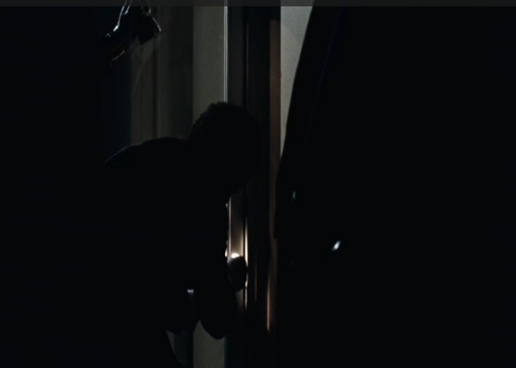
In the first scene, the mis-en-scène element of lighting is used; the shadows create a sense of tension and mystery. In the second scene, the mis-en-scène elements of setting, props, and costumes convey the image of two journalists working in a busy, lived-in newsroom that closely matches the actual newsroom of the Washington Post at the time of the film’s events.

Cinematography
Cinematography involves anything relating to how a film is shot: including framing (what is in the frame), shot distance (wide, close-up, medium), angle (low, high, eye-level), and movement (panning, tracking, handheld). For example, the first shot below uses a wide lens that allows us to see both a news broadcast on a television-set as well as Bob Woodward working in the background against the context of that broadcast. The second is an overhead shot used to make Woodward and Bernstein appear small against the overwhelming size of the Library of Congress:
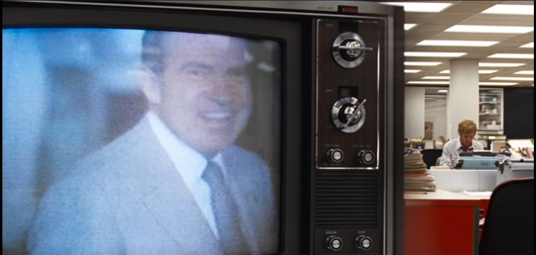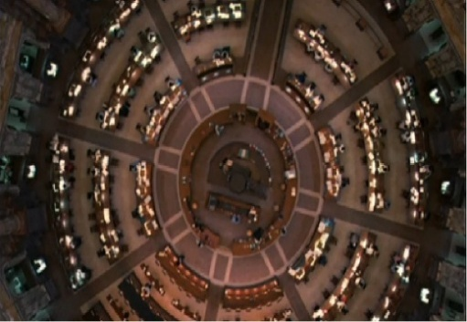

Editing
Editing denotes the process of selecting and assembling shots into a sequence. This includes the length of a shot, the rhythm of shots in a sequence, as well as choices such as whether shots follow each other quickly or slowly dissolve into each other. In the following scene, editing is used to cut sequentially between two close-up shots, conveying an intimate but tense back-and-forth conversation:
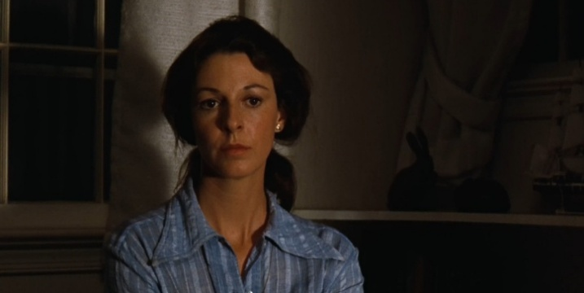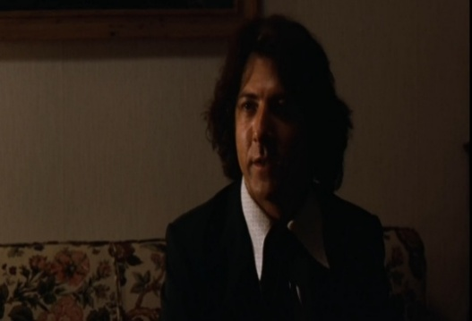

Sound
Bordwell and Thompson differentiate between two types of sound. Diegetic sound is all the sound that exists within the film's depicted world, such as voices, ringing phones, beeping cars, and pinging socials, but also any music played by radios or bands inside the film's reality. Non-diegetic sound is any sound that exists outside the world of the film and is added for the audience's benefit. Common examples are soundtracks or voice-over narration. It is beyond the scope of this thesis to embed sound into paper, but imagine the first shot set to the sound of ringing phones and typewriters clacking, and the second against eerie silence; then consider the effects these choices have on the reading of the scene:
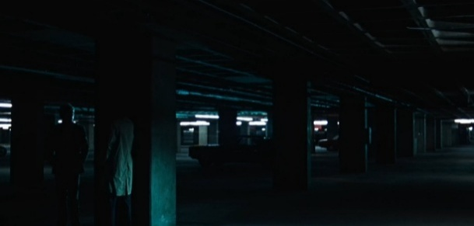

The stylistic choices and narrative cues often work in cohesion to trigger schemata, but also to subvert them and replace them with new schemata, leading the audience through a temporal sequence that keeps them testing new hypotheses. Take this scene, for example:
A journalist working behind a cluttered desk, as established in the mythology section, is a signifier likely to activate the schema for the diligent Watchdog archetype. But the same scene will activate quite different schemata depending on whether it is well-lit and set against upbeat music, or consumed by shadows while an ominous soundtrack plays. In the former case, the stylistic cues confirm the Watchdog hypothesis; in the latter, they introduce ambiguity or threat, and the viewer begins to test a different hypothesis. When the journalist then utters something like 'Hah! These suckers will believe anything I write!', the dialogue acts as a further cue that rejects the Watchdog schema altogether and activates the Reptile schema in its place. The point is that no single cue produces a reading; rather, it is the sum and interaction of narrative and stylistic cues that guides the viewer toward one schema or another.

3.2.3 Style, Schemata, and This Thesis
For this thesis, the most important implication of Bordwell’s schema theory is that cinematic meaning is produced by the cumulative activation and confirmation or rejection of schemata across the full temporal experience of the film. This thesis therefore uses mythological signifiers as introduced by Barthes, narratological structures in the model of Greimas, and cinematic techniques as identified by Bordwell to approximate the schemata that the combination of these elements are likely to activate, analyzing the corpus in a manner that can be coded and compared while remaining attentive to the ideological meanings those schemata produce.

3.3 Qualitative Analysis
This study adopts a qualitative methodological approach, employing textual analysis to examine representations of journalists and journalism in popular film in the social media era. As established in the theoretical framework, the interpretation of any film is invariably a subjective process: mythological signs, actantial structures, and cinematic cues do not produce fixed and universal meanings, but activate schemata in viewers whose prior cultural knowledge shapes how those cues are decoded. The most suitable way of addressing this interpretive complexity is to embrace it and employ a methodology that treats subjectivity as a feature rather than a flaw (Denzin & Lincoln, 2011). According to Hammarberg et al. (2016), Qualitative research is suited to investigating phenomena that are complex, sensitive, or insufficiently understood, particularly when the research is concerned with processes and requires detailed, contextually grounded insight.
While Hammarberg et al. were not writing about film explicitly, these descriptors apply directly to the nature of fictional narratives. Films are complex, sensitive, and rarely understood in a singular way; an understanding of detail and some contextually grounded insights are necessary when approaching them beyond the surface level. The most salient of these descriptors for this study, however, is 'concerned with processes'. As established in the theoretical framework, both film production and interpretation are composed of complex, interlocking processes: the societal processes that determine who dictates hegemony and who reproduces it in film; the semiotic processes by which first-order signs are emptied and refilled with mythological meaning; and the cognitive processes by which viewers activate, test, and confirm or reject schemata in response to narrative and stylistic cues. The analytical method of this thesis focuses on identifying and interpreting these cues, and approximating through knowledge of shared cultural schemata the mythological meanings audiences are likely to have constructed from them.
This approach to qualitative film analysis is grounded in David Bordwell's conception of film interpretation as a cue-based, processual activity. Bordwell argues that meaning in fiction film is actively constructed by viewers through their engagement with narrative, stylistic, and formal cues (Bordwell, 1985; Bordwell, 1989). In this sense, interpretation is neither arbitrary nor wholly subjective, but informed by the structures and strategies employed by the film text itself. This is directly compatible with Hall's encoding and decoding model, which similarly posits that audiences bring their own frameworks to the decoding of encoded messages, and with Barthes's account of second-order signification, in which mythological meaning is produced through the interaction of sign and cultural context.

3.3.1 Textual Analysis
Following Bordwell, this thesis analyzes how cinematic techniques, narrative structure, and archetypes guide viewers toward inferences about journalism, social media, and their relationship. Rather than treating films as simple reflections of reality or as containers of fixed meanings, this study examines the processes through which mythological meaning is generated, naturalized, and contested within the film text. This method of interpretation fits within the specific form of qualitative research known as textual analysis. As Norman Fairclough argues, texts are elements of social events that can shape knowledge, value, belief, and attitudes (2003). Since this study is concerned with how social structures and hegemonic processes are reflected, reproduced, and occasionally challenged by film texts, textual analysis is the most viable approach. All the more so because textual analysis has been widely used to examine texts as sites of ideological struggle (Fairclough, 2003), consistent with Hall’s (1980) understanding of representation as a domain in which meaning and power are contested.
The analysis in this thesis operates on two levels. The first-order level of diegetic narrative elements is coded in the coding scheme below, cataloguing the surface-level patterns that can be compared across the corpus. The second-order level of mythological connotation is applied interpretively in the findings and close-analysis chapters, where the ideological meanings of those surface patterns can be decoded.

3.3.2 The Corpus
The corpus consists of popular American films about journalists, journalism, and journalism-adjacent social media figures released between 2015 and 2026. The 2015 cut-off was chosen because by this point social media had been adopted across virtually every demographic and had become thoroughly embedded in both news production and consumption (Pew Research Center, 2015). By 2015, most filmmakers and audiences therefore possessed the cultural schemata necessary to situate any depiction of journalism within a social media reality, even when social media is not explicitly present in the film, as is the case with period pieces such as The Post (2017). The relative absence or presence of social media in a journalism film released after 2015 is therefore itself a meaningful finding rather than a neutral omission. Additionally, 2015 is on the cusp of the current journalism crisis, which is often dated to around 2016.
The decision to focus solely on American films is grounded in two considerations. First, American films continue to achieve the largest global dissemination, whether through theatrical release or streaming services (Hesmondhalgh, 2019; Miller et al., 2005), and thereby shape pan-Western perceptions of journalism more consistently and at greater scale than films from countries with lesser international reach. Second, American film is also the primary site of the hegemonic structures described by Herman and Chomsky's five-filter model, which this thesis applies to the film industry as well as the news media. The Hollywood studio system is governed by the same ownership, advertising, and sourcing filters as the institutional press (Halford, 2010), making American films the most ideologically coherent corpus for studying the journalism myth in its hegemonic context. Third, most existing research on the representation of journalists in film has historically concentrated on American productions (Ehrlich and Saltzman, 2015; Good, 1998; Harris, 1976; McNair, 2010; Ness, 1997). Limiting the corpus to American films ensures consistency with prior scholarship and situates this study within that existing body of work.

Inclusion Criteria: Popularity
Because an important goal of studies like these is to examine how the journalistic myth circulates through popular cultural products, it is essential that the films in the corpus can be described as popular or as having reached an audience large enough to meaningfully participate in the naturalization or destabilization of myth. To operationalize this, films were included if they met at least one of the following criteria:
Box office performance: During its theatrical run, the film was released internationally and ranked among the top 25 grossing films domestically in its release year, or grossed at least 20 million USD globally.
Streaming success: The film appeared in the top 10 to 20 charts on major streaming platforms such as Netflix, Disney+, or Amazon Prime during its release period, or was reported by industry sources as among the most-streamed films of the week, month, or year. This criterion allows the inclusion of films that may not have performed strongly in theaters but achieved significant viewership through digital distribution channels.
Awards recognition: The film was nominated for or awarded by any of the following: the Academy Awards, the Golden Globes, the BAFTA Awards, the Sundance Film Festival, the Cannes Film Festival, or the Toronto International Film Festival. This ensures that films of potential cultural significance and longevity, which may not have had immediate popular reach, are included in the corpus.

Weighted Popularity Score and Popularity Discrepancy Score
To account for the many modern channels of film distribution, especially those on the margins of or outside the channels governed by Herman and Chomsky's five-filter model, this thesis additionally operationalizes a Weighted Popularity Score (WPS). An initial attempt was made to gauge the popularity of films falling outside the previously established inclusion criteria by tallying their mentions across different social media platforms. However, this proved unfeasible for several reasons. First, certain films in the corpus have titles that are also commonly used words: Mainstream is an obvious example, and filtering search results by adding the release year or the words 'film' or 'movie' did little to narrow them. Adding the name of the director or lead actor shrank the results for generically titled films disproportionately compared to more specifically named films like Deadstream (2023), producing a skew that was unpredictable and difficult to correct. Second, social media mentions did not reliably correlate with views: both Mainstream (2020) and Spree (2020), for instance, star actors with sizeable fanbases (Andrew Garfield and Joe Kerry, respectively), and a significant proportion of the interactions these films generated on social media concerned interviews or promotional photographs of the actors rather than the films themselves. Third, this thesis is attentive to the fact that a film popular solely among one demographic may be rendered invisible by a film that is only marginally popular across all demographics. A purely aggregate popularity metric would therefore systematically undercount films with a strong but demographically specific audience.
To address these issues, interaction data was sourced from two platforms: IMDb and Letterboxd. IMDb is the most visited film platform on the internet, and its most engaged-with films tend to reflect mainstream tastes, high-budget productions from mainstream studios, and box-office successes (Ahrefs, 2026; Similarweb, 2026; Wasserman et al., 2013), while Letterboxd is widely cited as the most popular film platform among younger (16-24) audiences and cinephiles with more avant-garde tastes (Alexander, 2020; Buchanan, 2024; Lang, 2023).
Sourcing from both platforms therefore allows the corpus to account for films that are popular among older, mainstream audiences as well as those that are more popular among younger, cinematically dedicated viewers; the latter being a demographic of particular relevance to this thesis, given that the margins are often the space where myths are most meaningfully challenged.
In order to average a film's popularity across both platforms, a formula was developed. Since IMDb is the most visited platform and more closely aligned with mainstream tastes, and since 'mainstream popularity' is the primary metric for inclusion, the engagement a film receives on IMDb is weighted more heavily than that on Letterboxd. The engagement measured is the most basic public-facing interaction available to a user on each platform: for IMDb, this is giving the film a star rating, and for Letterboxd, this is logging the film as 'watched'. Since rating a film is a slightly more active engagement than simply logging it as watched (which is also reflected in the fact that films generally accumulate more Letterboxd logs than IMDb ratings, even though Letterboxd has considerably less overall traffic), this lends IMDb interactions some additional weight. The weight distribution settled upon is 60/40 in favor of IMDb. Given the inherently subjective nature of these considerations, this distribution is not derived from exact calculations but represents a considered estimation of the relative weight each platform should carry in a composite popularity score.
Each platform’s raw interaction count is divided by 500,000 and multiplied by 100, where 500,000 represents a practical popularity cap above which a small number of outliers would otherwise skew the results. The two resulting scores are then combined with the 60/40 weighting to produce the final WPS. The formula is as follows:
WPS = ((IMDb ratings / 500,000 x 0.6) + (Letterboxd watches / 500,000 x 0.4)) x 100
A WPS of 100 would therefore represent a film with 500,000 interactions on both platforms.
In addition to the WPS, a Popularity Discrepancy Score (PDS) was developed to measure the degree to which a film's popularity is skewed toward one platform or the other. Since IMDb skews toward mainstream audiences and Letterboxd toward younger, more niche audiences, a high PDS indicates that a film is significantly more popular on Letterboxd than on IMDb, suggesting it resonates primarily with a younger or more cinematically engaged demographic. A low PDS indicates that a film's popularity is more evenly distributed across both platforms, or weighted toward IMDb, suggesting broader mainstream appeal. The PDS is calculated using the unweighted platform scores (that is, without the 60/40 distribution applied), as the goal here is to measure the raw discrepancy between platforms rather than a weighted composite. The formula is as follows:
PDS = (Letterboxd score – IMDb score) / (Letterboxd score + IMDb score)
Where both scores are calculated as (raw interaction count / 500,000) x 100. The PDS therefore ranges between -1 and 1 in theory; however, in practice, all films in the corpus have a positive PDS, meaning Letterboxd interactions consistently exceed IMDb ratings in relative terms. The size of the discrepancy is what varies meaningfully across the corpus, and its implications for the distribution of the journalism myth across different audience demographics will be discussed in the findings chapter.
While the WPS served as an inclusion criterion only for films that did not meet the box office, streaming, or awards thresholds described above, both the WPS and PDS were calculated for every film in the corpus, regardless of why that film was included. This allows for meaningful comparisons across the full corpus: patterns in how different types of films score on both metrics can be identified and analyzed in the findings chapter. The WPS and PDS were calculated on the number of logs and reviews at that specific moment in time. These numbers are not static, especially since many of the films in the corpus are very recent and still being engaged with on both platforms.

Inclusion Criteria: Content
The narrative criteria that define a film as being about journalists or journalism in the social media era are as follows:
Journalist as protagonist or antagonist: One of the main protagonists or antagonists is a journalist or a journalist-adjacent social media figure. They cannot be a side character; they must be either the central character or have sufficient screen time and plot relevance to function as a significant actantial figure in the narrative.
Journalism as primary focus: The film revolves primarily around journalistic themes, whether institutional journalism, social media content creation, or their convergence. The Post (2017) is included because the narrative revolves around a journalist and centers on classic journalistic challenges such as editorial decision-making and press freedom.
Journalistic use of social media: The film depicts social media being employed in a journalistic manner or in ways that reflect journalistic themes. Profile (2018) is included because its protagonist uses social media as an investigative tool in the service of traditional journalism. This criterion ensures that films touching on the convergence of social media and institutional journalism are included in the corpus.
The films in the corpus were sourced from the IJPC database, but also by browsing tags such as 'Journalist(s)', 'Journalism', 'News', 'Media', 'Social Media', and 'Newsroom' on aggregators of streaming service offerings such as Justwatch.com and Reelgood.com, as well as film databases including IMDb and Letterboxd. Films were also sourced from online discussions about journalism and social media in film. In total, 31 films passed through the filters and were included in the corpus.

3.3.3 Limitations
Several limitations of both the corpus and the methodology of this thesis are worth acknowledging explicitly.
First, the corpus is not exhaustive but a curated collection of films selected according to the popularity metrics laid out in the methodology. It is therefore possible that insightful or original films were left out for not meeting those metrics, and equally possible that some films that did meet them were nonetheless missed. The reason for the latter is partly practical: no database was found that catalogues every film about journalism, journalists, or journalism-adjacent influencers in a manner that is both exhaustive and easily or reliably searchable. The IJPC database, while exhaustive, is nonetheless curated, meaning films may have been missed. Since the IJCP aims to collect all depictions of journalists, synopses were used to gauge whether the journalist(s) had enough presence to warrant inclusion in the corpus. This was often a judgment call, and some worthy inclusions may have been left out. Other comprehensive databases, such as IMDb, Letterboxd, Metacritic, and Rotten Tomatoes, rely on user-generated labels, which are sometimes imprecise. Films featuring a journalist working within a horror or comedy context may lack a journalism label entirely, while other films were flagged with labels such as 'journalist' or 'media' but ultimately did not meet the threshold of journalistic subject matter required for inclusion. Despite careful sourcing, it is likely that some films that would have qualified slipped through the net.
Second, the focus on American films excludes potentially significant non-American productions. In an era of global streaming services such as Netflix, films from other countries are beginning to achieve the kind of popular international reach that was traditionally reserved for Hollywood productions, and a fully global corpus of journalism films would need to account for these.
Third, the 2015 cut-off, while not arbitrary, is nonetheless imprecise. The adoption of social media across different demographics was a gradual process that some argue began as early as 2008, with the founding of Facebook, or even in 2003, when Myspace was launched. This means that some films of potential mythological importance, such as The Fifth Estate (2013) about WikiLeaks, and Nightcrawler (2014), a film about a Reptile archetype working as a freelance reporter, were excluded from the corpus. The 2015 threshold was nonetheless decided upon to ensure that social media was not only technically available but thoroughly embedded in the cultural zeitgeist of both filmmakers and audiences.
Fourth, the boundaries of the corpus involved interpretive judgment in two related ways. The decision of whether a film was “journalistic” enough for inclusion was, in borderline cases, a subjective call: films such as Superman (2025) and Official Secrets (2019), in which journalists are present but the journalistic content was deemed insufficient, were excluded on these grounds and may nonetheless prove relevant to the study of the journalism myth. The category of “journalist-adjacent” social media figure involved similar judgment: this thesis allowed some flexibility in what constitutes a journalist-adjacent influencer to account for the fact that traditional journalistic roles, as they migrate to social media, may not arrive wholly intact. The journalist-adjacent influencer in Spree, for instance, is for much of the film a conventional streamer, but was included because he also streams events he witnesses and occasionally interviews subjects. Other researchers may find that the net was cast too wide or not wide enough, and that the boundaries of both categories should be drawn differently.
Sixth, this thesis limits itself to film, which means that other media of comparable or greater popularity are not represented. Series are a particularly significant omission: they are arguably more consumed than films today and, by virtue of their extended running times, are especially effective vehicles for exploring the many dimensions of journalism and social media in sustained depth. Series such as The Newsroom may prove extremely insightful as representations of the journalistic myth, and their exclusion is a genuine gap that future research could address. Video games are a further omission. The investigative, truth-seeking nature of journalism makes journalists potent video game protagonists, particularly in games that offer an alternative to conventional violent gameplay. Games such as Outlast, whose protagonist is a journalist, may prove revealing when studying how journalistic roles are embodied by players and how the journalistic myth is transmitted to younger audiences through interactive media.

3.4 Coding Scheme
To structure and systematically analyze the qualitative data from the corpus, this study employs a coding scheme consisting of multiple categorical tables. The coding categories and codes are derived from prior research on the representation of journalists in film, as well as from the concepts developed in the theoretical framework. The coding scheme operates primarily at the first-order level of the two-order actantial model: it catalogues the diegetic narrative elements, demographic characteristics, and convergence patterns that can be systematically identified and compared across films. The second-order mythological readings of these coded elements are then applied interpretively in the findings chapter and the close-analysis chapter, where the ideological implications of the patterns identified by the coding scheme are developed.

3.4.1 Table A1: Journalist Demographics
The coding categories in this table capture the demographics of on-screen journalists and journalist-adjacent social media figures represented in the corpus, covering gender, age, and ethnicity. This situates the study within an existing body of work tracking journalist representation over time (Ehrlich and Saltzman, 2015; Good, 1989; McNair, 2010; Myers, 2025; Ness, 1997; Richardson, 2025). The demographic profile of the ideal journalist as naturalized by film is itself an ideological statement about who is culturally authorized to occupy the mythological here role.

3.4.2 Table A2: Journalistic Professional Roles
This table codes the specific professional roles that journalists and journalist-adjacent figures fulfill in the films studied. As established in the theoretical framework, certain archetypes and moral dispositions have historically been associated with specific professional roles. This table examines whether these associations persist in the social media era and whether new professional roles have begun to appear in the corpus.

3.4.3 Table A3: Journalistic Archetypes and Moral Behavior.
This table codes the presence of McNair's journalist archetypes and their associated moral dispositions in the corpus, namely the Watchdog, the Witness, the Lovable Rogue, the Reptile, the Repentant Sinner, and the Heroine (McNair, 2010). Coding archetypes allows for analysis of how character type intersects with professional role, demographic profile, and narrative positioning across the corpus. This table codes whether the journalist is Truth-seeking or truth-manufacturing/obscuring, as well as whether they work at least in part for the public interest or whether wholly for selfish interest.

3.4.4 Table A4: Journalistic Platforms
This table codes which platforms journalists are depicted as working for, and whether these platforms are shown as thriving, struggling, or failing within the narrative. The platform's diegetic status is itself a mythological sign: a thriving newspaper connotes the health of that branch of the journalistic institution, while a failing one connotes its vulnerability in the social media era.

3.4.5 Table A5: Journalist Career Stability and Motivation
Research establishes that career stability has suffered considerably in the journalism industry in the social media era. This table codes whether and to what extent these real-world conditions are represented in the corpus as potential mythological signs.

3.4.6 Table A6: Social Media Impact on Journalists, Institutions, and Public
The theoretical framework details the ways in which social media platforms have significantly affected journalists' working conditions and stress levels. This table codes whether journalist use social media in their reporting, and whether they experience stress or harassment from it. This table also tracks whether the diegetic public views journalism and social media in a negative or positive way.

3.4.7 Table A7: On-Screen Depiction of Social Media
This table codes whether social media is explicitly depicted on screen, in what form (diegetic, non-diegetic, or both), and whether these depictions are framed in a positive, neutral, or negative register. This allows for an assessment of social media elements as an emerging system of mythological signs and cinematic cues.

CHAPTER 4: Findings
Across the 31 films analyzed, a surprising and, in this thesis's view, crucial finding is that there are almost no instances of convergence between social media and traditional journalism. Instead, a consistent pattern emerged of journalism-centered films that staunchly avoided social media on one hand, and social-media-centered films that touched little, if at all, on the subject of traditional journalism on the other. True convergence occurred in only two films. This near-total absence of convergence is itself a significant result: the framework developed in this thesis anticipated the possibility that social media's disruption of journalism might be reflected in film as a convergence of the two worlds, either through destabilization of the journalistic myth or through its renegotiation. What the corpus shows instead is a clean and consistent separation, which, as the following sections will argue, is its own ideological statement. The containment mechanisms identified in the theoretical framework, especially exclusion and re-naturalization, prove pivotal for explaining why this separation exists and what ideological work it performs. For reasons of clarity and readability, the findings are therefore divided into three sections: journalism-centered films, social-media-centered films, and convergence films.

4.1 Journalism-centered Films

4.1.1 The Retreat into the Past
What stands out immediately is how many journalism-centered films take place in the past. Out of the 23 journalism-centered films in the corpus, 14 are set some years before the time of their production, with 11 being period pieces set in an era in which social media was either non-existent or by all means irrelevant. This means that Jenkins's speculation that the journalism film might become a retrospective genre has largely been proven by the corpus.
We can see both re-naturalization and Hall's concept of exclusion operationalized here: the disruptive and threatening element of social media is barred from the myth altogether.
The vast majority of the films set in the past are true stories about exceptional journalists that firmly reinforce the journalistic myth. When viewed in the context of the contemporary social media reality in which these films were produced and consumed, this suggests at least a tendency on the part of filmmakers to portray an analog past in which classic journalistic values were expressed by real journalists, unimpeded by the disruptive and complicating forces of social media.
In Barthesian terms, the period piece is a powerful mythological tool because it naturalizes the past as a space of moral purity. By setting the journalistic myth in an era before social media existed, these films empty the journalistic hero of any contemporary ideological contamination and fill them instead with the timeless signified of the watchdog ideal. As such, the retreated-into past then becomes a second-order sign for what journalism should be, and implicitly, for what some feel it is no longer allowed to be in the social media present. The proliferation of journalism period pieces since 2015 is therefore a mechanism of both exclusion and re-naturalization operating at the level of historical setting, and a temporary counter to Good's prediction that the journalism film would decline into irrelevance in the social media era. In short, the genre has not declined, but retreated.
It is also worth considering the specific political context in which this re-naturalization takes place. The post-2016 proliferation of prestige journalism period dramas maps neatly onto the period in which institutional journalism came under arguably its most sustained public attack since its inception, with the rise of the 'fake news' discourse and the political delegitimization of the mainstream press. This is precisely the condition that Gramsci's concept of organic crisis describes: a moment in which hegemonic institutions lose credibility and the myths that sustain them are most visibly under pressure. The response of the film industry, as this corpus demonstrates, was to reassert the journalistic myth more potently, and to do so wherever possible by retreating into a pre-crisis past.

4.1.2 Distribution, Popularity, and Hegemonic Reach
Myth-reinforcing journalism period films account for a significant portion of the films included in the corpus on the merit of box office success and awards prestige. This suggests that such films enjoy significant popularity through traditional cinema distribution channels and that they are also critical darlings among the most prestigious award bodies. In other words, the myth-reinforcing journalism period drama thrives in the classic hegemonic Hollywood environment.
This traditional popularity is also reflected in the popularity discrepancy score (PDS) of these films: most of the journalism period dramas had a low PDS, suggesting they are popular across demographics of age and film affinity. The journalistic myth, as reproduced by these films, is therefore a broadly consumed and critically legitimized cultural product, circulating through precisely those institutional channels that Herman and Chomsky's ownership and advertising filters most directly govern.

4.1.3 Demographics

Gender
Among the journalists featured in the journalism-centered films, 24 were female, and 15 were male. Which means that, at least according to this corpus, the notion that men make up the bulk of journalists in film no longer holds true. In fact, the ratio of female to male journalists in film is considerably higher than the real-world ratio among American journalists, which is about 51% men to 46% women (the rest did not specify gender) (Pew Research Center, 2023). The fact that women make up 61% of journalists in film is therefore a surprising finding that warrants exploration.
Table 1. Gender of journalists in journalism-centered films, compared to US journalist population (Pew Research Center, 2023).
Gender | Corpus (N) | Corpus (%) | US journalists (Pew, 2023)
Female | 24 | 61.5% | 46%
Male | 15 | 38.5% | 51%

The vast majority of the female-led journalism films are biopics or true stories, which suggests a deliberate effort to recover and celebrate female journalistic heroism as part of the contemporary reinforcement of the journalistic myth. In fact, women make up 65 percent of the Witness and Watchdog archetypes, while only one woman inhabits a villainous archetype.
As the archetypes section will demonstrate, this trend has produced a dual watchdog-heroine figure whose personal and professional arcs reinforce each other in a manner that strengthens the myth on two fronts simultaneously.

Age and Seniority
Almost all of the journalists in the journalism-centered films fall into the middle age category. Only 3 were explicitly portrayed as young, and only 2 as old. Very few were ostensibly at the junior level of their career; most were either reasonably established or occupied a senior position. The average film journalist is therefore a somewhat mature individual in the prime of their life and career. This is not insignificant for the reinforcement of the journalistic myth: the ideal journalist is mature enough to command trust and respect, while not being so old as to seem redundant or out of touch. They occupy a sweet spot in which they are embedded right in the middle of society, and therefore ideally positioned, both socially and symbolically, to act as its watchdog.

Ethnicity
Out of the 39 journalists featured in the journalism-centered films, only 2 were part of an ethnic minority, meaning that journalist protagonists in the corpus skew heavily white. This is significant when compared to the actual demographic makeup of the United States, which is approximately 57% white as of 2023 (USAFacts, 2025), and even when compared to the journalism profession itself, in which approximately 76% of journalists are white (Tomasik, E., & Gottfried, 2023). In the corpus, by contrast, approximately 95% of journalists were white, a skew of nearly 20 percentage points even relative to the already predominantly white profession.
Some of this skew can be explained by the fact that almost half of all journalism-centered films in the corpus are period pieces from a time when the United States, and journalism in particular, were significantly less diverse. More than half of the journalism-centered films were based on true stories which happened to involve white people. When looking only at journalism-centered films that were neither period pieces nor based on a true story, the ratio becomes approximately 78% white to 22% non-white, which is significantly closer to the current real-world ratio among journalists.
Table 2. Ethnicity of journalists in journalism-centered films, compared to the US journalist population and the US population.
Group | Corpus (full) | Corpus (excl. period & true story) | US journalists (Tomasik & Gottfried, 2023) | US population (USAFacts, 2025)
White | 92.3% (36/39) | ~78% | 76% | 57%
Non-white | 7.7% (3/39) | ~22% | 24% | 43%

However, it is important to note that when it comes to true stories, filmmakers choose which stories to portray, and some worthwhile true stories about minority journalists have likely been left untold. Any causal explanation for this exclusion is ultimately conjecture, but the section about the Heroine archetype will offer a hypothesis.

Sexuality
There is only one (potential; the film leaves it unclear) LGBTQ journalist with significant screentime in the corpus: namely, Kayla Pospisil, a young producer working for Fox News in the movie Bombshell. It must be said here that a character’s sexuality is less readily identified than gender and ethnicity, and most often needs to be written into the narrative to be expressed. This makes sexual minorities rare in films where LGBTQ themes have no narrative presence. The number was nonetheless low.

4.1.4 Narrative
As expected, almost every journalism-centered film sees a journalist occupying the first-order Subject actant and journalism as an institution occupying the second-order Subject actant. And, in line with Ness’ definition of the journalism narrative, truth, and who seeks, suppresses, and controls it, creates the narrative tension.
In the vast majority of journalism-centered films in the corpus, the second-order Opponent actant is filled by the concept of hegemonic power. This is especially true of the true story films, where all but one film sees this actant filled by hegemonic power.
In many cases, a representation of the hegemonic elite is explicitly present at the first-order level as well. In The Post, one of the Opponents is the Nixon government; in Spotlight (2015), it is the clergy and the power they project in the Boston community. In other films, however, the actant of the first-order Opponent is filled by an individual who, through connotation, comes to be representative of hegemonic power at the second-order level. In The Woman in Cabin 10 (2025), for example, the first-order Opponent is an individual billionaire who uses wealth and connections to obfuscate secrets. Little stretch is needed to find in this figure a signifier at the second-order level of hegemonic power. Such is the case as well in Bombshell, where female journalists take on a powerful media mogul who, at the second-order level, can again be read as an embodiment of hegemonic power. The most surprising example of this may be Late Night with the Devil (2023): ostensibly a straightforward horror film with a nefarious demon on the Opponent actant, it is revealed toward the end of the film that the journalist Subject was complicit in summoning this demon during a gathering at the Grove, a real-world location where prominent beneficiaries of hegemony such as presidents, media moguls, and tech billionaires are said to meet annually. The supernatural Opponent is at the second-order level a mythological sign for the hegemonic elite, and the journalist's complicity in summoning it is an unusually direct acknowledgment of the journalist's own entanglement with hegemonic power.
In films where hegemonic power occupies the second-order Opponent actant, the Object is invariably some form of truth, while the Receiver is in most cases the public at the first-order level and the film's audience as the real-world target of the journalistic myth at the second-order level. When viewed through the second-order actantial model, the vast majority of journalism-centered films in the corpus reproduce the journalistic myth in a remarkably traditional and consistent form.
Those films that edge close to criticizing institutional journalism do so by shifting the position of the journalist within the standard actantial structure while leaving the public versus hegemony core intact. This makes them straightforward examples of shadow acknowledgment at the level of the individual journalist, and of inoculation and narrative containment at the level of the journalistic institution.
In Richard Jewell (2019), for example, the Subject is an ordinary member of the public while the Opponent actant is filled by a journalist working in collusion with an FBI agent. At the second-order level, the public-versus-hegemonic-power structure of the standard journalistic myth remains entirely intact; the only difference is that the journalist, whose Shadow is fully embraced, shares the Opponent actant with an FBI agent as dual representatives of hegemonic power.
The consistency of the second-order actantial structure across the corpus, and the way even seemingly dissenting films recuperate rather than destabilize it, is the clearest evidence that the journalistic myth is ardently reinforced in the period studied. The social media disruption has not altered the actantial make-up of the journalism film but rather sharpened the opposition between the legitimate Subject and Receiver on one side, and the hegemonic forces that oppose truth on the other.

4.1.5 Archetypes
Table 3. Archetype distribution among journalists in journalism-centered films, with dual archetypes shown as a separate category to reflect the fused Heroine figure discussed in this section. Four Artist outliers in The French Dispatch are excluded.
Archetype (solo) | N (solo) | Total appearances (solo + dual)
Heroine | 4 | 11
Watchdog | 9 | 15
Witness | 8 | 9
Repentant Sinner | 4 | 4
Lovable Rogue | 2 | 2
Reptile | 1 | 1
Dual archetypes | N
Watchdog-Heroine | 6 | —
Witness-Heroine | 1 | —

The Heroine as the New Face of the Journalistic Myth
The most striking finding among the journalism-centered films in the corpus is the popularity of the Heroine (11 instances). The reason this archetype is so highly represented is partly that it rarely stands alone but is most often complementary to the Watchdog or Witness archetype; the two strands being fused, as in The Post or Boston Strangler, into a dual watchdog-heroine figure whose personal and professional arcs reinforce each other and culminate simultaneously.
In some films featuring the Heroine archetype, the expression of this strand is straightforward and tied directly to the journalist's first-order actantial narrative. In these films, the Heroine is typified in the manner observed by McNair: she must fight for acceptance, recognition, and sometimes basic respect in a male-dominated, overtly sexist environment (2010). In Bombshell, for instance, the three Heroine journalists are directly victimized by the male Opponent, and their Object is to expose his sexual harassment for the benefit of themselves and other women working in similar environments. In Boston Strangler, the female protagonist, initially assigned to the lifestyle beat, must fight both the prejudices of the newspaper's male leadership and the male police department in order to pursue the case of the Boston Strangler: a murderer of women.
In other films, however, the Heroine expression is more implicit, and the female-journalist-versus-male-hegemony pattern exists more predominantly at the second-order actantial level. In both Scoop (2024)and She Said, teams of female journalists work to expose rich and powerful abusers of women (Prince Andrew and Harvey Weinstein, respectively). In these films, the female journalists do not operate in overtly sexist environments, and the glass ceiling is not part of the narrative; they are in fact portrayed as either highly successful reporters or decorated veterans of the profession. However, by exposing male abusers of female victims, the Heroine archetype is nonetheless implicitly present, especially because these films tend to portray the female journalists as being more emotionally invested in the case than their male colleagues, because of the gendered injustice. Additionally, even those female journalists who do not personally experience overt sexism are in most cases still coded as Heroines through mythological signs associated with the archetype; most commonly the struggle to balance a demanding case with family obligations or motherhood.
This fusion of watchdog and heroine is ideologically significant. Heroine narratives that depict female journalists exposing male elites create what might be called a double underdog structure: the female journalist is positioned both as a truth-seeker challenging institutional power and as a gendered subject confronting patriarchal authority. This symbolic alignment places her firmly on the side of the people, while male antagonists embody elite dominance in both its professional and personal forms. In doing so, such narratives reinforce the journalistic myth of speaking truth to power while simultaneously coding the female journalist as an outsider to the elite structures she is challenging, thereby obscuring her own frequent proximity to those structures. The feminist narrative strand is therefore recruited into the myth’s service, strengthening its ideological function by creating a gender-coded divide between the female journalists and the male representations of hegemonic power.
In a Barthesian sense, the rise of the female carrier of the journalism myth is the corpus’s most clear instance of mythological reconstitution: the white male has been compromised as an agent and beneficiary of hegemony; therefore, the myth reconstitutes itself by filling a new form that is seen as further removed from the hegemonic elite.
Simultaneously, however, the new demographic occupant of the Hero journalist does not stray far from hegemony herself: as evidenced by the corpus, she is most commonly a middle-age-category white woman in a senior position at a major news outlet. In this sense, her position is a complex one. While she challenges white male hegemony from a marginalized gender position, she simultaneously operates from within structures of racial and institutional privilege. As such, her challenge to one axis of power coexists with her embeddedness in others. This is especially apparent in those films in the corpus that are based on true stories, wherein all but one of the women (Sam McAlister, who is explicitly posited as a lower-class outsider within the BBC team) come from well-connected upper-middle-class or wealthy backgrounds and hold advanced degrees, mostly from prestigious institutions such as Yale, Harvard, and Stanford.
It is important to add here that some films starring the Heroine admit these hegemonic ties readily. In Bombshell, Megyn Kelly is shown as both benefiting from her elite status and being complicit in Fox News's populist output. While in The Post, Katharine Graham is the heiress of the Washington Post, and is shown to have grown up among the very top of America's elite. In such films, the hegemonic Shadow is readily expressed, and the women's exposure of the male hegemonic Opponent figures is shown to come at great personal cost. The choice between loyalty to the white, male hegemonic elite and the truth is in these cases the main narrative tension, and the choice for truth ultimately the decision that earns the Heroines a place at the side of 'the people’.
It is more problematic, however, when the hegemonic position of such a Heroine is not acknowledged, and her implied outsider status derives solely from her being a woman in a man's world. Such cases perhaps reveal something about the precarious balance the mythical journalist must strike between being on the side of the people on one hand and being an established source of authority on the other. As mentioned in the theory, journalism, especially in the interregnum of our organic crisis, is both criticized for being a mouthpiece for the elite and simultaneously trusted more than grassroots social media channels, precisely because of its established institutional status and the myths that sustain it. As such, the ideal representative of the journalism myth may exist in the middle of a spectrum where the white, compromised hegemonic male occupies one end, and the marginalized, 'radical' figure described by Gitlin occupies the other. Given that the majority of Americans are white and benefit to an extent from the currently contested hegemony, it may be that the transfer of the journalist Hero from white male to white elite female represents the point on that spectrum where the average viewer (or filmmaker) deems the balance between hegemonic distance and hegemonic embeddedness to be just right.
While the ideological function of the Heroine can be debated, so too can the question of whether her proliferation is an asset to the cinematic and real-world female journalist. Despite the ostensible feminist power of the Heroine archetype, it also severely limits the narratives in which female journalists are centered and the cases they are shown to tackle. In only two films (Civil War (2024) and A Private War (2018)) were female journalists portrayed as simply doing journalistic work without gender dynamics being central to the narrative, the reporting, or presented as a strong undercurrent. This means that, despite making up the majority of journalists on-screen, women are still rarely positioned by filmmakers as being simply a ‘default’ journalist.

The Watchdog and the Witness
The Watchdog is the most prevalent archetype in journalism-centered films, followed by the Witness. As noted above, these archetypes are most commonly combined with the Heroine archetype. The high prevalence of these heroic archetypes relative to more ambiguous or villainous ones suggests that the modern journalist is represented in film predominantly as a heroic figure, which is consistent with the broader finding that the journalistic myth is heavily reinforced and re-naturalized across the corpus.

The Repentant Sinner
There are four Repentant Sinners among the journalism-centered films, and all four are white and male. There is considerable variety in how their sins and repentance are portrayed. In A Beautiful Day in the Neighborhood (2019), a jaded journalist with a tendency to write scathing profiles finds his outlook transformed when he meets children's television hero Mr. Rogers, about whom he ultimately writes a comprehensive and loving piece. In True Story(2015), a journalist discredited for fabricating stories attempts to rehabilitate his reputation by interviewing a truth-twisting serial killer, only to dig himself deeper. In Late Night with the Devil, a failing talk show host makes a deal with a demon in exchange for a thriving career, a deal he comes to regret. In Vengeance (2022), an urban journalist sets out to write a condescending piece about rural 'hicks', and ultimately finds his assumptions about these people overturned. With the exception of Late Night with the Devil, the pattern among these films is consistent: the Repentant Sinner ends up rediscovering the value of genuine journalism, reinforcing the myth of the passionate, truth-driven reporter. This is narrative containment at the level of the individual arc: the journalist strays from the myth's values and is brought back, confirming that the values hold.
Read against the potential ideological function of the Heroine, there may be some gendered implication here: the white, male hegemonic journalist hero of yesteryear has fallen and become compromised. And yet, there is hope for this figure, if he repents.

The Gender-Swapped Lovable Rogue
There are only two Lovable Rogues in the entire corpus, and both are notable for the same reason: they are women, and both are portrayed in exactly the grammar that McNair associates with the male Lovable Rogue of prior decades. McNair describes the Lovable Rogue as a charming and untrustworthy figure, a 'bad boy' whose serial romantic tendencies and allergy to commitment are presented as roguish rather than reprehensible, often embodied by handsome leading men such as Richard Gere or George Clooney and most at home in the romantic comedy (2010).
In this corpus, the Lovable Rogues are also found in romantic comedies (Players (2015) and Trainwreck (2015)), and like their male predecessors, their personal lives revolve around casual romances and a determined avoidance of commitment, with the plot hinging on whether their latest romantic prospect can persuade them to give up their bachelor lifestyle. What makes these figures significant is the precision with which the archetype has been transposed: the female Lovable Rogue embodies the same (usually male-coded) characteristics and appears in the same narrative role and genre as her male forerunner. The fact that both versions of these characters are journalists suggests that the Lovable Rogue archetype is sufficiently embedded in the mythology of the journalism profession to survive the gender update intact.

The Migration of the Reptile
The Reptile archetype appears only once in the journalism-centered films of the corpus, a significant scarcity compared to its prevalence in prior decades of journalism film (McNair, 2010). This thesis argues the scarcity is not coincidental: the image of the Reptile paparazzo and the ratings-driven television news psychopath has migrated from the figure of the traditional journalist onto the social media influencer, where, as the social media findings section will demonstrate, the archetype has become the dominant one by a considerable margin.
This migration serves the journalistic myth through the mechanism of displacement. The shadow expression that the journalism myth has always required, the controlled admission that the institution can produce corrupt figures, can now be outsourced to a figure outside of the institution. The traditional journalism film no longer needs to internalize its own Shadow, because the Shadow lives elsewhere: in a different genre, starring in a different kind of film altogether
The result is a journalism film that can portray the institutional press in wholly heroic terms without the usual mythological obligation to admit its own failures, because the failures have been relocated to a figure in a different kind of film.

The Exception
In only one film could the journalists not be classified as one of McNair's moral archetypes. That film was The French Dispatch (2021), whose journalists would, in McNair's expanded archetypal vocabulary, be classified as Artists: journalists who value and are known for their literary prowess more so than their coverage of facts (2010). McNair posits Truman Capote and Hunter Thompson as examples. The archetypes were not stretched to include the Artist. First, because the Artist can only be tenuously morally classified (McNair, 2010), and second, because The French Dispatch proved to be the only example across the entire corpus that supplied such archetypal outliers.

4.1.6 Professional Roles
When it comes to the professional roles represented in the journalism-centered films some patterns are discernible. As research by McNair would lead one to expect, most of the Watchdog archetype journalists are investigative reporters, while virtually every Witness is either a war correspondent or a war photographer. There are exceptions: one of the Watchdogs in Scoop is a producer and one in The Post is a publisher. For the most part however, the traditional link between heroic archetypes and their most commonly practiced professional roles still holds.
A more interesting pattern emerged among the Lovable Rogue and Repentant Sinner archetypes: with one exception (the Repentant Sinner in Late Night with the Devil, who is a talk show host), all of these characters are magazine writers. This is particularly notable among the Repentant Sinners, whose narrative arcs most commonly move from fabricating stories or writing from an ideological bias to embracing honest and empathetic reporting. This suggests that the magazine writer is perceived as a professional role with greater creative latitude than the institutional reporter, for better or worse; a space where the journalist's individual Shadow can surface more freely, and where the journey back to the myth's ideals is therefore more dramatically potent.

4.1.7 Mythological Signs
Most of the journalism-centered films include, to some extent, the mythological signs described by Saltzman, McNair, and others. This is expected of the period films, where busy newsrooms and paper-stacked desks are indeed omnipresent. Surprisingly, however, cluttered and paper-strewn newsrooms also proliferate the sets of films taking place in our digital present. This is especially true for those films starring Heroines or Watchdogs and wherein journalism itself is the central theme. While some modern newsrooms undoubtedly still use paper, the proliferation of this sign may connote first and foremost a mythological inheritance. Compare, for example, the newsrooms from the period films The Post and Boston Strangler with the almost-present-day newsrooms found in Bombshell (a TV station no less) and She Said:
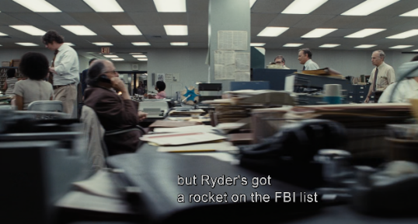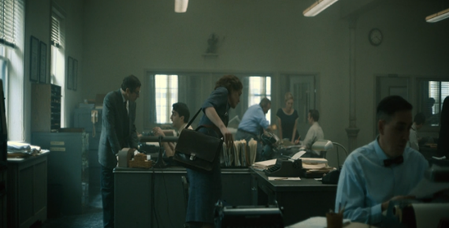
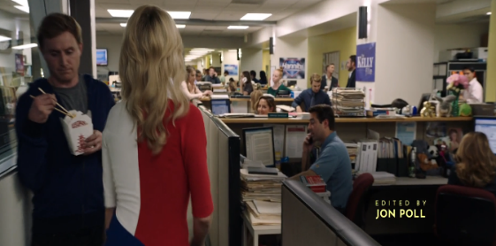
In films starring journalists, but which are not about journalism thematically, the newsrooms are, by contrast, revealingly sparse.
Many of the films also show the journalists having to make great personal sacrifices for their profession. This is especially pronounced for the female journalists, who are portrayed much more frequently than their male counterparts as being torn between their family obligations and the story they are pursuing. In Boston Strangler, the journalist protagonist is criticized by both her husband and her mother for neglecting her domestic duties, and the home in which her family lives is desecrated by either the Boston Strangler or an impersonator. And in both Scoop and She Said, which for the most part portray a journalistic environment free of overt sexism, most of the female journalists are nonetheless shown forced to balance the demands of motherhood with the pressures of investigative work.
As mentioned in the framework, this problem does impact real-world female journalists disproportionally, and the inclusion of this gendered sign is therefore an acknowledgment of the reality women often have to deal with. However, as is the case with the Heroine narrative, it also limits the variety of signs women express on-screen and offers another hurdle to representing the female journalist as an unflavored default. Especially when considering that, when female journalists of a certain age do not have children, they tend to be portrayed as either unhappy, as is the case in Christine, or as cold and relentlessly ambitious, as is the case in Richard Jewell. This means that despite the overall positive portrayal of female journalists throughout the corpus, old tropes like the ‘News Bitch’ (Ghiglione, 1990) are still operational as gendered signs. Taken together, this suggests that women in journalism films are still often caught in a double bind when it comes to family life.
Other mythological signs may be found in the cinematic cues used to create a sense of high stakes, tension, or urgency: low-key lighting and chiaroscuro in scenes dealing with mystery or moral ambiguity; close-ups in moments of revelation or important decisions; obstructed framing to create a sense of voyeurism or complicity in exposure; and hectic cross-cutting to evoke panic or immediacy. While such techniques appear in many other types of film, they have a long history in journalism films, particularly those that are thrillers or deal with high-stakes investigative cases.
The film that integrated many such tension-building techniques into the journalism film is All the President’s Men, and many of the journalism-centered film in the corpus, especially the true stories, reflect that stylistic legacy to some extent, whether as inherited signs or homage. Compare, for example, these two shots: one of Carl Bernstein in All the President’s Men, and the other of Megan Twohey in She Said, both walking up to the house of an interviewee, silhouetted against the dark, and filmed voyeuristically from behind bushes:
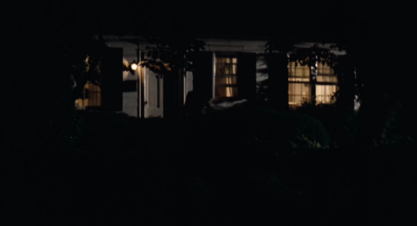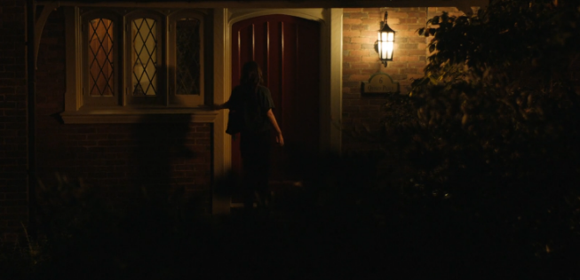
This distant, partly obstructed shot lends a predatory feel to the frame. Yet the drama genre makes a literal predator unlikely, and the sense of danger is instead projected inward, onto the unknown occupant of the house, building tension until the door is finally opened.
Because journalism films must compete with high-octane action films and violent thrillers for attention, and since investigative journalism stories rarely place the journalist in actual bodily danger, these tension-building shots and techniques recur across the genre.
A common example is the scene where the journalist, in the process of taking on powerful hegemonic figures, begins to suspect they are being followed. Compare the iteration of this sign across both All the President's Men and She Said:
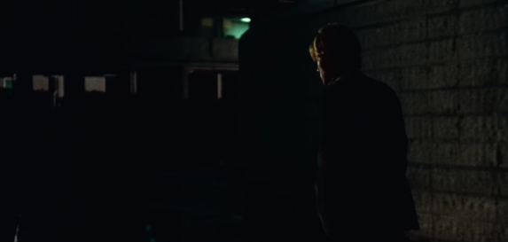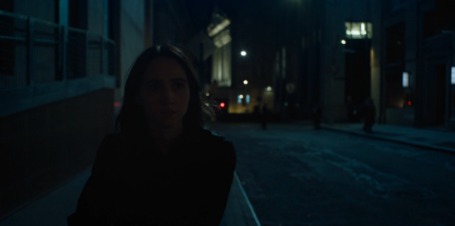
In both cases, a tracking shot follows the journalist down a dark street while an ominous and tense soundtrack plays. And in both cases, the journalist is positioned to one side of a wide frame, leaving room for the danger to emerge. The tension builds, until:
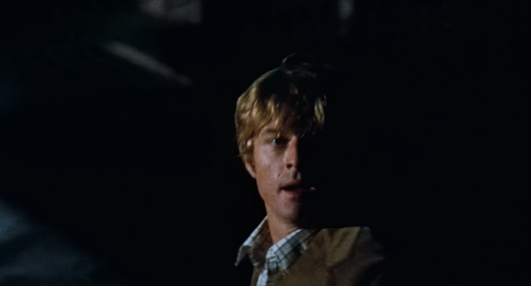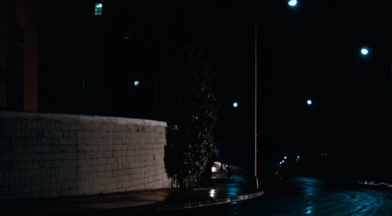
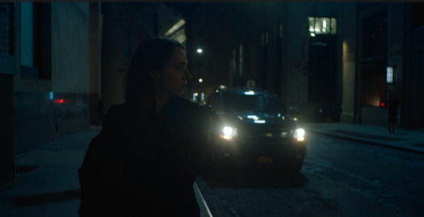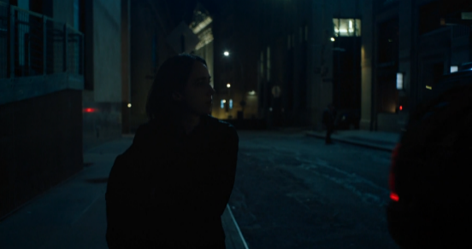
Nothing; just their paranoia.
What we see in these cases is a sly Bordwellian play of cues and schemata. Framing, soundtracks, and lighting are borrowed from the thriller genre, where such cues typically pay off in the form of real danger. In the journalism film, however, these cues trigger schemata for danger in the audience without the violent culmination. This produces two effects: it conveys in a tangible way the high stakes that are genuinely at play, albeit in a more abstract form, during high-profile investigative cases. And secondly, it injects much-needed tension into films that are, at their core, about phone calls and typewriters.
The mythological signs and cinematic cues found in the journalism-centered films in the corpus were quite typical of those historically used in films that most emphatically reinforce the journalistic myth. This adherence to tradition in mise-en-scene, character portrayal, and cinematic technique only serves to confirm that the period studied is largely characterized by the traditional journalism myth-vehicle.
In all four of the films featuring the Witness archetype, the common signs of the war reporter are present: the main journalist characters drink and party hard; they are portrayed as drawn to risk, keep a stoic face and a steady hand when filming gruesome scenes, and express a jaded worldview (Ehrlich and Saltzman, 2015; McNair, 2010).
The mythological signs specific to the convergence between social media and journalism will be included in the following subsection.

4.1.8 Social Media: a Glaring Absence
Social media has little presence in the journalism-centered films in the corpus. This absence is expected in the period pieces, but even in films set in the present or in a period when social media was already widely adopted, it is rarely visible. This is exclusion, the containment mechanism that the theoretical framework identified as the power to determine what never enters the frame, operating at the level of much of the corpus.
In some films, the exclusion seems to serve an ideological function. In Civil War (released in 2024, set either in the near future or an alternative version of the present), an aspiring teenage journalist is briefly shown uploading a photo to a nondescript social media platform on her phone. However, the moment she is adopted into a team of seasoned war reporters, she is never seen using either her phone or social media again, instead wielding a photo camera for the rest of the film. This seems like a deliberate choice: the film revolves solely around the war reporter's experience in an active combat zone and staunchly avoids other thematic threads, including the politics behind the war and the ideological role of journalism in escalating or preventing a conflict. To dwell on the implications of social media in a modern conflict would have pulled the film away from this lean central subject matter. The young journalist's discarding of her phone at the moment she is taken under the wing of experienced reporters is therefore also a mythological sign: at the second-order level, it connotes that to become a real journalist is to leave the amateur social media world behind. This contrast between amateurish social media and professional journalism will be further expanded in the social media focused section of the findings.
In films like Trainwreck, Players, and Venom (2018) (all set in the present), social media appears to be absent simply because these are fundamentally classic and formulaic genre films in which the journalist character is recruited because they handily map onto an archetype, while barely touching on journalism as a theme. These are films that could have been made just as well in the 1980s. The journalist characters in Players and Trainwreck are Lovable Rogues in trope-heavy romantic comedies, their profession only lending credence to the archetype. In Venom, the journalist protagonist is the gruff-but-valiant detective-adjacent reporter found in the pulps and comics of the early twentieth century (McNair, 2010), his capacity as a watchdog journalist functioning primarily as an excuse to guide him into the film's plot, which has little to do with journalism itself.
However, there are three journalism-centered films wherein social media does play a significant role. It is likely no coincidence that all three of these films (She Said, Bombshell, Scoop) revolve to some extent around the #MeToo movement, which unfolded largely on social media platforms (De Vries, 2020).
In all three films, social media appears as a source of collective power. Following the logic of #MeToo, women are shown connecting on these platforms, sharing stories of abuse, exposing their abusers, and celebrating the journalists who brought down figures like Prince Andrew and Harvey Weinstein. Often, this connection takes the form of social media as vox populi, with the viewer shown direct feeds of messages of support.
In other cases, the connection is more implicit. She Said, the film about the reporters who exposed Weinstein and ignited the #MeToo movement, approaches social media's potential to give voice to the silenced in an oblique way. Ironically, it features virtually no social media throughout, neither on screen nor in dialogue. Yet the opening sequence manages to foreshadow the entire movement with remarkable economy and elegance. The film begins with a flashback to the nineties of a wide-eyed young woman, enamored with film production, working on a set, before cutting abruptly to a shot of her running away in a panic:
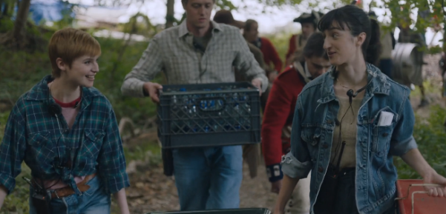
It then jumps to New York in 2016, showing a sequence of shots of young women scrolling through their phones:
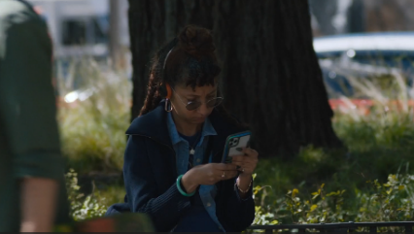
The connotation is clear: social media has given women a voice, and the abuses of the past will be dragged into the light. That this sequence is expected to activate schemata for both #MeToo and the collective power of social media through such minimal cues speaks to how deeply embedded these associations have become in our collective consciousness, and to the mythological charge that social media now carries as a sign.
There are scenes across these films where the journalists and the diegetic social media audience are shown as both practically and ideologically aligned against the power structures the journalists are challenging. In these moments, the journalist Subject and the diegetic Receiver audience are posited together in opposition to the hegemonic Opponent, with the Receiver simultaneously assuming a Helper role by either circulating the Object (the truth) or enacting punishment on the Opponent. In Scoop, for example, the social media audience is shown engaging genuinely and emphatically with moments from the Andrew interview, while at the same time punishing him through memes and relentless notifications that overwhelm the former prince's phone as he stands naked and exposed:
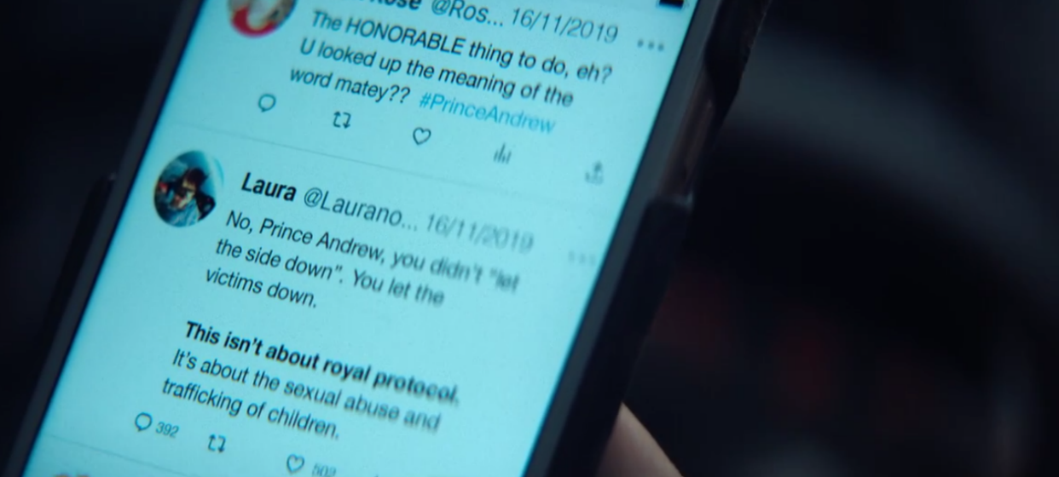
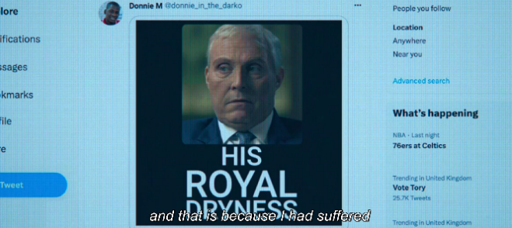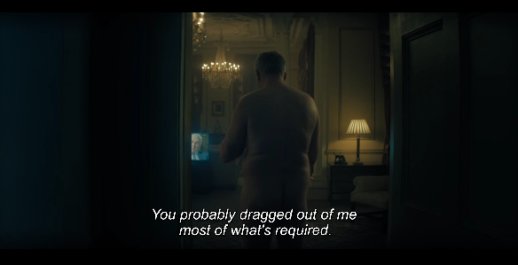

On the flip side, social media is also depicted as the source of the harassment predicted in the framework, although mainly in Bombshell. In this film, Megyn Kelly is the target of an online harassment campaign driven mostly by Donald Trump on Twitter. Bombshell integrates social media signs non-diegetically, showing messages on a phone directly to the viewer through stylized overlays. When the messages first start and Megyn feels herself in control of the situation, they pop up on screen with a neutral ping. When the harassment cascades, however, the tweets become uncontrollable and burst on the screen in a relentless torrent of visuals and pings. This way of portraying social media elements through cinematic audio-visual cues as an uncontrollable (often hostile) force is more common in the social-media-centered films of the corpus, especially those of the horror genre. However, the fact that these signs are consistent across genres and themes suggests they have become sufficiently naturalized schemata-triggering-cues to be deemed universally legible by the audience.
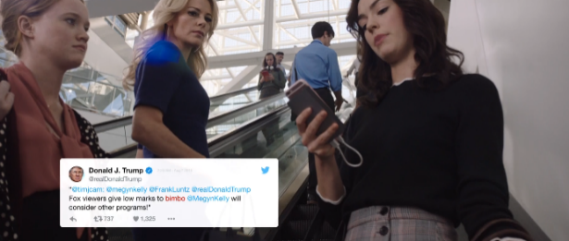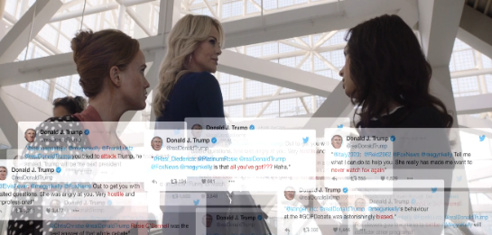
4.1.9 Adaptation Pressure
Adaptation pressure from social media is shown mostly in Bombshell and Scoop. In Bombshell, Fox News leadership is shown adapting their coverage in response to then-candidate Trump's social media messages. In Scoop, BBC producers are shown gauging items by their viral potential, against the backdrop of dwindling ratings and looming lay-offs. However, while Bombshell portrays Fox News's adaptation to the social media reality as the behavior of a thriving but increasingly greedy platform degrading its values for ever greater reach, Scoop frames adaptation as a survival strategy. But in the end, the film culminates with traditional journalism reasserting itself and shaping social media discourse rather than the other way around, signaling the triumph of the institutional press over the social media noise and hearsay that had until then dominated the Prince Andrew case. This is narrative containment on an institutional scale: the threat of social media is acknowledged within the diegetic world, and the narrative resolution vindicates the myth's core values precisely by crowning traditional journalism king once more. This subordination of social media to traditional journalism is captured overtly in one of the film’s final shots, when dozens of citizens use their phones to film and share on social media a massive screen showing the BBC broadcast of the Andrew interview:
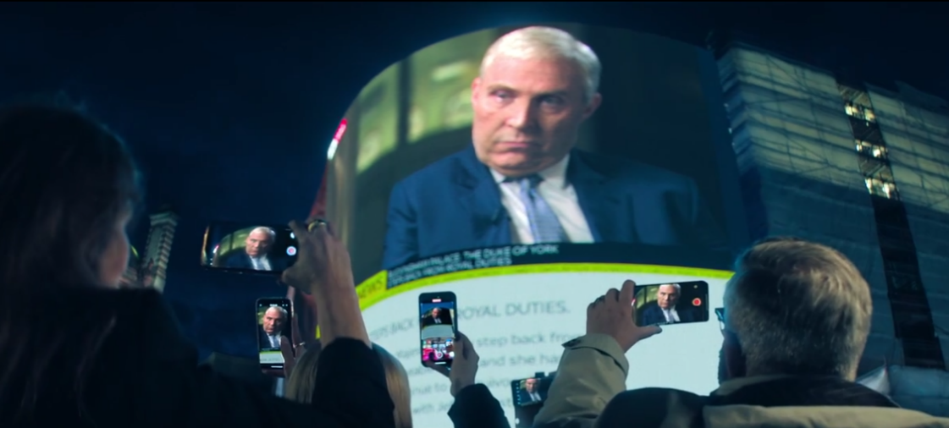
Here, journalism is again a unifying, tone-setting institution, while social media is merely a disseminator.
Otherwise, the systematic near-absence of social media across journalism-centered films is itself a meaningful finding at the second-order level. By excising social media from the diegetic world of journalism, these films naturalize the myth that institutional journalism and social media are mutually exclusive realms. This is the journalism-centered film's most consistent implicit ideological statement about social media, and it is made entirely through absence rather than critique.

4.2 Social-media-centered films

4.2.1 Distribution and Popularity
What immediately stands out among the social-media-centered films is that none of them were included in the corpus on the merit of box office success or awards prestige. With the exception of Dumb Money, every single social media focused film was produced by a minor studio and released directly to streaming, often on relatively minor platforms such as Peacock and Shudder. This suggests that the market for social-media-centered films is still considered too small, or the subject matter too niche, for large studios to invest in their production and distribution according to the traditional Hollywood model.
A related finding is that while the corpus extends back to 2015, all of the social-media-centered films were released well after 2020. Given that the wide adoption of social media is typically placed around 2012 or earlier, this means filmmakers have lagged considerably when it comes to the production of social-media-centered films, at least within the parameters of this corpus's selection criteria.
And yet, every social media focused film in the corpus was included on the basis of its weighted popularity score (WPS), suggesting that outside of the traditional Hollywood environment, there is considerable audience interest in social-media-centered films. This finding is further supported by the fact that many social-media-centered films had a higher WPS than some journalism-centered films that had a traditional cinematic release and were included on the basis of significant critical prestige. Several journalism-centered films from large studios featuring high-profile actors did not make the corpus because their WPS was significantly lower than those of even the most ostensibly low-profile social-media-centered films that did (The Independent (2022), Truth (2015). Social media films appear to exist and thrive almost exclusively outside of the traditional Hollywood distribution system, which resonates with the idea of social media as a platform through which outsiders can build significant reach beyond the hegemonic output governed by Herman and Chomsky's five-filter model.
However, the weighted popularity discrepancy score (PDS) of the social-media-centered films complicates this picture somewhat. All of the social-media-centered films in the corpus have a high PDS. With the exception of Players, the seven social-media-centered films and two convergence films make up the top nine films in the corpus by PDS, suggesting that social media films are significantly more popular among younger, cinematically adventurous viewers while being relatively unpopular among older, more mainstream demographics. The audience for social-media-centered films is significant, but also demographically specific and largely distinct from the audience for traditional journalism films.
The journalistic myth, as reproduced by prestige journalism films with low PDS scores, circulates broadly across age groups and viewing habits, reaching mainstream audiences through precisely the hegemonic channels the five-filter model governs. While social-media-centered films, by contrast, circulate among a younger, more digitally native audience through platforms operating on the margins of that hegemonic system. The two mythological worlds are thematically separate and distributed through different channels to somewhat different audiences. This infrastructural and demographical separation mirrors the thematic separation within the corpus itself, and suggests that the exclusion of social media from the journalism film is also replicated at the level of distribution and audience demographics.

4.2.2 Demographics
Table 4. Demographic comparison of journalists in journalism-centered films and journalist-adjacent influencers in social-media-centered films.
Demographic | Journalism-c (N=39) | Social-media-centered (N=10)
Female | 61.5% (24) | 50% (5)
Non-white | 7.7% (3) | 20% (2)
Young | 7.7% (3) | 100% (10)
LGBTQ | 2% (1) | 0% (0)

Gender
The social-media-centered films in the corpus are notably more diverse than the journalism-centered films across most demographic categories. When it comes to gender, the ratio among journalist-adjacent influencers is exactly balanced: five male and five female. Coupled with the complete absence of the Heroine archetype in these films, and the lack of any gender-based narrative themes or plot threads, it becomes clear that social-media-centered films are not, as journalism-centered films largely are, a cultural battleground for gender equality. There is also no meaningful difference in archetypes between male and female influencers: both are equally likely to be either a Reptile or a Repentant Sinner.
There are plausibly several reasons for this balance. First, as noted in the theory section, social media is accessible to anyone and therefore may offer a platform to those who have historically been excluded from institutional journalism. As such, neither the marginalization of women nor their predominance as a corrective move is ideologically present in these films. Second, since social-media-centered films often seem to function as a warning addressed to all social media users, as the findings will establish, equal gender representation serves this ideological function of the emerging myth more readily than a skewed one would. Third, since real-world social media use is itself ubiquitous across virtually all demographics, a balanced gender ratio simply reflects the world these films are depicting.

Age
More than half of the journalist-adjacent influencers in the corpus were portrayed as explicitly young. Only four hovered in a range that could be described as early-to-mid thirties, which edges toward the middle age category established in this thesis, but would count as young by most real-world standards. This skews somewhat younger than the actual profile of successful creators, who in industry studies cluster predominantly among mid-early Millennials rather than Gen Z (Adobe, 2022). However, the career status of the influencers in the corpus tracks with their age: all of the explicitly young influencers have a career coded as 'aspiring', while all of the older influencers, who actually make money from the platforms, have a career coded as either 'failing' or 'precarious'. In this sense, the corpus posits social media as a young person's game: the young aspire, while the older ones cling to a dying career.

Ethnicity
The social-media-centered films also skew white, though less markedly than the journalism-centered films. Approximately 20% of journalist-adjacent influencers in the corpus are non-white, compared to only 5% of the journalists in the journalism-centered films. The sample is small enough that firm conclusions are difficult to draw, but the relative increase in ethnic diversity is consistent with the broader argument that social-media-centered films reflect a more demographically open media environment than the institutional journalism world depicted in journalism-centered films.

Sexuality
There were no overtly LGBTQ characters among the social-media-centered films in the corpus. This is somewhat surprising given that gender and sexuality are popular topics across social media platforms, especially among young people (Bates et al., 2020; Cronesberry & Ward, 2024). On the other hand, as mentioned earlier, non-conforming gender identities and sexualities are rarely as passively visible as gender or ethnicity. The lack of queer narratives in social-media-focused films may be another example of their ideological function as universally applicable warnings rather than as vessels for personal stories.

4.2.3 Genre and the Punishment of the Influencer
The most popular genre among the social-media-centered films is horror. Within the brief period in which social-media-centered films have existed as a recognizable cycle, a firm association between social media and the horror genre has already been established. From the social-media-centered films researched for this thesis that did not meet the selection criteria, the majority were also horror films (Skillhouse (2024); Host (2020); Cam (2018)) or thrillers (Searching (2018); Missing (2023); Unfriended (2014)).
The horror and thriller themes are expressed with consistency. The journalist-adjacent influencer has transgressed, either before the film's events or during them, personal and societal norms in pursuit of social media engagement, and is subsequently punished through violence, typically at the hands of a serial killer, a monster, or one of their own victims. In almost every case, these films end in the death of the journalist-adjacent influencer; a death that the film's narrative logic presents as deserved. This pattern, in which the hunger for social media engagement is met with justified violent retribution, is a recognizable iteration of a well-established tendency in horror film to punish characters for societal transgressions (Clover, 1987; Dika, 1990).
If the slasher film of the 1980s and 1990s punished promiscuity as a transgression against community norms (Welsh, 2010), the contemporary social media horror film punishes the desire for viral engagement in the same manner. Both involve a young person transgressing communal values in pursuit of individual gratification, and both are met with violent retribution that is framed as deserved. This suggests that social media aspiration, especially when driven to extremes, has become a communally recognized sin in the cultural imagination, comparable to promiscuity in horror films of the past.
The films in the corpus suggest this sin takes two main forms, both of which overlap with the transgressions most commonly associated with the Reptile archetype in traditional journalism (McNair, 2010). The first is sensationalism, and the willingness to transgress social and even legal norms in order to generate it. In Spree, an aspiring influencer escalates from filming his work as an Uber driver to killing passengers on camera in order to garner followers. In Superhost (2021), travel vloggers deliberately leave negative reviews of Airbnb properties so that the resulting confrontations with owners can generate the drama needed to revive their failing channel. In Tragedy Girls (2017), two teenagers move from following serial killers to committing their own murders in order to find material for their podcast.
The second transgression is misinformation. Where sensationalism is the influencer's willingness to manufacture reality in order to generate content, misinformation is the willingness to manufacture truth for the same goal. Both are antithetical to the journalistic myth's core Object, which is the pursuit and delivery of truth. In several of the social-media-centered films in the corpus, the influencer is punished for what they claim. In Deadstream, the influencer's entire channel is built on the premise that he is genuinely confronting real dangers, and his punishment is measured to the fraudulence of this claim: the haunted house turns out to be real, and the danger he performed for his audience becomes the danger that kills him. In Spree, the protagonist's murders are initially dismissed by his audience as staged content, their natural assumption being that an influencer would fake reality for engagement rather than enact it. The films suggest that both sensationalism and misinformation are so inherently embedded in social media content creation that even genuine transgression is read by the diegetic audience as just a manufactured performance.
At the second-order level, the influencer's death is a mythological statement about the consequences of transgressing the boundaries of legitimate public voice. The horror film performs displacement in its most extreme form: the Shadow (the illegitimate media figure, the person who speaks without institutional sanction) is physically destroyed. This is the journalistic myth asserting its own borders through the most explicit narrative mechanism available. The celebration of violence against influencers may already be a genre convention of contemporary horror film, and its emergence is as such evidence of how deeply the opposition between legitimate institutional journalism and illegitimate social media content creation has been naturalized as a mythological contrast. Jenkins's predicted migration of journalistic ideals to a new, non-institutional figure has, in these films, been met with the most violent possible refusal.
When it comes to the social media focused drama films in the corpus, the pattern is broadly similar, but the outcome is somewhat more introspective and realistic. Here, the journalism-adjacent influencer transgresses personal and societal norms in pursuit of social media engagement, but ultimately faces their transgressions through emotional punishment, whether through self-judgment or the judgment of the public, rather than through violence. In Mainstream, for example, a young woman's relationship with a charismatic social media personality leads her to compromise her own values in pursuit of engagement, before the public destruction of her collaborator forces her to confront the sinful costs of the path she chose.

4.2.4 Archetypes
Table 5. Archetype distribution among journalist-adjacent influencers in social-media- centered films.
Archetype | N
Reptile | 6
Repentant Sinner | 3
Watchdog | 1

It is no surprise, then, that the most common archetype among journalism-adjacent influencers in the corpus is the Reptile, followed by the Repentant Sinner. Out of the nine journalist-adjacent influencers in the corpus, six are Reptiles, and three are Repentant Sinners. When it comes to popular films, journalism-adjacent influencers are overwhelmingly portrayed as villains, and occasionally as contrite ones.
The prevalence of the Reptile archetype in social-media-centered films is the other side of its omission in journalism-centered films. As argued in the journalism-centered films section, the Reptile has migrated from the traditional journalist onto the influencer figure, allowing journalism-centered films to maintain the heroic Persona without internal contradiction.
The one significant exception is Dumb Money, in which the journalist-adjacent influencer occupies the Watchdog archetype rather than the Reptile. This film will be discussed in detail in the convergence chapter, where its status as the sole example of a social media influencer embodying the heroic journalistic myth will be analyzed as a study in narrative containment as well as mythological reconstitution.

4.2.5 Professional Roles
Three of the journalist-adjacent influencers fulfilled a professional role that could be described as a travel journalist or travel vlogger. Two were adjacent to traditional crime reporters, while one functioned as a financial reporter. The remainder were effectively gonzo reporters: actively seeking out and engaging in sensational events in the mode of Hunter S. Thompson, inserting themselves into dangerous or transgressive situations in pursuit of content. The archetypes and age groups were distributed fairly evenly across these journalistic analogues, with no meaningful pattern emerging between professional role and archetype. What is notable, however, is that the gonzo mode of journalism, historically the most ethically contested figure in the journalistic tradition, now finds its most culturally visible iteration in the social media influencer, whose transgression of societal norms in pursuit of engagement is identical to the gonzo reporter's transgression in pursuit of the story. The difference, in the terms of the journalistic myth, is that the gonzo reporter transgresses in the service of truth, while the influencer transgresses selfishly in the service of engagement.

4.2.6 The Diegetic Audience as Actant
In the social-media-centered films, the audience has a far more prominent presence than in journalism-centered films, both implicitly and narratively. What is particularly interesting is that, despite influencers being portrayed negatively, so too is their diegetic audience, which often fills the Opponent actant, sometimes at the first-order level and almost always at the second-order level.
The second-order actantial model for social-media-centered films tends to follow this structure: the Subject is the influencer, the Object is social media engagement, and the Receiver is the influencer themselves. The Helper is sometimes the social media platform, though more often the disavowal of social media itself serves this function. While the first-order Opponent is often a diegetic representation of societal retribution (a monster, a ghost, or a serial killer), the second-order Opponent is implicitly the social media audience, whose appetite for transgressive content is what drives the influencer to cross the lines they ultimately pay for.
This actantial positioning of the diegetic audience as Opponent implicates the audience that enables and demands the influencer's transgression and, by extension, implicates the non-diegetic audience likely to use social media themselves. Some journalism-centered films, such as Nightcrawler (2014) and Natural Born Killers (1994), hint at a similar dynamic by suggesting audience complicity in encouraging sensationalist reporting. This pattern is considerably more prominent and central in social-media-centered films, however, where the diegetic audience is an active participant in the transgression that the emerging social media myth must punish.
What makes this dynamic particularly interesting is that the diegetic audience in social-media-centered films is often itself divided. In Spree, while some audience members encourage the influencer's transgressions, others criticize him for cheap clickbait or accuse him of faking the murders. A similar dynamic appears in Deadstream, where some audience members encourage the streamer to take increasing risks while others accuse him of faking his content. The diegetic audience thus expresses both sides of the journalistic myth's Shadow: it simultaneously demands transgression and condemns it, pushing the influencer toward the very line it then punishes them for crossing. In this sense, the social media platform is depicted as a site of irresolvable tension, where the influencer is forced to transgress communal norms in order to satisfy an audience that will criticize them for doing so regardless. The platform holds the power; the creator and the audience do not. Social media, in these films, is less a tool than a trap.
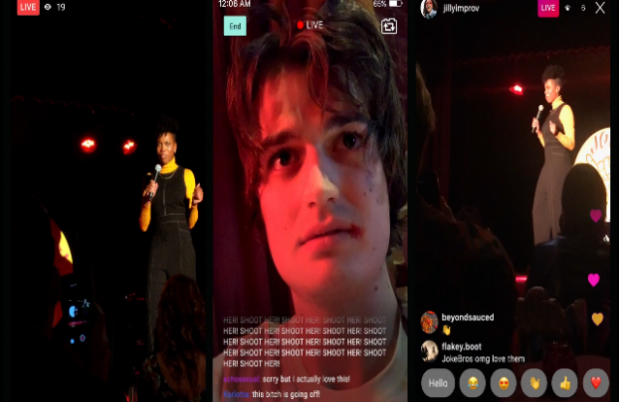

4.2.7 Social Media as Institution: Hegemony Without a Myth
This idea of social media as an adversarial power over both the depicted influencer and the audience becomes especially significant when considered against the finding, established in the theoretical framework, that social media platforms have themselves become tools of hegemony on a scale and reach that would make Charles Kane giggle nervously. If the influencer at the first-order level denotes the concept of social media as an institution at the second-order level, as the actantial patterns described above suggest, then the near-universal negative portrayal of the influencer-as-Reptile implies that social media as an institution is viewed almost universally negatively in popular film, even though its hegemonic function is in structural terms not unlike that of the institutional press described by Herman and Chomsky. This is a striking finding, and one that requires some explanation. This thesis proposes three possible reasons for it.
The first concerns the relative novelty of social media and the absence of any established mythological framework through which to naturalize it. If read at the second-order level, then social media platforms, like the influencer protagonists on the first-order level, are still ‘aspiring’. This tracks with the findings in the theory, wherein social media is positioned as a new challenger fighting for dominance in the interregnum. It has not yet taken root as a mythologized institution. The myth of the objective, independent journalist, however, arose more than a century ago, and has been deeply embedded in the fabric of western culture through decades of repetition, codification, and the kind of sustained second-order signification described by Barthes. While this myth is routinely questioned, and most people possess some awareness of the press as a hegemonic tool, its mythological naturalization proves sufficient to sustain it alongside any critique. Social media, by contrast, has had no such process of mythification. Early public discourse around social media did briefly celebrate its democratic potential, as noted in the theoretical framework, yet this was followed so rapidly by its consolidation into the hands of a handful of corporations, and by a sustained news cycle around manipulation, addiction, algorithmic radicalization, and election interference, that any potentially positive myth was unable to take root before the negative one had already calcified. Social media arrived in the cultural imagination already compromised, and the films in the corpus reflect this.
The second reason concerns the visibility of social media's hegemonic ownership. As Gramsci argues, hegemony is most effective when it is least visible; when the dominant ideology appears as common sense rather than as the agenda of identifiable individuals (1971). Institutional journalism, whatever its hegemonic function, benefits from the myth of the fourth estate: the ideological machinery is hidden behind the Persona of the public-serving watchdog. Social media platforms, by contrast, are visibly controlled by a small number of named, extremely wealthy individuals whose motivations are widely and reasonably assumed to be the accumulation of money and power rather than the public good. This visibility undermines the conditions under which hegemony is most comfortably accepted.
This may also explain one of the most structurally distinctive features of the second-order actantial model of social-media-centered films: the collapse of the Subject and Receiver into the same entity. In the journalism myth, the journalist (Subject) pursues truth (Object) for the benefit of the public (Receiver), and the institution of journalism serves the hegemonic order while appearing to serve the people. In social-media-centered films, the influencer (Subject) pursues engagement (Object) for the benefit of themselves (Receiver). Social media, in other words, does not even perform the ideological function of appearing to serve the public. Where journalism serves hegemony while appearing to serve the people, social media, as these films depict it, serves only itself.
A third reason might be found in social media's threat to the existing hegemony. As outlined in the framework, social media is Hall’s alternative information channel come to challenge the old and the known, as well as being a key site of the mostly unbridled and unchecked struggle for ideological dominance taking place outside of legacy media systems. As noted before, the journalist-adjacent influencer is usually depicted as either a Repentant Sinner or a Reptile, but in both cases as an illegitimate voice. The threat of social media as an illegitimate voice with real weight in the struggle for dominance, posits it readily as a threat.

4.2.8 Mythological Signs of the Social Media Influencer
It may be too early, and social-media-centered films may yet be too few, to meaningfully catalogue all of the mythological signs that denote the journalism-adjacent social media influencer. However, several recurring signs have stood out across the corpus.
The first is the consistent portrayal of the environment in which journalism-adjacent influencers operate as empty, isolated, and lonely, often expressed through wide shots. In Dumb Money, the journalist-adjacent influencer creates his videos in a large, markedly empty basement; In Spree, the influencer filming in his car is repeatedly shown against a barren road, while the influencer in Deadstream spends the entire film alone in a haunted house, with overhead shots regularly establishing his solitude. in Influencer, the titular influencer is shown small and isolated when filming herself against a vast, empty space. Take these two shots, for example, where her active social media feed is contrasted with her monumental loneliness:

A second recurring sign is the awkward portrayal of the filming process itself. In journalism-centered films, the production of content is typically effortless: journalists do their work without technical hiccups, typewriters never jam, cameras roll without fail, and television presenters speak to the lens with professional ease. In most social-media-centered films, by contrast, cameras and microphones are constantly being set up and fumbled with: the technical process is laid bare. Recordings fail, memory cards fill up, and lens caps are left on. Subjects are redirected, interrupted, and ham-fistedly instructed by the influencer. On-camera performances are portrayed as awkward, multiple failed takes are shown, and the act of speaking directly to a camera is made ridiculous by the influencer's isolation and visible self-consciousness, often contrasted with an over-the-top, manufactured on-screen persona.

At the second-order level, the mis-en-scène choices constitute a mythological sign system that naturalizes the opposition between institutional journalism and social media content creation. The empty environment connotes alienation and illegitimacy, while the fumbling production connotes amateurism and pretension. Together, they produce a second-order sign that positions social media content creation as something of a caricature of journalism: it is isolated where journalism is communal, effortful where journalism is effortless, and ridiculous where journalism is serious. While social media as a subject for films is new, this semiotic pattern of mise-en-scene, framing, and character action already seems to constitute an emerging set of mythological signs. In Bordwell's terms, these signs are already sufficiently naturalized to function as reliable schema triggers for contemporary audiences: the empty room and the fumbling activate schemata of illegitimacy and amateurism in the same way that the cluttered newsroom and the ringing telephone activate schemata of urgency, dedication and professionalism in journalism-centered films.

4.2.9 Social Media On-Screen
Further mythological signs may be found in the on-screen portrayal of social media platforms themselves. As may be expected, every social-media-centered film features on-screen social media use, with most showing it both diegetically and non-diegetically. As in some journalism-centered films, social media is occasionally used as a vox populi, showing the opinion of the diegetic audience on the influencer or the events unfolding. In social-media-centered films, however, this function is more direct and more active, especially in films where the influencer is shown streaming live: the diegetic audience here is not merely a background chorus but an entity the influencer must actively manage, respond to, and satisfy, often in a quite hostile manner.
The platforms themselves are also coded as mythological signs, with a visual and auditory grammar that appears consistent enough across the corpus to already constitute a recognizable set of second-order connotations. When the protagonist has a positive relationship with social media, likes, follows, and messages of support ping pleasantly into the scene, often cross-cut with the protagonist smiling or set over an upbeat soundtrack. The notifications arrive in a manageable trickle, accompanied by thumbs up and heart emojis, and the overall tone is one of warmth and validation. When social media fills the Opponent actant, however, the same elements are transformed: updates arrive relentlessly; the pings become incessant and jarring; and angry emoticons and hostile messages flood the screen, often shown as an avalanche of content that overwhelms the protagonist's device and sometimes the entire frame, cross-cut with the protagonist's panicked face and accompanied by a hectic, stress-inducing soundtrack. Some films present such signs in particularly creative ways. In Mainstream, for example, when the influencers start seeing viral success, emojis explode from their laptop against an upbeat soundtrack. When one of the influencers becomes overwhelmed by the fallout of their virality, however, she throws these same emojis up into the sink:
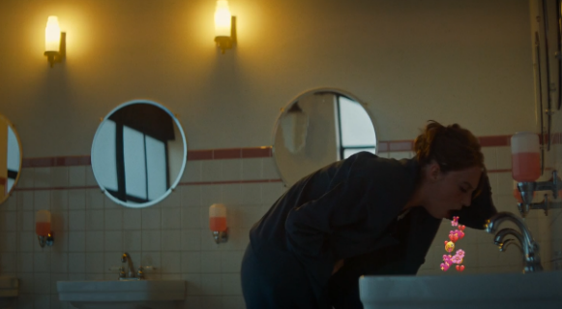
At the second-order level these cues constitute a mythological sign system in which the social media platform is coded as a fundamentally unstable and ungovernable force. Whether it rewards or punishes, it does so on its own terms. The platform is depicted as neither a tool in the hands of its users nor a neutral mediator between creator and audience. Rather, it is an entity with its own logic and its own power. Follower counts, like tallies, and comment feeds, whether positive or negative, connote the vulnerability of both the influencer and the audience to a system they cannot control and whose expression they cannot contain. The platform has the power while the individual, whether creator or consumer, does not. In Bordwell's terms, these visual and sonic cues have already consolidated into reliable schema triggers: the pleasant ping activates schemata of success and validation, while the hostile avalanche of messages activates schemata of threat and loss of control. The speed at which these cues have been naturalized, across a genre that has existed for less than a decade, is itself evidence of how deeply the social media grammar has been absorbed into the cognitive schemata of contemporary audiences.

4.3 Convergence Films
The most striking finding concerning the convergence films is that there are only two of them. For the purposes of this thesis, a convergence film is defined as one in which both journalism and social media are themes of equal narrative importance; or in which a traditional journalist transitions from an institutional platform to social media, or vice versa; or in which social media is used consistently throughout the film and is instrumental to both the narrative and the journalistic work of the protagonist. The sample is too small to discern meaningful patterns of any sort, but it is instructive nonetheless to briefly outline the premise and convergence elements of each film. The near-total absence of convergence films is itself a significant finding of this thesis: it confirms that the separation between the journalism myth and the emerging social media anti-myth is maintained across the corpus.
The more ideologically and thematically straightforward of the two convergence films is Profile (2018). This film follows a Watchdog-Heroine archetype who uses social media (Facebook and webcam conversations) to present herself as a Muslim convert and go undercover in the social media pipeline ISIS uses to recruit young British women to Syria. Profile is also the only example in the corpus of a screen-life film: a film that takes place entirely on the protagonist's computer screen, with the viewer watching her open social media pages, drag files, make video calls, and search online as though the film screen were the computer screen itself. More prominent examples of the screen-life format include Searching (2018) and Missing (2022), which did not make it into the corpus as the roles their characters fulfilled were not sufficiently journalist-adjacent.
Screen-life films are interesting because they operate on the assumption that the viewer possesses enough knowledge of computers and social media to infer all the cues necessary to piece together the film’s events. By extension, they demonstrate that computers and social media platforms can supply enough narrative cues on their own to carry an entire film, which is itself evidence of how fully the visual grammar of social media has been absorbed into the cognitive schemas Bordwell describes.
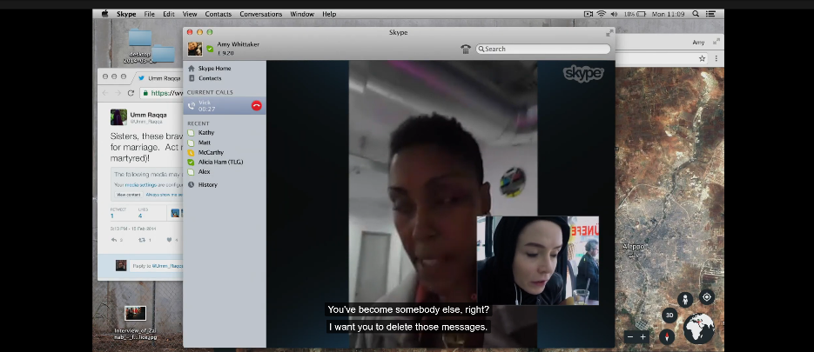
In terms of its ideological statement about social media, Profile is relatively neutral. The journalist adopts social media primarily as a tool to aid traditional journalism: she uses it to find, contact, and develop a relationship with an ISIS recruiter, and publishes her findings in a traditional newspaper. The film shows social media as a space that can be exploited for nefarious recruitment, and also as one that a skilled journalist can use for more righteous ends. While a narrative thread involves the journalist becoming dangerously close to her subject through social media messaging and webcam sessions, this dynamic could plausibly have unfolded over the phone or in person. The film does not commit to any strong ideological statement about social media beyond displaying it as a tool, and its convergence is therefore somewhat superficial, touching mostly on the pragmatic convergence of journalism and social media.
The other, more layered and ideologically interesting convergence film is Not Okay (2022), which will be discussed in closer detail in the close-analysis chapter.

CHAPTER 5: Close Analysis

5.1 The Post
Steven Spielberg's The Post is arguably the torchbearer of our times when it comes to naturalizing the journalism myth on screen. The reason is straightforward: The Post functions simultaneously as Spielberg's love letter to the journalistic institution and as a prequel and homage to Alan Pakula's All the President's Men (1976), the film widely considered to have shaped both the modern conventions of the prestige journalism drama and the ideal conception of the Watchdog journalist (Ehrlich and Saltzman, 2015; McNair, 2010). Where Pakula's film centered the myth on its traditional white male carrier, Spielberg's performs reconstitution: Kay Graham, the film's Heroine-Watchdog, becomes the new bearer of the journalistic ideal, and her transformation is the engine through which the myth is renewed.
Every facet of The Post is steeped in its mythological inheritance. The plot follows the same paper during (The Washington Post) the events that led up to those depicted in All the President's Men, and Spielberg's technical and narrative choices are in constant dialogue with Pakula's film. Dark and light are used to build tension: figures withdraw into shadows to contemplate high-stakes decisions, and there is a constant sense that anonymous forces may be operating just out of frame. Tracking shots build momentum, following characters as they pace about, march briskly through the newsroom, or run to deliver crucial information in time. These are time-tested thriller techniques, deployed by both Pakula and Spielberg to bring a sense of risk and urgency to the journalistic film. Beyond these dramatic choices, the filmmaking in both films is relatively sober, letting dialogue and performance carry most of the weight rather than foregrounding spectacle. Journalism, the films imply, is serious business.
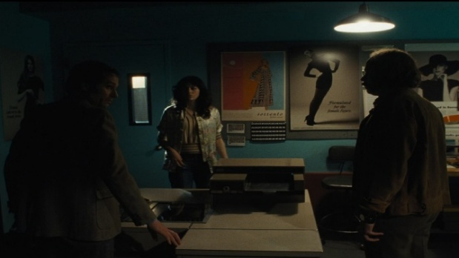

As in All the President's Men, the heroic journalists in The Post are portrayed as perpetually in motion in service of the truth: the newsroom buzzes, phones ring, clerks run about. Whenever a journalist is forced to be stationary, every available surface is cluttered with binders, papers, and documents, even restaurant dinner tables and living room floors. At the second order, these signs naturalize the journalistic institution as the tireless, truth-seeking Subject of the myth, encoding the idea that institutional journalism is always on the mission.
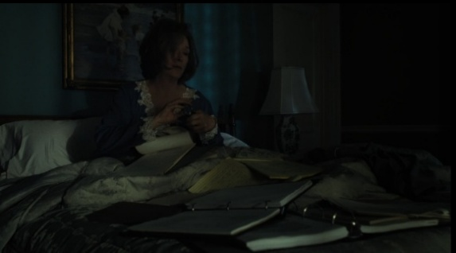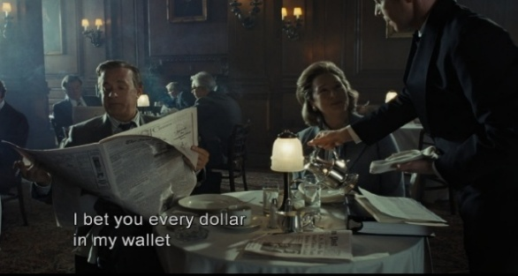

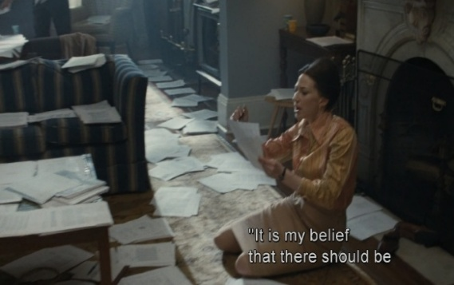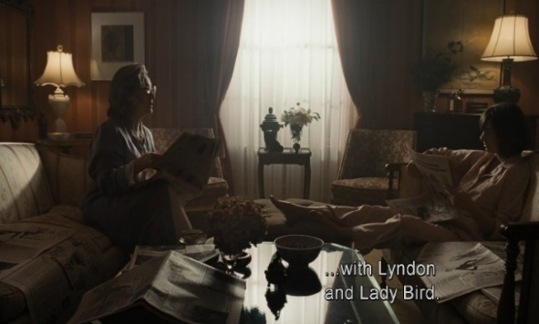

Another stylistic element shared by both films is the overhead shot, used to convey the diminutive stature of the individual journalist against the massive institutions they must navigate or fight, lending a David versus Goliath quality to the journalism myth. Compare, for example, Pakula's overhead shot of the Library of Congress with Spielberg's shot of the stock exchange:
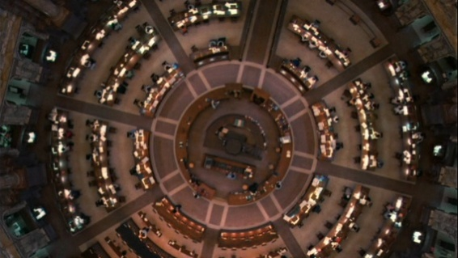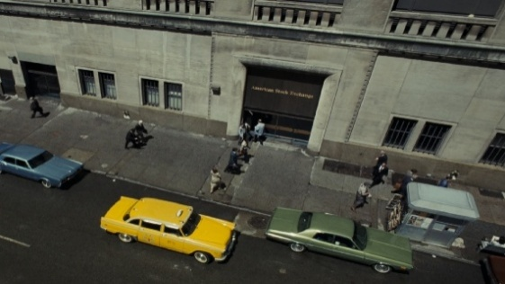

The Post differs from its progenitor in two ways that are central to the journalism myth's modern tactics of survival, and both of these differences center on Kay Graham. Her inclusion introduces a female presence and a dual Watchdog-Heroine archetype to a narrative from which, despite Kay Graham's historical role during Watergate, both were absent in All the President's Men. Kay is, in the terms of the findings, a Heroine-Watchdog: a figure whose personal arc against patriarchal authority and professional arc against hegemonic power run parallel and culminate simultaneously, with the feminist narrative strand recruited directly into the myth's service. Her transformation from insecure custodian of the Washington Post to decisive publisher is the vehicle through which Spielberg performs reconstitution: the compromised white male carrier is shed, and the myth re-emerges through a figure the crisis has not yet reached, with its ideological content intact.
Mapping the film onto Greimas's actantial model clarifies how this transformation is structured. The Subject is Kay Graham, heiress and publisher of the Washington Post. The Object is the decision to publish the Pentagon Papers, a decision that belongs exclusively to her. Ben Bradlee functions as Helper: he drives the journalistic pursuit, but requires Kay's authorization to complete it. The Opponent is the Nixon administration, which attempts to suppress the story through institutional pressure. The Receiver is the American public and, the film suggests, democracy itself. The Sender is, at first glance, the leaker, but given the narrative weight placed on Kay's choice, it resolves into the journalistic mission itself: the obligation of the press to hold power accountable. Crucially, this Sender operates on Kay alone. She is the only character the narrative requires to be transformed, and the only one who must overcome self-doubt, deference, and a lifetime of subordination to male institutional authority. Bradlee faces no such arc. It is therefore Kay around whom the myth is actively constructed, and through whose transformation it is reinforced. At the second order, the journalistic institution itself occupies the Subject actant, with truth as its Object and the real-world audience as its Receiver; hegemonic power, embodied by the Nixon administration, fills the Opponent. What the second-order model reveals is that Kay's personal arc and the institution's mythological function are encoded as the same trajectory: her defeat of the patriarchal forces in her personal life and her authorization of the press to defy the state culminate into a single dramatic act, making her individual transformation the vehicle through which the journalism myth reconstitutes its claim to speak truth to power on behalf of the public.

Spielberg reflects this arc in elegant stylistic terms. In an early scene, Kay walks nervously down a hallway, throwing a quick glance at portraits of her forebears before looking away, as if ashamed to claim her connection to them. When she walks through the door, the camera sits low, at Kay's eye-level, as a room full of darkly dressed businessmen towers over her. This pattern, Kay moving through doors into oppressive, masculine environments of dark colors, recurs throughout the film. And in each of these environments, her agency impeded upon. In the boardroom she is spoken over and ignored. At the stock exchange she is made to take the Washington Post public, ceding some control to shareholders in a shadowy room that reads as a visual of both hegemonic and masculine suffocation. This color coding operates as a recurring mythological sign: the dark, gloomy settings of the masculine institutional world are set against the color and light of Kay's domestic spaces. She straddles two worlds, and her movement between them tracks the arc of her reconstitution as myth-carrier.
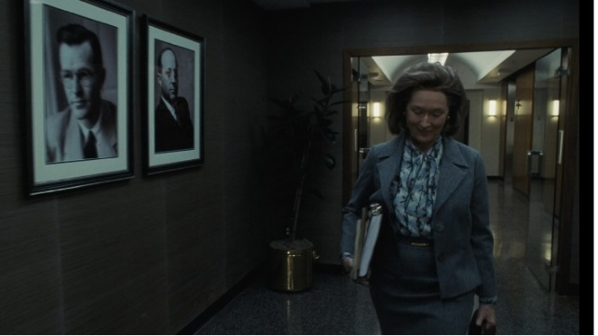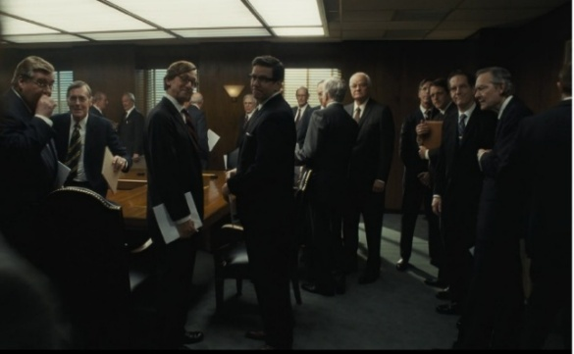
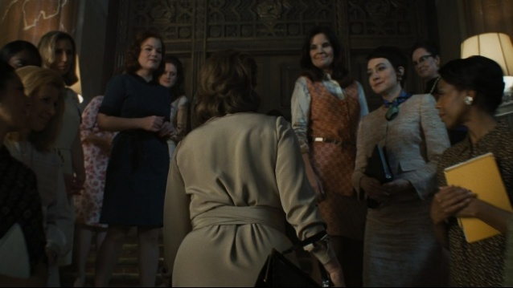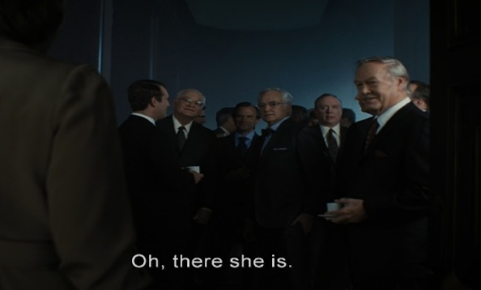

Every decision Kay makes of her own agency happens in a liminal or domestic space. She gives Bradlee the go-ahead to pursue the story in her own foyer, and she confronts McNamara in the sunroom, framed against garden doors. Her arc culminates in the dining room, the heart of her domestic world, where, dressed in her nightgown, she overrules the board and decides to publish the McNamara papers. By this point, she has pulled the men into her world, inverting the spatial logic that structured her earlier subordinance. The Heroine-Watchdog's double underdog structure is encoded in these spatial signs: every gain in personal agency maps directly onto a gain in institutional authority, and the domestic sphere, coded as feminine throughout, becomes the site where both the patriarchal and hegemonic Opponents are finally overcome.
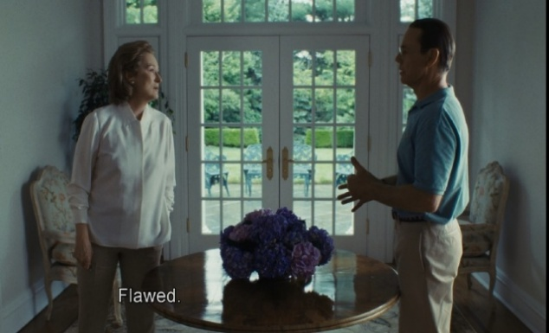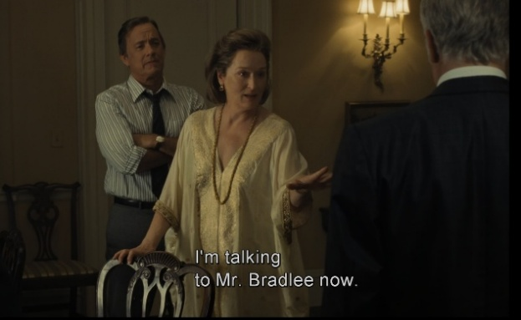
A brief exchange of dialogue between Kay and a young female government clerk foreshadows quite neatly the culmination of Kay’s feminist and journalist archs. Offering support before Kay’s court hearing, the clerk says (talking about the Vietnam War):
‘My brother. He’s still over there, and … Well, I hope you win.’ Then, smiling, she adds, ‘Besides, I like to see someone telling these guys what’s what.’
The Hegemonic Shadow
However, in contrast to All the President’s Men, Kay also represents Spielberg’s acknowledgment of what the journalistic myth attempts to hide: namely, that the press is deeply embedded in the same hegemonic structures it purports to expose.
Kay is a media heiress, part of the old and established elite. She is close friends with McNamara, the man whose papers the Washington Post wishes to leak. And, importantly, her newspaper has just gone public, putting interest in her company in the pockets of those most invested in maintaining hegemony.
In fact, that Kay is herself a member of the elite only strengthens the second-order operation of the myth. The apparent betrayal of her own class and the risking of her newspaper, encodes the Watchdog's sacrifice in especially strong terms. The myth requires the journalist to choose the public over self. This is inoculation working in tandem with reconstitution: the myth admits the journalist's hegemonic ties, then makes the severing of those ties the central dramatic event, naturalizing the claim that such actions are possible and, through the Heroine-Watchdog figure, that it is now available to someone the old white male carrier could not have represented.
The film’s climactic shot confirms the reconstitution. Kay descends the courthouse steps, newly recognized as a press leader, surrounded by admiring young women. The image encodes the Heroine-Watchdog's double underdog victory succinctly: her personal claim to institutional authority in man’s world and the press's collective claim to public trust are compressed into the same visual sign.
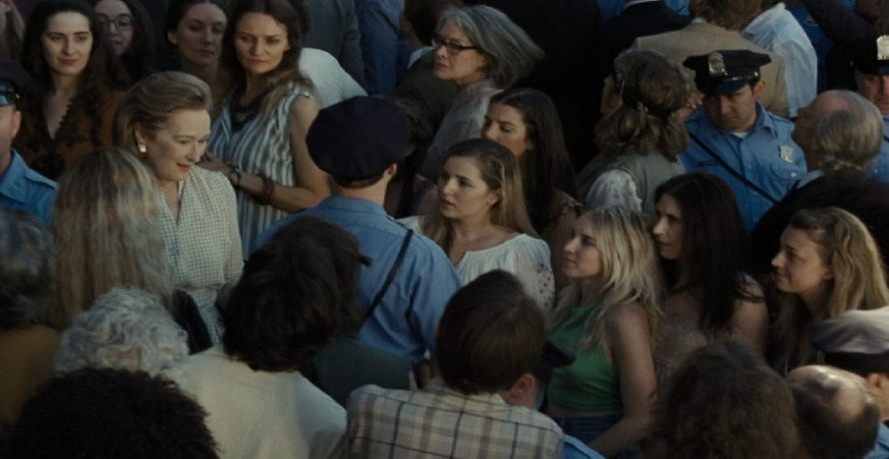
Whether Spielberg is conscious of the Heroine’s ideological function or not is beside the point; as Barthes insists, myth operates regardless of intent. The effect is that The Post is, like All the President's Men before it, offers a powerful and traditional depiction of the Watchdog, but reconstituted in a new carrier.

Re-naturalization and Modern Discourse
The Post is a formidable example of re-naturalization, and it performs this work on several levels at once. By presenting a direct prequel to All the President's Men, the film plugs into a mythological expression that is already established. every viewer familiar with Pakula's film, which is to say the audience The Post is implicitly addressing, watches Spielberg's film knowing that the institution it is defending is about to produce the most celebrated piece of journalism in American memory. The film, therefore, does not have to argue that the Washington Post deserves the audience's faith, but inherits that faith from a film it assumes has already been absorbed into the cultural imagination. The myth is reasserted here through intertextual elements rather than fresh arguments, and this is re-naturalization in a remarkably potent form.
The period setting reinforces this effect. The Pentagon Papers story occupies a somewhat mythological sweet spot: a threatened but uncompromised press that is heroic but not yet self-congratulatory, operating in the last moment before the myth became aware of itself as myth (Ehrlich and Saltzman, 2015). Post-Watergate journalism has had to grapple with its own mythologization, while pre-Watergate journalism is still ignorant of it. This is an ideal temporal position from which to renew the myth.
The 2017 release date gives this retreat much of its modern applicability. The Post is not about Trump, but it is nonetheless unthinkable without him. The film arrived in the thick of the fake-news era, when institutional journalism was being attacked most vehemently, and when the Persona of the fourth estate was being stripped through declining trust and hostile competing information channels. These modern attacks on the press are condemned implicitly towards the film’s resolution, when a reporter reads aloud the Supreme Court’s motivation for vindicating The Post:

‘The founding fathers gave the press the protection it needs to fulfill its essential role in our democracy. The press was to serve the governed, not the governors.’

Set against the climate during which the film was made, this heroically presented scene begs to be read as a contemporary statement. In the same register, the film's closing scene, the break-in at the Watergate complex, seems to be a similar promise to the 2017 viewer that the institutional press will again prevail over a corrupt presidency. This particular scene offers the emotional reassurance that history bends toward journalistic vindication, at precisely the moment when that argument was being lost in the real world. In Barthes's terms, the myth is reasserted in direct response to the challenge by retreating to a terrain where the myth's victory is already historically guaranteed.

This is where Henry Jenkins's prediction about period journalism films finds its most convincing expression. Jenkins argued that such films might function in the manner of the Western, using the conventions of an earlier era of film to digest contemporary anxieties through familiar frameworks. Spaghetti Westerns did this with Vietnam (Jenkins, 2020), while The Post does it with fake news and the Trump administration. A 2017 film about present-day journalists confronting Trump would have had to grapple with declining trust, collapsed business models, platform capture, and the fragmentation of the public consensus. The Post, however, is allowed to skip all of it by routing contemporary anxiety through a setting in which that anxiety has already been resolved in the myth's favor; the film can deliver a form of reassurance that no contemporary-set film could believably deliver in the same way. In the period film, the modern contestation is imported and resolved on familiar grounds.

Seen this way, re-naturalization and exclusion operate as a pair rather than as alternatives. Exclusion keeps social media and the contemporary crisis out of the frame while re-naturalization fills the cleared space with the myth in its uncontested historical form. The Post demonstrates the two mechanisms working in tandem, and it is precisely this coordination that makes the film such an effective vehicle of mythological renaturalization at a moment when the myth was most visibly under pressure.

Analog Nostalgia

The scenes that Spielberg seemed to have had the most fun with creatively are those that show the mechanical workings of the newspaper press. While the film is a period piece and therefore void of any post-millennial technology, the intimate and concrete way in which the printing process is portrayed in the film seems especially deliberate in our modern, digital context.

It happens at the end of the film, after the resolution has settled and the press has emerged victorious. A pleasant theme plays as type is set in an intimate close-up; machines whirl gently, keyboards clack, and papers flap from the belt; the soundscape has an ASMR quality to it, as details are lovingly inspected by caring workers. It is a small, but poignant celebration of the traditional printing process, pictured here as an artisanal craft, close-up and personal.

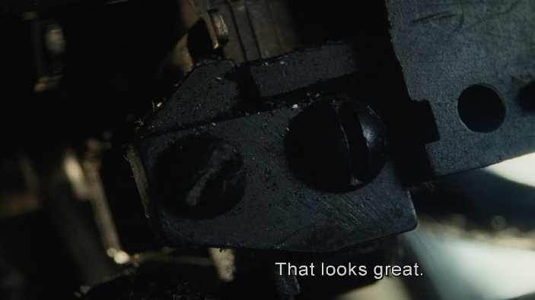

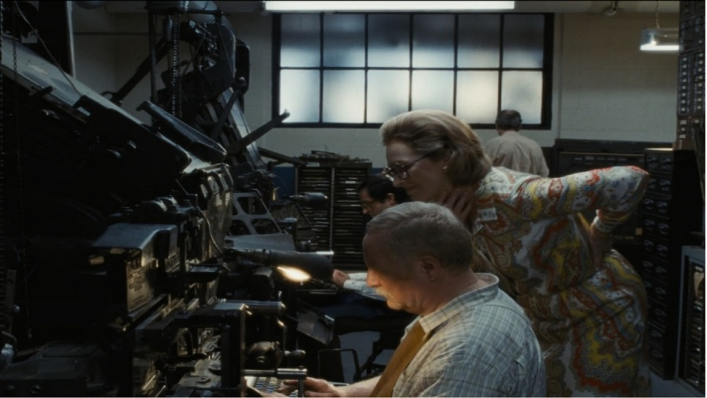

The scene culminates in another overhead shot. The gentle, hopeful theme suggests that this time we are not looking at an individual dwarfed by a hostile institution, but rather two journalists cradled by a massive, benevolent, and sanctifying press:



The journalistic myth seems to come full circle in this shot. While the myth is reinforced by stories of exceptional individuals, Spielberg zooms out here to foreground the press as an institution to which such exceptional individuals are both insignificant and crucial. It is another way in which Spielberg both acknowledges the porousness of the journalistic myth while also reinforcing it. Ultimately, however, like its inspiration All the President’s Men, The Post is a decisive enforcer of the journalistic myth, and a text-book example of the ideological function of the Heroine-Watchdog dual archetype.

5.2 Not Okay
Not Okay is one of only two films in the corpus that portrays a significant convergence between the worlds of traditional journalism and social media. It is also the most scathing critique of both. In the world of Not Okay, traditional journalism is wholly compromised by and subordinate to the demands of social media; what is shown is a corrupted mimic of traditional journalism draped over the relentless content churn of social media platforms. If The Post showed us the ideal myth-carrying Heroine, the protagonist of Not Okay is a clear example of the social-media-compromised Repentant Sinner.
Opening Cues and The Repentant Sinner Archetype
The film primes the viewer to judge Danni from its first frame. A title card warns of an unlikeable female protagonist; the protagonist herself, Danni Sanders, then narrates: "Have you ever wanted to be noticed so badly, you didn't even care what it was for?" The opening montage cuts from her isolated, cluttered apartment to a torrent of hostile tweets ("@TheDanniSanders choke on your own vomit"), the pings ramping up until they merge into a buzzing, before cutting to an image of a bomb detonating. Danni, now addressing the viewer directly: "Well let me tell you: be careful what you fucking wish for." The Repentant Sinner narrative as identified in the findings is fully encoded before any plot has begun: someone who wanted social media engagement above all else, got it through means that crossed societal boundaries, and is now punished by the same environment she courted. The direct address implicates the viewer; this is a warning-against-social-media film in the register the findings section identified.
Narrative: Actantial Inversion at Two Orders
The framework's two-order actantial model is where the film's inversion is clearest. Structurally, Not Okay is indeed akin to such influencer-punishing social media films. At the first-order actantial level, the Subject is Danni, a photo editor at a magazine who desires nothing more than social media fame: her Object. The Sender is this desire for fame as well as her own isolation (again, social-media-centered films tend to posit these figures as lonely outsiders). The Helper is Rowan (a figure we will come to later), and her Opponent is the social media audience she needs to win over before they catch on to her lies. What makes Not Okay such a uniquely interesting film, however, is how Danni abuses her journalism career, and especially the Witness archetype, to further her goals of social media fame, inverting the journalism myth in the process.
Danni works as a photo editor at a fictional magazine called Depravity, a name that already functions as a mythological sign connoting the moral bankruptcy of the media environment she inhabits. She wants to be a writer, and she wants to be seen. Her scheme begins when she uses Photoshop to fabricate a trip to Paris to impress her few social media followers. When a terrorist attack happens in Paris during her supposed visit, she seizes the opportunity to present herself as a survivor: a Witness in the most literal and mythologically loaded sense. The method of fabrication is crucial because Danni constructs her lie using the tools and credibility of her journalism career. She uses Photoshop to place herself in Paris. She uses her position at the magazine to write a first-person account of the attack. She leverages her professional affiliation to gain access to support groups and public platforms. The institutional credibility of journalism becomes the foundation on which her lie is built. This is especially ironic, as the Witness is the journalistic archetype most aligned with the myth of objective truth (McNair, 2010).
This inversion is especially visible at the second-order actantial level. Read against the actantial model of traditional journalism films, the second-order Subject here is the social media influencer as an emerging cultural figure: someone who claims the journalist's authority to address the public and shape discourse, without the institutional structures, professional norms, or accountability the journalism myth holds up for us as guarantees of credibility. The second-order Object is the attention normally given to the journalist on the merit of their credibility, which here is fabricated. The second-order Sender is the social media ecosystem's reward structure, which grants visibility to engagement regardless of whether that engagement is grounded in truth. The second-order Receiver is the real-world social media audience, shown as both complicit (they elevate figures like Danni willingly) and vengeful (they destroy such figures with equal enthusiasm once the fabrication is revealed). The second-order Opponent is truth and accountability, concepts that the traditional journalism myth claims as its own, and which are here grossly perverted.
Convergence: Journalism Hollowed Out
At the level of convergence, the film stages a disastrous relationship between journalism and social media, which the theoretical framework predicts will proliferate if algorithms are to set the journalist’s agenda. In Danni's world, journalism is already subservient to social media. The magazine exists, the professional title exists, the institutional trappings exist, and Danni uses all of them; yet they function entirely in service of the social media algorithm. Her journalism career is hollowed out from within: its credibility and institutional authority are repurposed as kindling for engagement. The film makes this subordination explicit: when Danni 'survives' her 'tragedy in Paris', she is embraced by the editorial staff and quickly promoted as her fabricated accounts direct traffic towards the magazine. Nobody questions her story. The magazine judges every prospective article by its viral potential, and Danni's success is expressed by her editor only in terms of coverage by online outlets and social media likes. Journalism, in this world, has been demoted to a cog in the social media machine. The convergence Not Okay depicts is therefore the absorption of journalism by social media, with the institutional structures of the former serving as a legitimacy engine for the attention economy of the latter. This is perhaps the most pointed ideological statement about convergence in the entire corpus, and it is made all the more damning by the fact that the institutional gatekeeping the journalism myth holds up as a guarantee of truth has already failed before the film's central lie is even told.
On the other hand, the film shows that the journalism myth cannot survive its convergence with social media. In the attention economy, the film posits, truth is secondary to engagement, and journalistic pieces are catalysts for social media traffic: the true source of the magazine's revenue. On an individual level, Danni measures her success by her rising follower count, never her rising journalistic stature; her journalism career has always been a stepping-stone towards social media celebrity. On an institutional level, the magazine celebrates her fabrication because it drives clicks. The myth's mask has not merely slipped; the institution behind it has willingly traded truth for engagement.
The film's most powerful indictment of both social media and modern journalism comes in the form of Rowan. Rowan is a young activist and survivor of a school shooting whom Danni meets at a support group for survivors of violence. She has a large social media following and commands genuine moral authority on the basis of lived experience. However, she does not communicate her message through digital channels. Rowan relays her experience through spoken-word performances given in person to live crowds. Her words are unmediated by screen or algorithm, and the emotional impact on her audience is direct and personal. Despite her social media presence, she largely eschews these platforms: she confuses Danni by giving out her phone number instead of her Instagram handle, for example. In this way, the film posits Rowan as a third option: journalism and social media are both corrupted; genuine messages cannot be mediated through these platforms anymore and should instead come from the speaker straight to the audience.
It is precisely because of the genuine nature of Rowan's message that she garnered such a large social media following. And it is because of this following that Danni latches onto her, attending her rallies and appearing alongside her in social media posts, absorbing Rowan's credibility by proximity. The film's dramatic and moral weight hinges on the relationship between these two figures, because Rowan represents what Danni pretends to be: someone whose public voice is grounded in authentic experience and whose social media serves a cause larger than herself. In actantial terms, Rowan functions at the first order as an unwitting Helper, providing Danni with the social capital and emotional credibility she needs to sustain her fabrication. Archetypically, however, Rowan occupies a role much closer to the Watchdog: she speaks truth, she holds power accountable, and she uses her voice in service of the public good. She is, in the terms of Jenkins's prediction, precisely the figure he envisioned: someone who carries the journalistic ideals of truth-telling and speaking truth to power without being a journalist, operating entirely outside institutional channels. The fact that the film positions Rowan as the moral center while indicting Danni suggests that Not Okay is sympathetic to the migration of journalistic ideals to non-institutional figures, provided those figures earn their authority through authentic experience rather than fabrication.
Simultaneously, the film suggests that social media cannot platform such a figure without crushing their genuineness under the wheels of engagement. Danni is the social media ecosystem personified, viewing every facet of real life, no matter how tragic or sensitive, as social currency. She responds to a video of Rowan advocating for gun control, for example, with 'I love your skin here!'. When she publishes her fabricated article, she tries to make its title (Not Okay) into a hashtag spanning both trauma-sharing and hip self-care tips. And when a photo of her is shared by a news platform as depicting a survivor of the terror attack, she replies happily 'That's me!' 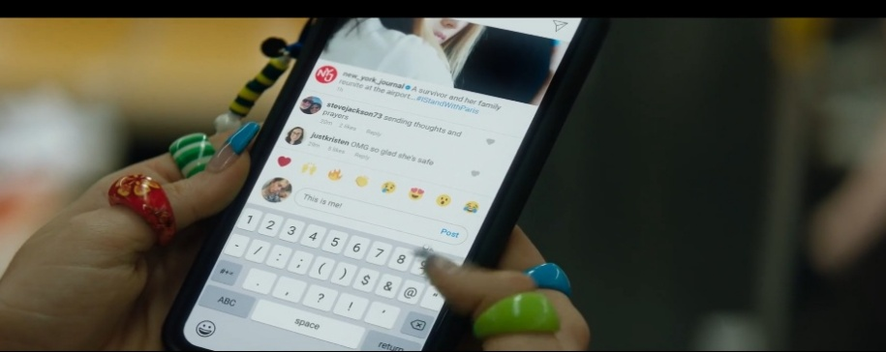
On a second-order level, Danni is the social media environment itself, churning genuine events and emotions into shareable content. Just like the social media algorithm, Danni only appraises Rowan after seeing how her activism translates into hashtags and shareable content: 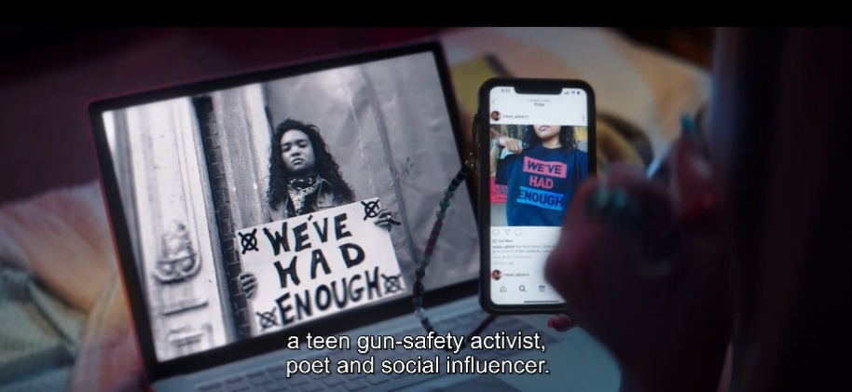
And when Danni’s lies finally come to light, she drags Rowan and her advocacy down with her: just as Rowan's genuineness lent credibility to Danni's lies by association, so do Danni's lies tarnish Rowan's credibility. The social media environment and genuineness, the film posits, do not mix.
Narrative Containment and Its Limits
At the level of narrative containment, the film both enacts the mechanism and strains against it. Not Okay can be seen as a film in which the values of the journalism myth are affirmed because of their violation, as the film punishes Danni for claiming the journalist's moral authority, specifically the authority of the Witness, without brandishing the journalist's commitment to truth. In doing so, it reinforces the idea that this moral authority must be earned through the institutional and ethical codes of traditional journalism, and that those who bypass those structures will be destroyed. This is a clear instance of what the theoretical framework terms narrative containment: the film's resolution vindicates the myth's core values even though it never features a traditional journalist hero.
The film's ending, however, is where the containment begins to strain. In many traditional journalism films, the resolution provides what Debord would call spectacular substitution: the emotional satisfaction of watching truth prevail substitutes for any actual impulse toward political engagement with the structural conditions the film depicts. Not Okay denies such a resolved satisfaction. After Danni is exposed, the film offers no redemption. She attempts to apologize to Rowan, who rejects her. She loses her job, her friends, and her social media following. The final scenes show Danni alone, walking through a New York street, recognized and heckled by strangers. There is no catharsis or restoration, and no indication that the system that produced her has been changed by her punishment. The social media ecosystem that elevated her remains fully unscathed and has simply moved on to its next target. In fact, the hatred of Danni has itself become the new story, the new hashtag to feed the content machine, simply taking the position of her fabricated story in the attention economy. There is no right or wrong in the social media reality, the film posits; Only content. Take for example these frames from a sequence showing other content creators lambasting Danni after her lies come out. These shots serve as a vox populi, showing the viewer what the diegetic audience thinks of Danni, but also demonstrate how her punishment has become content:

This refusal of catharsis distinguishes Not Okay from most social-media-centered films in the corpus, which tend to end in the influencer's death or total destruction and frame that ending as definitive closure. Not Okay instead leaves Danni alive and humiliated, wandering through a world that has not changed. In doing so, the film gestures toward the limits of displacement as a containment mechanism: punishing the individual cannot resolve the structural crisis, because the structures that produced the transgression remain.
Implicating the Viewer
It is here that the film delivers its most pointed indictment, directed at the non-diegetic audience watching the film. The title card invited us to judge an 'unlikeable female protagonist', and for the duration of the film, we do. As the film unfolds, however, the word 'unlikeable' begins to shift in meaning. It pertains less and less to a private moral assessment and more and more to the act of 'liking' on social media: to the currency of approval that governs Danni's world and, the film implies, our own.
To understand this shift, it is worth returning to who Danni actually is. Stripped of moral judgment, what the film shows us is a young woman who does not understand social cues. She butts in late to jokes that do not concern her. She takes a seat among people who clearly do not want her there. In the cafeteria, people get up when she tries to join them for lunch. This alienation is expressed through stylistic cues, too. In many shots before her social media popularity, Danni is placed on the margins of conversations in which she is not included, clutching her phone as if unsure how to navigate an interaction without it: 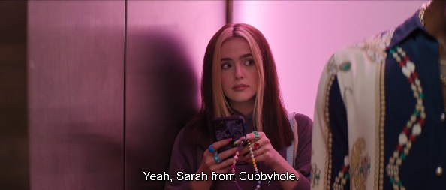 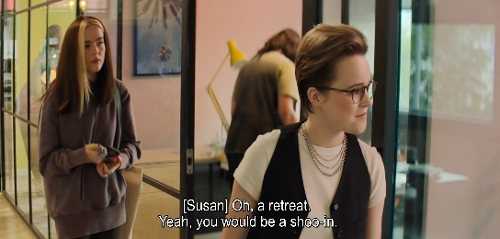
She is lonely and desperate to connect, but she does not understand how connection works outside of digital platforms. She only understands the language of social media: likes, emojis, follows, and hashtags.
Social media is the prism through which she comprehends human connection. She tries to submit an article about her grief for having missed 9/11. She laments to a gay black man and his lesbian friend how much she regrets not being a minority. She views traumatic events and marginalization as shortcuts to attention because she has internalized that such indicators carry currency on social media. Every relationship, every emotion, every tragedy is filtered through the question of whether it can generate engagement. This is a pathology, and the film invites us to condemn it. And yet, Danni is not an aberration. The world around her constantly affirms that her view of a social media-mediated society is the norm.
For example, when Danni's popularity takes off, she appropriates buzzwords like 'Woke' to further push her reach. But when a man at a party records a short with her, he likewise says 'Hey, fuck terrorists!' into the camera like it is a catchphrase, because Danni's supposed survival of a terrorist attack is her social relevance in the eyes of others:
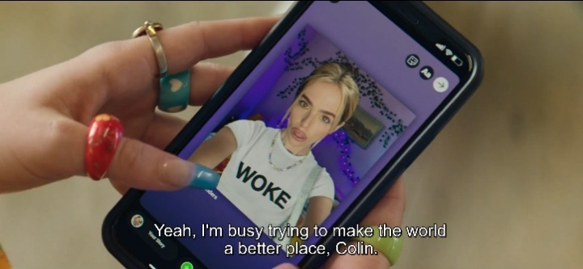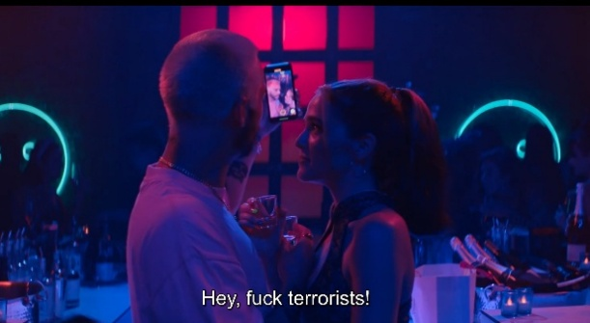
At the same party, a woman stops her, quickly checks her phone, and only after recognizing Danni as the girl from the story does she deem her worth talking to. And people at the party do not mingle naturally; they interact only to take selfies. Most of the guests are shown with phones in hand, clustered around a selfie-chair:
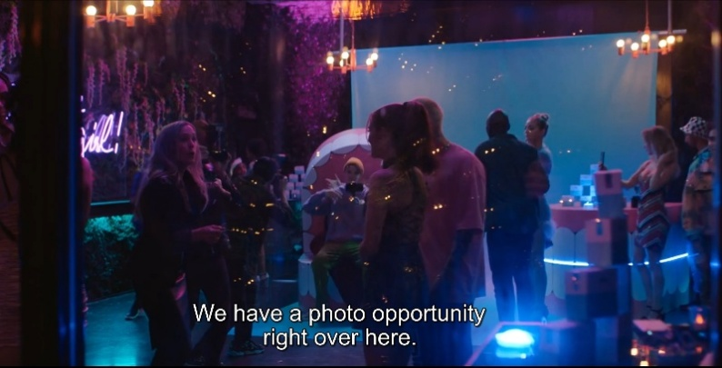
Just like Danni only sees the world through a social media prism, Danni is only seen by her colleagues once her social media star rises. Where the film framed her on the margins before, after her newfound popularity, she is suddenly the center of attention.
,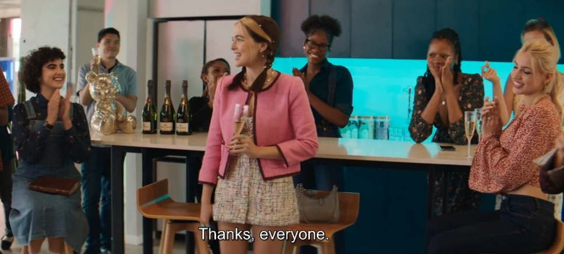
Everyone in Danni's world gauges the worth of others through social media metrics. Everyone rewards the visibility that Danni's fabrication provides. The system incentivizes precisely the behavior it punishes. Danni did not invent the rules of the attention economy, but she internalized them, and she played by them.
Even when emotionally charged events happen unmediated by screens, they are still treated as spectacle rather than a problem to solve. For example, in the climactic scene where Rowan discovers Danni's deceit and the two fight, an entire office watches them through the glass as if through a screen:
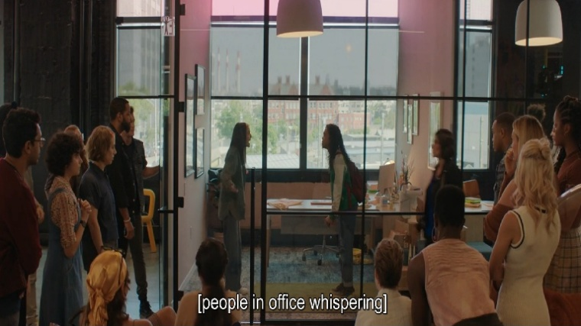
The film, in other words, shows us a world in which genuine behavior and involvement are structurally unrewarded. The magazine does not care about truth, just like the public does not care about credentials. The only currency that buys connection, respect, and professional advancement is engagement and the tragedies and emotions that drive it. In such a world, Danni's transgressions are the logical outcome of the incentive structure, and her punishment resolves nothing because the structure remains intact. Our invitation to judge her from the start of the film is, then, a trap. We are made complicit in the judgment of a person whose transgressions were shaped by a world we helped create. While most social-media-centered films in the corpus implicate the non-diegetic audience as complicit in the influencer's transgressions to some extent, Not Okay goes further: the reading the title card so firmly encodes, that Danni deserved what she got, is simultaneously the reading that implicates the viewer most deeply.
Mythological Signs
Shephard's stylistic choices reinforce these arguments throughout. The opposition between social media driven Danni and the authentic and present Rowan is expressed through recurring cues. Rowan is often framed from a low hero-angle, in medium shots that show her surrounded by relatives, friends, and community, with whom she physically interacts. The visual grammar of her scenes connotes heroism, collectivity, connectivity, and purpose:
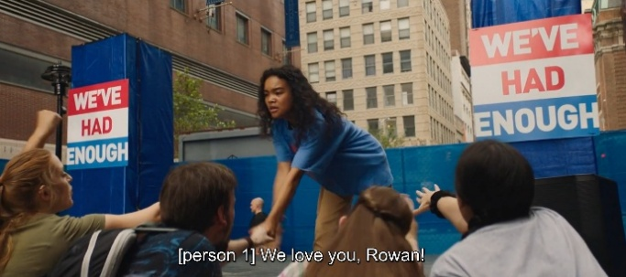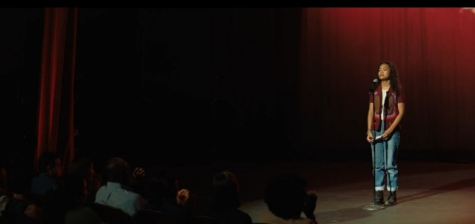
Danni, who writes about her experience alone in her room, is her visual opposite. When she is not at work, she is framed as explicitly solitary in her small apartment, scrolling through the social media feeds of people whose lives seem fuller and more visible than hers. She is never without her phone, and often uses multiple devices simultaneously, while the clutter in her room denotes how much she neglects her physical reality in favor of her social media environment:
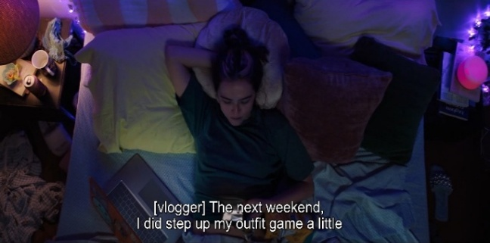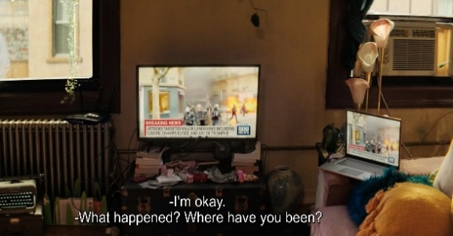
As her lie unravels, she is increasingly filmed in tight close-ups, alone in ever-darkening spaces, her face filling the frame as notifications and messages crowd the screen around her. The tightening of the frame around Danni as her world closes in mirrors the horror film's formal vocabulary of confinement and claustrophobia, connecting Not Okay to the broader pattern of social-media-centered films that punish the influencer through genre conventions traditionally reserved for the punishment of transgression:
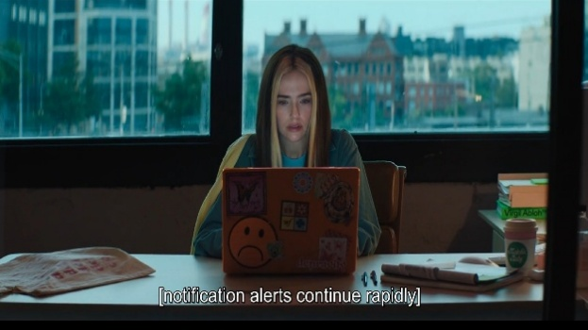
The film's handling of social media on-screen likewise confirms the mythological sign system identified in the findings chapter. In the first half, when Danni's fabrication is succeeding, social media notifications appear in the frame as warm, encouraging signs: likes, follows, and supportive comments that ping gently into view. Danni smiles at her phone; the visual and sonic grammar is one of validation. In the second half, after her exposure, the same formal elements are transformed, as the opening sequence already demonstrated. Notifications become relentless and hostile; angry comments and abuse flood the screen; and the social media notifications are shown against an ominous non-diegetic soundtrack. In the examples below, the first shot shows a full-screen social media post where comments and shares keep rising against an upbeat soundtrack: Danni is happy that her article is going viral. In the second shot, however, the thousands of notifications across three platforms are set against ominous music; here, Danni's lie has been exposed, and every notification represents hate coming her way.
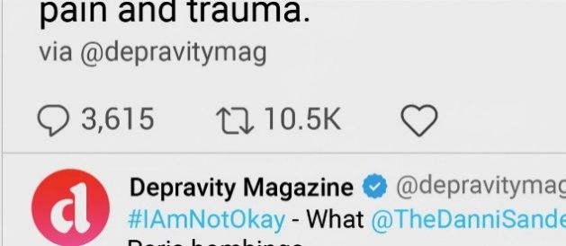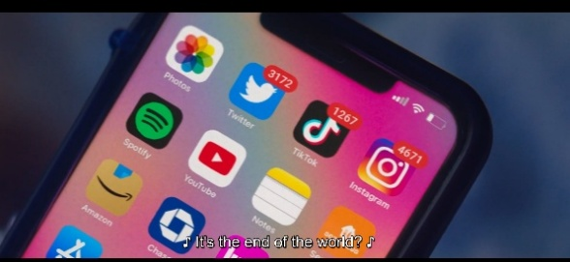

The phone, previously a source of comfort, is now a machine for social punishment. At the first-order level, these are different states of the same technology, but at the second-order level, they constitute the same mythological sign system observed across the social-media-centered films in the corpus: social media is coded as an inherently volatile force that rewards and punishes on its own terms, and the individual who depends on it for validation is ultimately at its mercy.
Not Okay is the most ideologically layered convergence film in the corpus because it operates at the intersection of the three categories this thesis has identified. It begins in the world of institutional journalism, moves into the world of social media, and shows the collision between the values of the former and the incentive structures of the latter. In doing so, it makes the most explicit statement about convergence in the entire corpus: that journalism, in its convergence with social media, has already been hollowed out; its institutional credibility has become a resource to be mined for engagement, while its gatekeeping function has been rendered destroyed. In Rowan, it offers a glimpse of Jenkins's predicted migration: a non-institutional figure carrying journalistic ideals through non-traditional means. In its refusal of cathartic closure, the film edges toward the kind of structural critique that the containment mechanisms identified in this thesis are designed to prevent. However, as the brunt of the critique is directed towards social media, to which journalism has become a compromised subservient, the journalism myth itself is not fundamentally destabilized. It is shown to be endangered by the social media reality, however: its values are affirmed in the clash, but its authority is posited to be diminished by association with a system it can neither resist nor escape.

5.3 Dumb Money
Dumb Money (Gillespie, 2023) is arguably one of the more interesting films in the corpus when it comes to the state of the journalism myth in the social media era. It provides the only example in the corpus of the Watchdog archetype migrating to a social media figure; it is the only film presenting social media as a comprehensive threat to current hegemony on an institutional scale; and it is also one of the only social-media-centered films produced by a large studio (Sony Pictures) and released through traditional Hollywood channels. There seems to be some contradiction in these facets of the film, but as this section will conclude, Dumb Money simultaneously performs narrative containment at the level of ideological function, cushioning much of the threat social media is allowed to pose throughout much of the film.
Narrative
The film recounts the 2021 GameStop short squeeze, framing the conflict as a David versus Goliath struggle between retail investors, organized through social media, and the hedge funds that dominate Wall Street.
When mapping the narrative structure of Dumb Money onto Greimas, the actantial structure positions Keith Gill as Subject, exposing the rigged financial system as Object, Wall Street elites as Opponent, the public as Receiver, ordinary social media users as Helper, and Keith’s own independent discovery as Sender. What is revealing is that every actant carrying the myth here sits outside the traditional institution: the Watchdog has migrated cleanly to a non-institutional figure, severing the myth from the institution across every actant that carries it.
Despite being an influencer, Keith embodies what McNair identifies as the Watchdog archetype: he uncovers a flaw in the system, and he reveals this flaw to his followers out of genuine civic conviction. The film makes clear throughout that his goal is not financial gain but the empowerment of ordinary investors and the exposure of Wall Street corruption. Even when tested during the film's climax, when all signs point to massive personal losses and even federal indictment, Keith remains true to his conviction and chooses to hold his stock as an ideological statement, inspiring his many followers to do the same. In doing so, Keith demonstrates traditional journalistic values in service of the public good, even in the face of great personal adversity, resembling the clear-cut heroes of Spotlight or The Post.
Dumb Money is therefore the corpus's clearest instance of Jenkins's second prediction: the journalistic ideals of speaking truth to power migrating to a new type of figure operating outside traditional institutional channels, blending the lines between activist and reporter in service of a community the institutional press has neglected. As the theoretical framework established, the Watchdog archetype is a form without content: it is defined by the function of holding hegemonic power accountable, and it travels wherever that function is performed. And Keith, in Dumb Money, embodies this migration.

Hero against Hegemony
The David-versus-Goliath mythological core of the film, as well as the subordination of the hegemonic structures to the novel threat of a social media collective, is delineated fully in the opening sequence of the film.
The film opens with several wide shots of a spacious, opulent, but empty mansion; a barren testament to wealth. We then see a man angrily pacing this locale, arguing over the phone with a contractor about additions to his newly bought mansion. A superimposed non-diegetic text appears next to the man, revealing him to be Gabe Plotkin, founder of hedge fund Melvin Capital; Net worth: 400 million, followed by a close-up of his expensive loafers. The man then picks up another call, and the film cuts to the man Plotkin is on the phone with: Steve Cohen, another superimposed text reveals, CEO of hedge fund Point72; Net worth: 12 billion. Cohen is shown getting a massage while watching a CNN financial segment. The presenter delivers the news stressed and urgently, in the same tone in which the two wealthy men talk to each other over the phone. All are clearly surprised by the events unfolding: "Did you see what's going on with GME?" Cohen asks, taking in the headlines. "They're holding." This prompts the millionaire into a panicked sprint, presumably forced into action by the news.

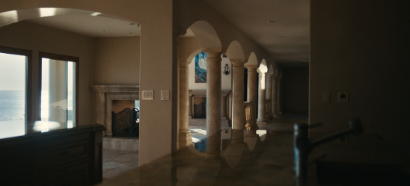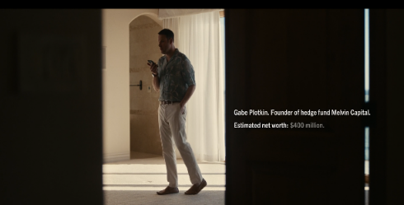

What follows is a series of cross-cut scenes: one of the millionaires, Gabe, running through his empty, opulent mansion; and another of a yet unidentified figure (they get no superimposed introduction yet, and we only see their legs and back) clad in sports gear running laps on a track.



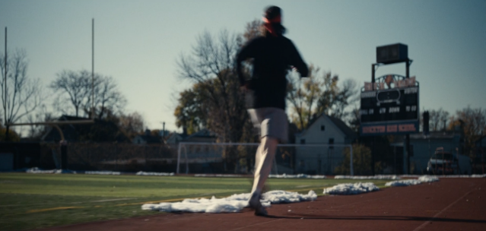

These cross-cuts already trigger in the viewer schemata of competition and opposition.
In between these cross-cuts are brief shots of news broadcasts delivering dramatic lines, such as "I've never seen anything like it!" and "This could be the ultimate short squeeze." The editing then becomes even more frantic and urgent, with additional cross-cuts showing not your typical investors, but ordinary people - a nurse, two teenage girls in a bedroom, and a young stoner with a bong in hand- reacting with surprise to the same news segments ("Holy shit!" says one of the girls). These shots function as cues for the viewer to hypothesize that the stakes of the competition between Gabe and the anonymous runner are of an historical scale, implicating not only institutions but ordinary people, too.
Finally, Gabe jumps behind his professional-looking desk and opens a graph that reveals distressing information, as he dejectedly mumbles "fuck…" Cohen calls him again and says: "It looks like there's one guy driving all the buying." Then we see the runner again, but this time we see their face as they cross the finish line and stop for a quick breather. It is a young man, shot from a low angle that establishes him as a heroic figure. His shirt reads "Game Over." "I believe his name is Roaring Kitty," Cohen says, "No, wait, or… DeepFuckingValue. He's Roaring Kitty on YouTube and DeepFuckingValue on Reddit."

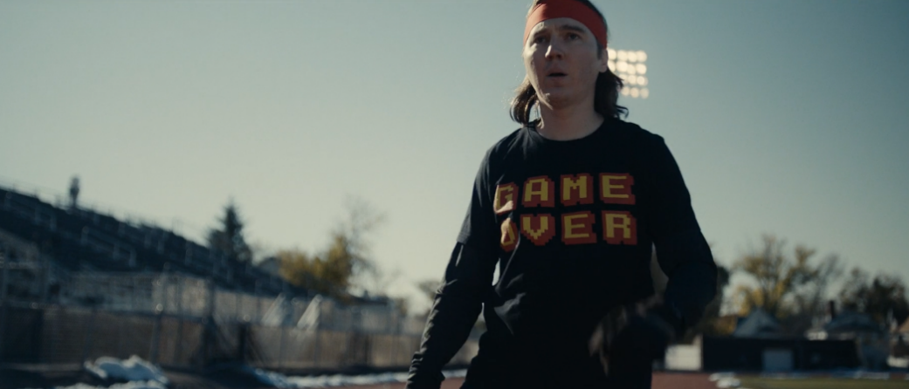

Meanwhile, cross-cuts show the man called Roaring Kitty is not done running just yet. He is just about to get serious: a close-up of him taking off his gloves; another close-up of him getting into position on his cheap, old Asics running shoes; then a close-up of him resetting his stopwatch; and finally, a close-up of his eyes, narrowing, determined, and he's off again.
This sequence encapsulates not only the crux of the events, but also how characters, ideology, class, and social media are presented throughout the film. In this short scene, we see how the decadently wealthy are defeated by a mysterious nobody who seems to beat them at their own game; how the millionaire is forced to sprint in his loafers while Keith is already on the track, dressed for competition, and ready to race; how traditional media is behind the facts, blindsided as much as the rich elites by what is transpiring; and how ordinary citizens have become players in a game usually reserved only for the anointed.
The film also establishes Keith as a social media hero-character: the low-angle shot of Keith crossing the finish line, the close-ups of running shoes and narrowing eyes, the shirt reading "Game Over", establishing him as the victor. This set-up is important; because While Keith Gill was behind the 2021 GameStop squeeze, it morphed simultaneously into chaotic and leaderless collective action (thousands of anonymous retail investors coordinating through Reddit), the consequences of which are still ongoing today, even though Keith Gill himself is no longer active in the movement. The film’s choice to center the narrative predominantly on the individual hero Keith, and a handful of ordinary citizens affected by the squeeze, sets the story up for clean narrative containment.
The Amateur Watchdog
What makes Dumb Money's portrayal of Keith interesting on the level of mythological signs is that it combines established signs of the Watchdog with some of the newly identified signs of the social media influencer, as well as a series of cues positioning Keith decidedly as a grassroots amateur.
On the character side, Keith is coded throughout as purposeful, driven, and earnest. In the mode of a journalist, he sets up and interacts with his equipment without the fumbling and awkwardness that defines many of the social media influencers in the rest of the corpus. His desk, as befits a journalist, is cluttered with paper, lending analog authority to what is in practice a wholly online output. His multi-screen setup, displaying Excel sheets and graphs, connotes similar professionalism.
His environment, however, tells a different story. Keith operates from a dingy, dark, and isolated basement, in line with the working environments of the other social media influencers found in the corpus, and a recognizable mythological sign of the influencer figure. And, like the pattern established among social media influencers, Keith is portrayed through a wide shot as lonely and isolated within it. His set-up connotes at least some professionalism, but his chair and microphone are clearly gaming peripherals.
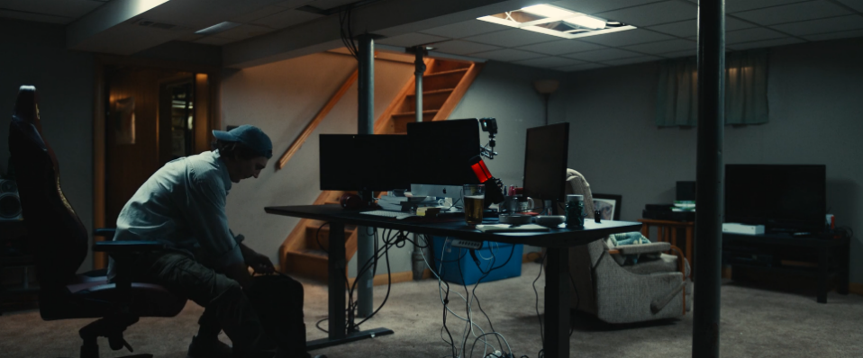

And when Keith goes live, although he is clearly an expert in his subject, he comes across as shy and slightly awkward. He also leaves room for doubt about his own expertise. Revealing his choice for the GameStop stock, he says: "I think everyone else is crazy, and I'm right, but… I have been wrong plenty of times in the past," showing a genuine fallibility a traditional financial reporter would likely not include in their report.
The most telling sign of his distance from professional institutions is perhaps his outfit. Although he is dressed in a decent button-up shirt, right before he goes live, he quickly changes into a kitten t-shirt and puts on a red karate-style headband. This latter choice is deliberate: Keith wants to present his authentic self. And he clearly likes kittens. His username, his t-shirt, and the posters on his basement wall are all of kittens, embedding him deeply within an internet culture for which kittens function as recognizable mythological signifiers (White, 2020). Interestingly, according to White, kittens are simultaneously signifiers of outsider status, established by early internet users as symbols of their independence from mainstream thought and institutions; a connotation that reinforces Keith's outsider positioning.

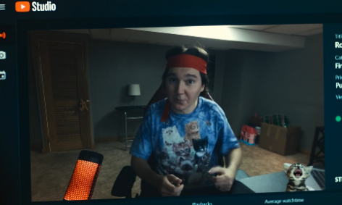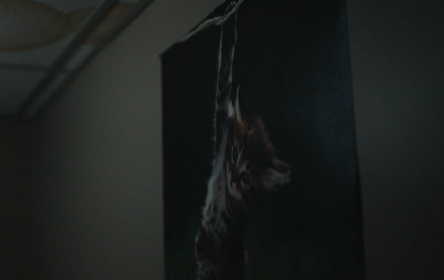

The character-level signs assert that Keith performs the journalistic function, while the environmental and physical signs assert that he does so from a grassroots level, outside the institutional structures that have historically authorized that function. In a Bordwellian sense, the cues trigger two schemata simultaneously: one of the authoritative, knowledgeable expert, and one of the upstart social media amateur. The film is having it both ways, and the two registers ultimately reinforce each other: Keith's heroism reads as more authentic because he operates from a basement rather than a newsroom, and the basement is redeemed because the figure inside it behaves like a Watchdog. Here, as is the case with Rowan in Not Okay, the reconstitution of the journalistic ideal depends precisely on the shedding of the traditional journalism signs in order to foreground authenticity.

The Diegetic Audience as Helper
The findings chapter established that the diegetic audience in social-media-centered films almost always occupies the Opponent actant, at the first or second order or both. The influencer's followers are shown as the force that drives the transgression the film ultimately punishes: they demand escalation, they reward sensationalism, and they turn hostile the moment the fabrication falters. Dumb Money inverts this pattern completely: the diegetic social media audience here occupies the Helper actant, at both the first and second orders.
At the first order, the retail investors Keith has organized through his YouTube streams and Reddit posts are the force that enables the squeeze: without their collective action, Keith's analysis would be an isolated curiosity rather than a real threat to the hedge funds. At the second order, they constitute the public whose collective action gives the journalism myth its democratic potency. The Receiver and the Helper here overlap: the public is both the beneficiary of the Object and the force that helps deliver it. In the heroic journalism film, this overlap is rare, as the public is usually abstracted into a passive Receiver whom the journalist serves from a distance. In Dumb Money, the public is active, organized, and powerful.
The sign vocabulary expresses this, too. The findings chapter established that social-media-centered films tend to posit the notification feed, the comment section, and the livestream chat as adversarial forces. Dumb Money’s social media depictions are the opposite: when Keith goes live, his chat is for the most part engaged and supportive; the comments are in-jokes, diamond-hands memes, and expressions of solidarity. The vox populi expression of the social media audience here is more in-line with that found in Scoop. The pings are pleasant. The follower count rises steadily rather than spiking and crashing. In Bordwellian terms, the same formal elements that trigger schemata of threat and loss of control in Not Okay or Spree here trigger schemata of solidarity and collective purpose; the only difference is the pace and the soundtrack.

The Community Activist
The cross-cutting in the opening sequence establishes this audience - influencer relationship visually. The nurse, the teenagers, the stoner, they are narrative participants whose individual reactions the film tracks throughout. They are the diegetic Helper given faces, returned to repeatedly so that the viewer comes to recognize them, and positioned in narrative parallel to Keith's own trajectory. When Keith holds, they hold. When Keith wins, they win. When the film shows the hedge fund's desperation, it is intercut with their jubilation. The structural parallel encodes the Helper-Receiver relationship as a communal project in which the Subject is merely the most visible participant.
This is Dumb Money's most direct iteration of what the theoretical framework has described as the migration of journalistic ideals to a new figure operating outside institutional channels. Jenkins's prediction imagined not merely a single outsider carrying the myth, but a figure blending the lines between activist and reporter in service of a community the institutional press no longer reaches. This community (mostly based on the Wallstreetbets subreddit) is expressed mainly through diegetic messages and vox populi type non-diegetic inter-cuts of memes and shorts, establishing them as both a cultural and political collective, more interested in communal ideology than money-making:

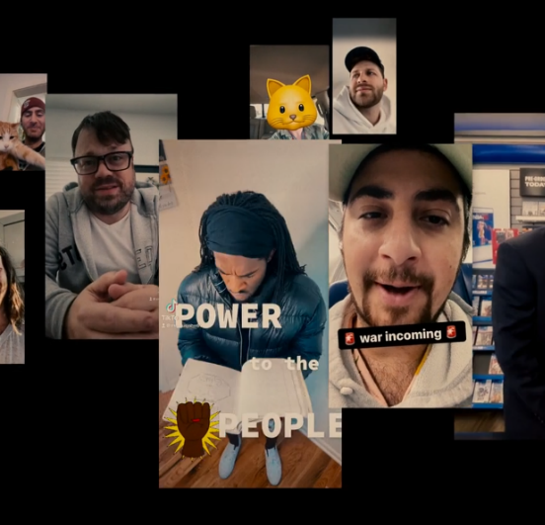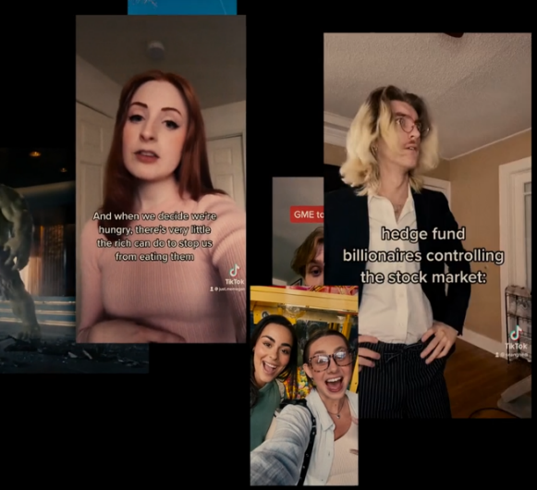

This in-group coded political community, and Keith’s central role as reporter within it, may be in fact the corpus’ clearest expression of Jenkin’s community activist reporter.
Narrative Containment
On the surface, it seems contradictory that the only film to suggest that social media can give ordinary people the power to trump powerful legacy systems is also the only social media focused film in the corpus made by a major studio and given a traditional theatrical release. Especially seems most of the other social media focused film in the corpus were produced by a minor studio and released direct to streaming, mostly on relatively marginal platforms. However, when viewed through a Hallian lens, Dumb Money offers a clean example of narrative containment.
The strongest critiques of hegemony, the theoretical framework argues, are not those that are suppressed, but those that are permitted in forms the dominant framework controls. Hall's account of primary definition makes this explicit: oppositional contributions are forced to insert themselves into the dominant framework's definition of what is at issue, and this insertion is where the ideological work is done. Dissent is permitted, but on terms the dominant framework sets. Dumb Money is an interesting example of this tactic.
The film offers some valid critique: it portrays the hedge fund elite as parasitic, dishonest, and contemptuous of the public; it celebrates the retail investors as genuine heroes; and it suggests that social media can deliver systemic truths to a mass audience in a way that institutional channels cannot. However, what the containment operates on is not the content of the critique but its scope and its resolution.
First, the critique is aimed at a specific and containable subset of the financial elite: hedge funds, rather than the financial system as a whole. Short-selling is depicted as a rigged game; the broader architecture of capital markets, retail brokerage, and financial regulation remains untouched. Robinhood, whose decision to halt buying of GameStop during the squeeze has been the subject of sustained political and legal scrutiny, is portrayed as a compromised but fundamentally outlying actor rather than as an integrated part of the system the film indicts. The systemic power that made the squeeze necessary (the financialization of the American economy, the concentration of capital, the absence of retail protection) remain outside of frame. The critique is specific enough to be cathartic and yet contained enough to be safe to elite structures through which the film was produced and disseminated.
Second, the resolution operates through the spectacular substitution Debord describes: the emotional satisfaction of watching the retail investors win substitutes for any actual impulse toward political engagement with the conditions the film depicts. The post-film epilogue confirms this: Plotkin's Melvin Capital shuts down; Robinhood faces lawsuits; and Keith retires from YouTube. The retail investors largely hold; some pay off debts, while others quit their jobs. The hedge fund industry as a whole, however, continues to exist. Just like the financial system as a whole continues to exist. The squeeze was a one-off correction rather than a structural rupture, and the film's resolution codes this as a happy ending, rather than as a failure of the insurgency it celebrates.
Third, the film performs the same individualization of collective action that the opening sequence established. By the film's end, Keith's personal arc has been resolved: his family is safe, his conviction has been overturned, and he has retired from the spotlight on his own terms. The collective that enabled the squeeze is dispersed while the heroic figure retires. Meanwhile, the hedge funds reconstitute themselves, and the system continues.
This containment is what makes the traditional theatrical release make sense from a hegemonic perspective. Sony Pictures did not produce and distribute a film that threatens the hegemonic order any more than The Post threatened the hegemonic order it celebrated. Dumb Money is, like The Post, a film that offers a critique and contains it. Both films stage the confrontation between a heroic truth-teller and a hegemonic Opponent and both resolve that confrontation through individual arcs that leave the broader system intact. Affectively, both deliver the emotional satisfaction of watching an individual representation of the powerful take a hit. And, importantly, both leave the viewer without any further political demand. The Post re-naturalizes institutional journalism as the vehicle of the myth, while Dumb Money naturalizes the social media Watchdog as a viable new vehicle of that same myth. And the fact that both films circulate through the same hegemonic channels and perform the same structural function is in itself evidence that the myth can be successfully reconstituted onto a non-institutional figure with little recalibration.

Conclusion
The analysis reveals that the journalism myth has not declined. In fact, it has proliferated, and it has done so through a coordinated set of mythological strategies that operate across all four constituents examined, allowing the myth to remain largely intact, mainly by refusing to recognize the new figures and conditions that now define the modern journalistic reality.
The most significant finding of the corpus is the near-total separation between journalism-centered films and social-media-centered films. Despite the deep and likely irreversible convergence of journalism and social media in reality, the corpus maintains an almost complete segregation between the two. The journalism film depicts a world in which social media scarcely exists, while the social media film depicts a world in which institutional journalism scarcely exists. This separation operates at the level of genre, ensuring that the challenge of social media cannot enter the frame of the journalism film, and that the legitimizing presence of institutional journalism cannot lend credibility to emerging social media figures like the influencer. The mythological worlds of journalism and social media exist apart from one another, reaching different audiences through separate channels and maintaining a gap between them, unlike reality.
Within that separation, each of the four constituents of the journalism myth has been affected or remained unaffected in a specific way. At the level of mythological signs, the corpus shows a striking reproduction of the traditional vocabulary of journalistic heroism. The cluttered newsroom, the paper-strewn desk, the compromised personal life, and the hard-drinking war reporter: such signs persist across the corpus. Where they appear in period pieces, their persistence reads as historical accuracy or period conventions. Where they appear in films set in the present day, however, they read as mythological inheritance, renaturalizing the journalism myth through a sign vocabulary whose origins have, in some cases, already begun to disappear from the real-world profession.
At the level of narrative, the corpus shows a remarkable stability in the second-order actantial structure of the journalism myth. Across almost every journalism-centered film in the corpus, the second-order Subject is the journalistic institution, the Object is truth, the Opponent is hegemonic power, and the Receiver is the public. Films that edge toward critique this structure do so by relocating the journalist within the actantial model rather than by altering the structure itself, and the public-versus-hegemony core of the myth emerges from these films enforced rather than challenged. The narrative logic of the journalism myth, in other words, has not been destabilized by the social media era. Rather, it has been reproduced ardently and consistently.
At the level of archetype, the corpus reveals the single most visible mythic response to the crisis: the migration of the Reptile from the traditional journalist onto the social media influencer. The Shadow figure who once populated the journalism film as the corrupt counterpart of the heroic Watchdog has been almost entirely relocated to a different kind of film altogether, where the influencer-as-Reptile is punished, most often through the conventions of horror, for transgressing the boundaries of legitimate public voice. This migration allows the journalism film to portray the institutional press in wholly heroic terms without the usual mythological obligation to admit its own failures, because the failures have been reassigned to a figure outside the institution. The binary Good and Saltzman identified as the reinforcing structure of the journalism myth continues to operate, but largely across the gap between two genres rather than within the single journalism film.
At the level of demographics, the corpus reveals the myth's clearest instance of reconstitution. The white man, historically the dominant carrier of the heroic archetype, has been largely displaced by the white woman as the most common face of the modern Watchdog. The Heroine-Watchdog dual archetype allows the myth to carry a feminist narrative strand into its service, creating a double underdog structure in which the female journalist's struggle against patriarchal authority and her pursuit of hegemonic truth are placed along the same story trajectory. The compromised white male carrier has been shed, and the myth has re-emerged through a figure the crisis has not yet stained to the same extent. The white male is no longer the myth's default carrier, but its marked one, the figure whose presence now activates schemata of hegemonic compromise; and the white female journalist has inherited the unmarked position the myth once reserved for him.
The two futures Henry Jenkins envisioned have both, to different extents, materialized. The journalism film has retreated overwhelmingly into the past, reproducing the myth most forcefully in period settings where it was never contested. And the journalistic ideals of speaking truth to power have migrated, in a handful of cases, to figures operating outside traditional institutional channels; most clearly in Keith Gill in Dumb Money and Rowan in Not Okay, both of whom earn themselves the Watchdog function through authentic experience and civic conviction rather than through institutional sanction. These are genuine instances of the migration Jenkins predicted, and they demonstrate that the myth can be reconstituted onto a non-institutional figure.
Howard Good's prediction of decline has not materialized in the period studied. The journalism film has proliferated, and the myth has proven remarkably adaptive. Whether this proliferation will continue, or whether the genre will yet decline as the institutional conditions that anchored it drift still further from the reality it depicts, is a question this thesis cannot answer. The organic crisis the framework identifies is still underway, and Good's prediction may yet be vindicated by a corpus that covers the decade ahead.
An open question this thesis leaves is whether the glimpses of real migration visible in Dumb Money and Not Okay represent the beginning of a broader mythic reconstitution onto non-institutional figures, or whether they remain exceptions, whose rarity proves the rule of the myth's resistance to such migration. The analysis supports both readings. Keith and Rowan are evidence that the Watchdog archetype can travel; that its function is separable from its institutional form. The overwhelming pattern of the corpus, however, is that popular film so far rarely chooses to employ such separation. The myth has so far proved willing to reconstitute its demographic carrier far more readily than its institutional setting, and the question of whether the latter reconstitution will follow the former or whether the institutional form will continue to be treated as inseparable from the mythic content it has historically carried is a question on which the future of the journalism myth now partly depends.
It might prove instructive to return to the Western analogy posited by Good and Jenkins and, in doing so, rekindle a question raised in the framework: is the journalism film a genre? And if so, is that genre defined by the mythological signs identified across this thesis as much as by its core narrative tensions? When people think of Westerns, they think of spurs and hats, cowboys and saloons. Yet as Jenkins suggests, beyond these trappings, the Western is mostly about the Frontier; the mythological core that makes the Western virtually inexhaustible. As the American frontier became dully domesticated, the genre simply moved into new ones. Star Wars (1977), set on frontier planets at the edge of an imperial core, is often classified as a space-western. In William Gibson's Neuromancer (1984), the virtual frontier of cyberspace is navigated by the aptly named Console Cowboys. Sketched through the actantial model, the core structure of the Frontier story maps readily onto most fictions labelled Western: fortune-seekers (Receiver) on a lawless frontier are exploited by outlaws (Opponent), and a free-spirited hero (Subject) arrives to save them. As long as lawless frontiers exist, if only in our imagination, it is unlikely this mythological core will ever fade wholly into obscurity.
Similarly, if the journalism myth, as most scholars seem to some degree suggest, is ultimately about the truth, who seeks it, who controls it, and who suppresses it (Ehrlich and Saltzman, 2015; McNair, 2010; Ness, 1997), then its survival is beyond doubt, precisely because the stakes and tensions such a myth generates are timeless. In ancient Egyptian mythology, Thoth was the scribe of the gods who introduced humans to the written word and the many truths it could carry; he was also, however, a trickster who gleefully spread what we might now call fake news. Likewise, the Roman goddess Fama lived in a house with a thousand windows from which she could see every truth in the world and share whichever ones she liked, though she was equally fond of rumors. And one does not need to dig deeply to find, in early discussions of social media and its democratic potential, comparisons to Prometheus, who stole fire from the gods to raise humans to a divine level. The mythological grammar of power, truth, and its transmission predates journalism by millennia and will outlast it by as much. The journalism myth is, in this sense, one historically contingent form that a deeper and more permanent mythology has assumed. And as we accelerate into a post-truth era, truth is likely to acquire an even heavier mythological weight, making its bearer an even more fabled Subject.
It is simultaneously dishonest to pretend that journalism's more material signs do not matter. Few would conflate a shaman with a doctor, and Thoth, similarly, was no journalist. There is a reason Schudson dates the dawn of journalism and its ideals of objectivity to the 19th century: it was then that the profession emerged with calcified rules, became embedded in our legal and financial systems, and became, to some degree, predictable and accountable. Like doctors, journalists are not trusted as individual practitioners so much as through the systems (schools, laws, market value) that are supposed to guarantee the values of the profession.
Just as most of us would rather walk into a hospital and find a licensed doctor than scroll through a list of shamans, toad-milkers, and humor-mongers, the idea of an established, institutional journalism offers some peace of mind. And so we look for journalists with press passes and pencils behind the ear, working behind cluttered desks, drinking hard, and neglecting their families. We look for signs to allay our fears that a truth-bearer might be a false idol.
And this is where the problem of our current crisis comes in. If journalists are losing their signs (who still carries a pencil?) and their established appearance has been compromised, to what, and to whom, will the myth of the truth-bearer be anchored once its current survival tactics fail? What will be the journalist's equivalent of trading the Colt for a laser gun, of moving from the plains to the stars? The temporal migration of the Western was a low-stakes affair; we can live, to an extent, without classic cowboys. The news media as they have existed, however, remain a pivotal constituent of our democracy. It therefore makes sense that the journalism myth, already partly undressed, holds on tightly to its skivvies.
As this thesis demonstrates, however, the journalism myth is remarkably adaptable, reconstituting carriers, ignoring challengers, and picking up or shedding mythological signs as needed. In this sense, it always was, and likely always will be, a ship of Theseus, transforming gradually beneath our feet as it sails into new moments of crisis and glory.

References
Abernathy, P. M. (2023). The state of local news. Northwestern Medill.
Adobe. (2022) Adobe “Future of Creativity” study: 165M+ creators joined creator economy since 2020. Adobe News. https://news.adobe.com/news/news-details/2022/adobe-future-of-creativity-study-165m-creators-joined-creator-economy-since-2020
Alford, M. (2010). Reel power: Hollywood cinema and American supremacy. Pluto Press.
American Press Institute. (2016). A new understanding: What makes people trust and rely on news.
Barris, A. (1976). Stop the presses! The newspaperman in American films. A. S. Barnes.
Barthes, R. (1972). Mythologies (A. Lavers, Trans.). Hill and Wang. (Original work published 1957)
Barthes, R. (1977). Image-music-text (S. Heath, Trans.). Hill and Wang.
Bartlett, F. C. (1932). Remembering: A study in experimental and social psychology. Cambridge University Press.
Bates, A., Hobman, T., & Bell, B. T. (2020). "Let me do what I please with it... don't decide my identity for me": LGBTQ+ youth experiences of social media in narrative identity development. Journal of Adolescent Research, 35(1), 51–83. https://doi.org/10.1177/0743558419884700
Benkler, Y., Faris, R., & Roberts, H. (2018). Network propaganda: Manipulation, disinformation, and radicalization in American politics. Oxford University Press.
Bettelheim, B. (1976). The uses of enchantment: The meaning and importance of fairy tales. Knopf.
Bordwell, D. (1985). Narration in the fiction film. University of Wisconsin Press.
Bordwell, D. (1989). Making meaning: Inference and rhetoric in the interpretation of cinema. Harvard University Press.
Bordwell, D., & Thompson, K. (2010). Film art: An introduction (9th ed.). McGraw-Hill.
Brandtzæg, P. B., Lüders, M., Spangenberg, J., Rath-Wiggins, L., & Følstad, A. (2016). Emerging journalistic verification practices concerning social media. Journalism Practice, 10(3), 323–342. https://doi.org/10.1080/17512786.2015.1020331
Brems, C., Temmerman, M., Graham, T., & Broersma, M. (2017). Personal branding on Twitter: How employed and freelance journalists stage themselves on social media. Digital Journalism, 5(4), 443–459. https://doi.org/10.1080/21670811.2016.1176534
Briziarelli, M., & Martínez Guillem, S. (2017). Reviving Gramsci: Crisis, communication, and change. Routledge.
Buchanan, M. (2024). Charting the rise of cinephile social platform Letterboxd. Screen Daily.
Campbell, J. (1988). The power of myth. Doubleday.
Carey, J. (1997). The press, public opinion, and public discourse. In E. S. Munson & C. A. Warren (Eds.), James Carey: A critical reader (pp. 373–402). University of Minnesota Press. https://doi.org/10.5749/j.ctttsvzt
Carlson, M. (2006). War journalism and the “KIA journalist”: The cases of David Bloom and Michael Kelly. Critical Studies in Media Communication, 23(2), 91–111.
Chambers, D., Steiner, L., & Fleming, C. (2004). Women and journalism. Routledge.
Chen, G. M., Pain, P., Chen, V. Y., Mekelburg, M., Springer, N., & Troger, F. (2020). “You really have to have a thick skin”: A cross-cultural perspective on how online harassment influences female journalists. Journalism, 21(7), 877–895. https://doi.org/10.1177/1464884918768500
Christians, C. G., Glasser, T. L., McQuail, D., Nordenstreng, K., & White, R. A. (2009). Normative theories of the media: Journalism in democratic societies. University of Illinois Press.
Clover, C. J. (1987). Her body, himself: Gender in the slasher film. Representations, 20, 187–228.
Cronesberry, K., & Ward, L. (2024). Exploring gender diverse young adults' gender identity development in online LGBTQIA+ communities. International Journal of Transgender Health. Advance online publication. https://doi.org/10.1080/26895269.2024.2344534
Debord, G. (1994). The society of the spectacle (D. Nicholson-Smith, Trans.). Zone Books. (Original work published 1967)
Denzin, N. K., & Lincoln, Y. S. (2011). The SAGE handbook of qualitative research (4th ed.). SAGE.
Deuze, M. (2005). What is journalism? Professional identity and ideology of journalists reconsidered. Journalism, 6(4), 442–464.
De Vries, A. (2020). Together we can break the silence: A critical discourse analysis of the #MeToo movement [Master’s thesis, University of Groningen].
Dika, V. (1990). Games of terror: Halloween, Friday the 13th, and the films of the stalker cycle. Fairleigh Dickinson University Press.
Douglas, M. (1992). Risk and blame: Essays in cultural theory. Routledge.
Edison Research. (2025). The top 50 podcasts in the U.S. for Q4 2024. Edison Podcast Metrics.
Ehrlich, M. C. (2004). Journalism in the movies. University of Illinois Press.
Ehrlich, M. C., & Saltzman, J. (2015). Heroes and scoundrels: The image of the journalist in popular culture. University of Illinois Press.
Ehrlich, M. C., & Saltzman, J. (2019). Fictional representations of journalism. In Oxford research encyclopedia of communication. Oxford University Press.
Fairclough, N. (2003). Analysing discourse: Textual analysis for social research. Routledge.
Ferro, M. (1977). Cinema and history. Wayne State University Press.
Freelon, D., & Wells, C. (2020). Disinformation as political communication. Political Communication, 37(2), 145–156. https://doi.org/10.1080/10584609.2020.1723755
Frye, N. (1957). Anatomy of criticism. Princeton University Press.
Gallup. (2024). Americans’ trust in mass media. Gallup.
Ghiglione, L. (n.d.). The American journalist: Fiction versus fact [Unpublished essay]. IJPC. https://www.ijpc.org/uploads/files/ghiglione.pdf
Gitlin, T. (1980). The whole world is watching: Mass media in the making and unmaking of the New Left. University of California Press.
Good, H. (1989). Outcasts: The image of journalists in contemporary film. Scarecrow Press.
Good, H. (1998). Girl reporter: Gender, journalism, and the movies. Scarecrow Press.
Good, H. (2020). The image of the journalist in popular culture in the 21st century. The IJPC Journal, 9.
Gramsci, A. (1971). Selections from the prison notebooks (Q. Hoare & G. Nowell-Smith, Eds. & Trans.). International Publishers. (Original work published 1947)
Greimas, A. J. (1983). Structural semantics: An attempt at a method (D. McDowell, R. Schleifer, & A. Velie, Trans.). University of Nebraska Press. (Original work published 1966)
Greimas, A. J., & Courtés, J. (1982). Semiotics and language: An analytical dictionary. Indiana University Press.
Hall, S. (1980). Encoding/decoding. In S. Hall, D. Hobson, A. Lowe, & P. Willis (Eds.), Culture, media, language (pp. 128–138). Hutchinson.
Hall, S. (1986). The problem of ideology: Marxism without guarantees. Journal of Communication Inquiry, 10(2), 28–44.
Hall, S. (1988). The hard road to renewal: Thatcherism and the crisis of the left. Verso.
Hall, S., Critcher, C., Jefferson, T., Clarke, J., & Roberts, B. (1978). Policing the crisis: Mugging, the state and law and order. Macmillan.
Hammarberg, K., Kirkman, M., & de Lacey, S. (2016). Qualitative research methods: When to use them and how to judge them. Human Reproduction, 31(3), 498–501.
Heravi, B. R., & Harrower, N. (2016). Twitter journalism in Ireland: Sourcing and trust in the age of social media. Information, Communication & Society, 19(9), 1194–1213. https://doi.org/10.1080/1369118X.2016.1187649
Herman, E. S., & Chomsky, N. (1988). Manufacturing consent: The political economy of the mass media. Pantheon Books.
Hesmondhalgh, D. (2019). The cultural industries (4th ed.). Sage.
Jenkins, H. (2020). Two scenarios for the image of the journalist in popular culture in a post-journalistic culture. USC Annenberg. https://assets.uscannenberg.org/journals/ijpc/Henry-Jenkins-Essay_Two-Scenarios-for-the-Image-of-the-Journalist-in-Popular-Culture-in-a-Post-Journalistic-Culture.pdf
Jung, C. G. (1969). The archetypes and the collective unconscious (2nd ed.). Princeton University Press.
Jung, C. G. (Ed.). (1964). Man and his symbols. Doubleday.
Kedem, A., & Neiger, M. (2024). Journalists’ ideological branding: Bridging professional and personal branding on Twitter. Journalism Practice, 18(9), 2172–2190. https://doi.org/10.1080/17512786.2024.2313141
Klaehn, J., & Mullen, A. (2010). The propaganda model and sociology: Understanding the media and society. Sociology Compass. https://doi.org/10.1111/j.1751-9020.2010.00275.x
Kracauer, S. (1947). From Caligari to Hitler: A psychological history of the German film. Princeton University Press.
Lang, B. (2023, November 22). How Letterboxd lured Martin Scorsese & got viewers into classic films. Variety. https://variety.com/2023/film/news/letterboxd-martin-scorsese-younger-audience-classic-films-1235804153/
Lewis, S. C., & Molyneux, L. (2018). A decade of research on social media and journalism: Assumptions, blind spots, and a way forward. Media and Communication, 6(4), 11–23. https://doi.org/10.17645/mac.v6i4.1562
Mandler, J. M. (1984). Stories, scripts, and scenes: Aspects of schema theory. Lawrence Erlbaum.
McNair, B. (2010). Journalists in film: Heroes and villains. Edinburgh University Press.
Miller, T., Govil, N., McMurria, J., Maxwell, R., & Wang, T. (2005). Global Hollywood 2. British Film Institute.
Milli, S. (2025). Engagement, user satisfaction, and the amplification of divisive content on social media. PNAS Nexus, 4(3), pgaf062. https://doi.org/10.1093/pnasnexus/pgaf062
Munich Security Conference. (2019). The great puzzle: Who will pick up the pieces? Munich Security Report 2019.
Myers, C. L. (2023–2025). Countering the frame: Black journalists and the politics of representation in silent film. The IJPC Journal, 11–12, 61–71. https://assets.uscannenberg.org/journals/ijpc/Christina-Myers_final.pdf
Ness, R. (1997). From headline hunter to Superman: A journalism filmography. Scarecrow Press.
Newman, N., Fletcher, R., Robertson, C. T., Eddy, K., & Nielsen, R. K. (2024). Reuters Institute digital news report 2024. Reuters Institute for the Study of Journalism.
Ott, B. L. (2017). The age of Twitter: Donald J. Trump and the politics of debasement. Critical Studies in Media Communication, 34(1), 59–73.
Painter, C., & Ferrucci, P. (2019). Taking the white gloves off: The portrayal of female journalists on Good Girls Revolt. Journal of Magazine Media, 19, 50–71.
Pew Research Center. (2022). Americans’ views of the news media.
Pickard, V. (2020). Democracy without journalism? Confronting the misinformation society. Oxford University Press.
Propp, V. (1968). Morphology of the folktale (2nd ed.). University of Texas Press. (Original work published 1928)
Rafter, N. (2006). Shots in the mirror: Crime films and society (2nd ed.). Oxford University Press.
Rathje, S., Van Bavel, J. J., & van der Linden, S. (2021). Out-group animosity drives engagement on social media. Proceedings of the National Academy of Sciences, 118(26), e2024292118. https://doi.org/10.1073/pnas.2024292118
Richardson, S. S. (2023–2025). Committing journalism while Black: Colorblind casting and the portrayal of Black journalists. The IJPC Journal, 11–12, 72–79. https://assets.uscannenberg.org/journals/ijpc/Richardson-Colorblind-Casting.pdf
Saltzman, J. (2005). Analyzing the images of the journalist in popular culture. IJPC Journal, 1(1).
Schiller, H. I. (1976). Communication and cultural domination. International Arts and Sciences Press.
Schudson, M. (1978). Discovering the news: A social history of American newspapers. Basic Books.
Shklovsky, V. (1971). Theory of prose (B. Sher, Trans.). Dalkey Archive Press. (Original work published 1925)
Sklar, R. (1994). Movie-made America: A cultural history of American movies (rev. ed.). Vintage.
Smith, S. L., Case, A., Pieper, K., & Hernandez, K. (2023). Hispanic and Latino representation in film: Erasure on screen and behind the camera across 1,600 popular movies. USC Annenberg Inclusion Initiative.
Sorlin, P. (1980). The film in history: Restaging the past. Barnes & Noble.
Storey, J. (2006). Cultural theory and popular culture: An introduction (4th ed.). Pearson.
Surette, R. (2015). Media, crime, and criminal justice: Images, realities, and policies (5th ed.). Cengage Learning.
Tatar, M. (1987). The hard facts of the Grimms’ fairy tales. Princeton University Press.
Tomasik, E., & Gottfried, J. (2023, April 4). U.S. journalists’ beats vary widely by gender and other factors. Pew Research Center. https://www.pewresearch.org/short-reads/2023/04/04/us-journalists-beats-vary-widely-by-gender-and-other-factors/
Tomlinson, J. (1991). Cultural imperialism: A critical introduction. Johns Hopkins University Press.
Tuchman, G. (1972). Objectivity as strategic ritual: An examination of newsmen’s notions of objectivity. American Journal of Sociology, 77(4), 660–679.
Tufekci, Z. (2018). Twitter and tear gas: The power and fragility of networked protest. Yale University Press.
Tumber, H., & Webster, F. (2006). Journalists under fire: Information war and journalistic practices. Sage.
USAFacts. (2025). America in facts 2025: Population [PDF]. https://media.usafacts.org/m/56f7fa7cbf9d5138/original/USAFacts_2025_DIGITAL_Population.pdf
Waisbord, S. (2020). Mob censorship: Online harassment of US journalists in times of digital hate and populism. Digital Journalism, 8(8), 1030–1046. https://doi.org/10.1080/21670811.2020.1818111
Ward, S. J. A. (2015). The invention of journalism ethics. McGill-Queen’s University Press.
Wardle, C., & Derakhshan, H. (2017). Information disorder: Toward an interdisciplinary framework for research and policy making. Council of Europe.
Wasserman, M., Mukherjee, S., Scott, K., Zeng, X. H. T., & Amaral, L. A. N. (2013). Correlations between user voting data, budget, and box office for films in the Internet Movie Database.
Weaver, D. H., Willnat, L., & Wilhoit, G. C. (2019). The American journalist in the digital age. Peter Lang.
Wells, C., Shah, D. V., Pevehouse, J. C., Yang, J., Pelled, A., Boehm, F., & Schmidt, J. L. (2016). How Trump drove coverage to the nomination. Political Communication, 33(4), 669–694.
Welsh, A. (2010). On the perils of living dangerously in the slasher horror film: Gender differences in the association between sexual activity and survival. Sex Roles, 62(11–12), 762–773.
Wilson, B. J. (2008). Media and children’s aggression, fear, and altruism. The Future of Children, 18(1), 87–118.
Zelizer, B. (2004). Taking journalism seriously: News and the academy. Sage.
Zelizer, B. (2017). What journalism could be. Polity Press.
Zuboff, S. (2019). The age of surveillance capitalism. PublicAffairs.

Appendix A: Coding Scheme

Table A1: Journalist Demographics
Dimension | Question (Yes/No) | Notes / Indicators
Sex | Is the journalist depicted as male? | Visual cues, dialogue, pronouns.
 | Is the journalist depicted as female? | Visual cues, dialogue, pronouns.
Seniority | Is the journalist depicted as junior / early career? | Experience, desk assignment, status.
 | Is the journalist depicted as senior / experienced? | Editor, seasoned reporter, leadership role.
Ethnicity | Is the journalist depicted as part of an ethnic minority? | Non-white.
LGBTQ+ | Is the journalist depicted as part of an LGBTQ minority? | Non-conforming gender identity, sexuality. Narrative cues.

Table A2: Journalistic Professional Roles
Role | Question (Yes/No) | Notes / Indicators
Anchor | Is the journalist depicted as a news anchor? | Studio presence, on-air reporting.
Reporter | Is the journalist depicted as a field reporter? | Covers events outside newsroom.
Photographer / Cameraperson | Is the journalist depicted taking photos or filming? | On assignment or supporting reporting.
Editor | Is the journalist depicted as an editor? | Supervises stories, assigns tasks.
Investigative Reporter | Is the journalist depicted as an investigative reporter? | Uncovers corruption or wrongdoing through investigative work.
War / Foreign Correspondent | Is the journalist depicted reporting from conflict zones? | International / conflict assignments.
Columnist / Critic | Is the journalist depicted as a commentator or columnist? | Opinion writing, media critique.
Media Owner | Is the journalist depicted as owning or controlling a media organization? | Publisher, station owner, executive producer.
Tabloid / Sensationalist Reporter | Is the journalist depicted as working for sensationalist or tabloid media? | Prioritizes scandal, gossip, entertainment.
Influencer | Is the journalist an influencer? | Primarily uses social media as a platform.

Table A3: Journalist Archetype / Moral Alignment
Archetype Category | Question (Yes/No) | Notes / Indicators
Watchdog | Is the journalist depicted as a watchdog? | Exposes corruption, seeks truth.
Witness | Is the journalist depicted as a witness? | Covers conflict zones, witnesses atrocities or disasters.
Heroine | Is the journalist depicted as a heroine? | Fights and/or overcomes sexism and sexism-related misdeeds in the workplace and beyond.
Lovable Rogue | Is the journalist depicted as a lovable rogue? | Charming rascal. Journalistically slightly compromised.
Repentant Sinner | Is the journalist depicted as a repentant sinner? | Starts as reptile but becomes repentant.
Reptile | Is the journalist depicted as a reptile? | Cunning, manipulative, self-serving behavior, stooge of power.

Dimension | Question (Yes/No) | Notes / Indicators
Truth-Seeking | Is the journalist engaged in truth-seeking? | Actively investigates, verifies, or pursues factual truth.
Truth-Manufacturing / Obscuring | Does the journalist manufacture, distort, or obscure truth? | Fabricates, exaggerates, suppresses, or manipulates information.
Works for Public Interest | Does the journalist work for the public interest? | Acts to inform, expose wrongdoing, or serve the public good.
Works Only for Selfish Interest | Does the journalist act only for selfish interest? | Acts primarily for personal gain, status, protection, or advantage rather than truth or public benefit.

Table A4: Journalistic Platforms
Dimension | Question (Yes/No) | Notes / Indicators
News Website or Online Magazine | Is the journalist shown working on or posting to a news website? | News portals, online-only newspapers or magazines.
News Station / Broadcast | Is the journalist depicted using a TV or radio station platform? | Television or radio news.
Newspaper | Is the journalist depicted producing or posting print content? | Newspapers.
Magazine | Is the journalist depicted working for a print magazine? | Magazines.
Streaming (Social Media) | Is the journalist depicted as streaming to an audience? | Live streaming to platforms similar to Twitch, YouTube, Instagram, or TikTok.
Social Media (Non-Stream) | Is the journalist depicted as posting to social media? | Articles, photos, or video posted to platforms such as Twitter, Instagram, YouTube, or TikTok.

Table A5: Journalist Career Stability & Well-Being
Dimension | Question (Yes/No) | Notes
Professional Success | Is the journalist depicted as professionally successful? | Recognition, scoops, promotions, followers.
Professional Failure | Is the journalist depicted as failing professionally? | Marginalization, mistakes, loss of reach and followers.
Career Stability | Is the journalist career depicted as stable? | Job security.
Career Precarity | Is the journalist career depicted as precarious? | Layoffs, freelancing, warnings.
Institutional Embeddedness | Is the journalist shown to work for a journalistic institution? | Works for a paper, television channel, network, or similar outlet.
Publication Success | Is the journalist publication depicted as thriving? | High readership, viral success, awards, strong funding.
Publication Failing | Is the journalist publication depicted as struggling or failing? | Layoffs, closure threats, low readership, financial pressures.
Personal Life Sacrifices | Is the journalist shown sacrificing personal and family life for their career, or pressured to choose between them? | Broken relationships, family friction, juggling parenthood and work.
Motivation | Is the journalist depicted as motivated or driven? | Idealism, ambition, fervor.

Table A6: Social Media Impact
Dimension | Question (Yes/No) | Notes
Social Media Use | Is the journalist shown using social media? | Any platform.
Central to Reporting | Is social media central to reporting? | Leads, sourcing.
Stress | Is social media linked to stress or burnout? | Emotional toll.
Ethical Impact | Does social media affect ethics? | Speed versus accuracy, blurred boundaries.
Priority Shift | Does social media shift priorities? | Does social media set the agenda?
Journalist Positive | Is the journalist positive about social media? | Embraces platforms, expresses positive sentiments.
Journalist Neutral | Is the journalist neutral about social media? | Instrumental use.
Journalist Negative | Is the journalist negative about social media? | Expresses negative sentiments about social media.
Social Media Adaptation Pressure | Is the journalist or platform pressured to adapt to social media audience or algorithmic demands? | Chasing virality, changing material to fit social media output, adapting output to viewer harassment or demands.
Social Media Adaptation Success | Is the adaptation successful? | Increased followers, revenues, visibility.
Public View of Journalism Positive | Does the public view journalism positively? | Positive comments about pieces, reporters; aiding in sourcing, trust.
Public View of Journalism Negative | Does the public view journalism negatively? | Distrust, criticism, hostility.
Public View of Social Media Positive | Does the public view social media positively? | Positive comments, trust.
Public View of Social Media Negative | Does the public view social media negatively? | Negative comments, distrust, hostility.

Table A7: On-Screen Depiction of Social Media
Dimension | Question (Yes/No) | Notes
On-Screen Presence | Is social media visually depicted on screen? | Interfaces, feeds, notifications.
Narrative Importance | Does social media play a narratively important role? | Drives plot events.
Dramatized Depiction | Is social media dramatized through cinematic cues? | Heightened sound, editing, framing.
Depicted as Positive | Is social media depicted positively through cinematic cues? | Easily navigated, responsive depiction, positive feedback such as messages, likes, and views.
Depicted as Negative | Is social media depicted negatively through cinematic cues? | Aggressive, overwhelming.
Depicted as Neutral | Is social media depicted neutrally? | Functional, background tool.
Used as Vox Populi | Is social media used as vox populi for the diegetic audience? | Used to convey diegetic public sentiment through memes, posts, and messages.

Appendix B: Corpus of Films
This appendix lists the 31 films included in the corpus, alongside their focus category, genre, fictional or true-story status, period setting, release year, inclusion metric, and Weighted Popularity Score (WPS) and Weighted Popularity Discrepancy Score (WPDS).
Film | Focus | Primary Genre | Secondary Genre | True Story / Fiction | Period / Contemp. | Year | Inclusion Metric | WPS | WPDS
Venom | Journalism | Action | Adventure, Sci-fi | Fiction | Contemporary | 2018 | Box Office Success | 100 | 0.555
Venom: Let There be Carnage | Journalism | Action | Adventure, Sci-fi | Fiction | Contemporary | 2021 | Box Office Success | 76.12 | 5.98
The Post | Journalism | Biography | Drama, Thriller | True Story | Period | 2017 | BoS + Awards | 48.76 | 0.347
Trainwreck | Journalism | Comedy | Romance | Fiction | Contemporary | 2015 | BoS | 39.16 | 0.293
Civil War | Journalism | Action | Thriller, War | Fiction | Contemporary | 2024 | BoS | 71.68 | 0.293
Spotlight | Journalism | Biography | Drama, Crime | True Story | Period | 2015 | BoS + Awards | 100 | 0.252
A Beautiful Day in the Neighborhood | Journalism | Biography | Drama, Family | True Story | Period | 2019 | BoS + Awards | 28.72 | 0.397
Bombshell | Journalism | Biography | Drama | True Story | Period | 2019 | Bos + Awards | 40.28 | 0.381
The Woman in Cabin 10 | Journalism | Drama | Mystery, Thriller | Fiction | Contemporary | 2025 | SS | 25.72 | 0.55
The French Dispatch | Journalism | Comedy | Drama, Romance | Fiction | Period | 2021 | BoS + Awards | 59.92 | 0.502
Richard Jewell | Journalism | Biography | Crime, Drama | True Story | Period | 2019 | BoS + Awards | 25.68 | 0.209
Whiskey Tango Foxtrot | Journalism | Biography | Comedy, Drama, War | True Story | Period | 2016 | BoS | 11.64 | 0.017
Dumb Money | Social Media | Biography | Comedy, Drama | True Story | Contemporary | 2023 | BoS | 29.36 | 0.631
Lee | Journalism | Biography | Drama, History, War | True Story | Period | 2024 | BoS + Awards | 12.56 | 0.514
Scoop | Journalism | Biography | Drama | True Story | Period? | 2024 | SS | 7.92 | 0.5
Players | Journalism | Comedy | Romance | Fiction | Contemporary | 2024 | SS | 7.16 | 0.678
She Said | Journalism | History | crime, Drama | True Story | Contemporary | 2022 | BoS + Awards | 17.08 | 0.481
Late Night with the Devil | Journalism | Horror |  | Fiction | Period | 2024 | WPS | 57.28 | 0.553
A Private War | Journalism | Biography | Drama, War | True Story | Period | 2018 | SS + Awards | 4.32 | 0.023
Not Okay | Convergence | Comedy | Drama, Thriller | Fiction | Contemporary | 2022 | SS | 22.68 | 0.846
Christine | Journalism | Biography | Drama | True Story | Period | 2016 | Awards | 6.4 | 0.493
Boston Strangler | Journalism | Crime | Drama, History, Thriller | True Story | Period | 2023 | SS | 11.88 | 0.359
True Story | Journalism | Bioghraphy | Crime, Drama | True Story | Period | 2015 | SS | 15.76 | 0.044
Tragedy girls | Social Media | Comedy | Crime, Horror | Fiction | Contemporary | 2017 | WPS | 5.48 | 0.581
Influencer | Social Media | Horror | Horror | Fiction | Contemporary | 2022 | WPS | 7 | 0.455
Deadstream | Social Media | Horror | Comedy | Fiction | Contemporary | 2022 | WPS | 9.88 | 0.589
Superhost | Social Media | Horror | Horror | Fiction | Contemporary | 2021 | WPS | 1.928 | 0.495
Mainstream | Social Media | Comedy | Drama | Fiction | Contemporary | 2021 | WPS | 6.344 | 0.837
Spree | Social Media | Horror | Horror | Fiction | Contemporary | 2020 | WPS | 42.44 | 0.919
Vengeance | Journalism | Comedy | Thriller | Fiction | Contemporary | 2022 | WPS | 13.56 | 0.45
Profile | Convergence | Mystery | Thriller | True Story | Contemporary | 2021 | WPS | 2.664 | 0.516

Appendix C: Coded Data
This appendix presents the raw coded data for each film in the corpus across all dimensions of the coding scheme. To keep the table readable, the corpus is split into four groups of roughly eight films each, and each group is presented against the full list of coding dimensions.

Films 1–8
Dimension | A Beautiful Day in the Neigborhood | A Private War | Bombshell | Boston Strangler | Christine | Civil War | Deadstream | Dumb Money
Gender journalist(s) | Male | Female | Female x 3 | Female x 2 | Female x 1 | Female x 2, Male x 2 | Male x 1 | Male x 1
Seniority | Senior | Senior | 2 x Senior, 1 x Junior | 1 x Senior, 1 x Junior | NA | 3 x senior, 1 x Junior | Senior | Junior
Ethnicity/Sexual Minority Status | No/No | No/No | No/No | No/No | No/No | 3 x No/No, 1 x Yes/No (MSO) | No/No | No/No
Age Group | Middle | Middle | Middle, Middle, Young (junior) | Middle, Middle | Young | 2x Middle, 1x Old, 1 x Young | Young | Young
Primary Professional Role | Writer | War Correspondent | Anchor, Anchor, Producer (junior) | Investigative Reporter | Anchor/Field Reporter | 2 x War Photo, 2 x War Correspondent | Influencer (gonzo) | Influencer (finance)
Archetype | Repentant Sinner | Witness | Heroine | Watchdog/Heroine | Heroine | Witness | Repentant Sinner | Watchdog
Truth-Seeking | Mixed | Yes | Yes | Yes | Yes | Yes | Yes | Yes
Truth-Manufacturing / Obscuring | Mixed | No | No | No | No | No | No | No
Primary Platform | Magazine | Newspaper | Television | Newspaper | Television | 2 x Wire, 1 x newpaper,1 x NA | Streaming | Streaming
Publication Status | NA | NA | Thriving | Thriving | Precarious | NA | NA | NA
Professional Outcome | Failing to Thriving | Successful | Successful (s), declining (s), aspiring (j) | Mixed | Stable/Aspiring | Successful x 3, aspiring x1 (Fj) | Precarious | Successful
Career Stability | Stable | Stable | Precarious | Stable | Precarious | NA | Precarious | Precarious
Personal Life sacrifices | NA | Yes | Yes x 2 (2xS) | Yes | Yes | NA | NA | NA
Motivation | From low (selfish) to high (public) | High | High x 3 (1x public, 2x selfish) | High | High | High | High | High
Works for Public Interest | No to Yes | Yes | Mixed | Yes | Yes | Yes | No | Yes
Works Only for Selfish Interest | Yes to No | No | No | No | No | No | Yes | No
Institutional Embeddedness | Yes | Yes | Yes | Yes | Yes | Yes x 3, No x 1 (FJ) | No | No
Public View of Journalism | NA | Positive | Mixed | Positive | NA | NA | NA | NA
Public View of Social Media | NA | NA | Mixed | NA | NA | NA | Negative | Positive
Social Media Use Journalist | NA | No | Yes | NA | NA | NA | Yes | Yes
Social Media Central to Reporting | No | No | Yes | NA | NA | No | Yes | Yes
Social Media Adaptation Pressure | Yes | NA | Yes | NA | NA | No | Yes | No: native
Social Media Adaptation Success | NA | NA | Mixed | NA | NA | NA | Yes | NA
Stress from Social Media | NA | NA | Yes | NA | NA | No | Yes | Yes
Harassment through Social Media | NA | NA | Yes x 1 (F, senior) | NA | NA | No | Yes | Yes
Social Media as Vox Populi | NA | NA | Yes | NA | NA | No | Yes | Yes
Social Media Ethical Impact | NA | NA | Yes | NA | NA | No | Yes | Yes
Social Media Priority Shift | NA | NA | Yes | NA | NA | No | Yes | NA
Journalist Attitude Toward Social Media | NA | NA | Negative | NA | NA | NA | Positive | Positive
Social Media On-Screen Presence | No | No | Diegetic and Non-diegetic | NA | No | Diegetic | Diegetic and non-diegetic (High) | Diegetic and non-diegetic (High)
Social Media Narrative Importance | NA | No | Yes | NA | NA | NA | High | High
Social Media Dramatization | NA | NA | Yes | NA | NA | NA | Yes | High
Social Media Depicted Tone | NA | NA | Mixed | NA | NA | Neutral | Negative | Positive

Films 9–16
Dimension | Influencer | Late Night with the Devil | Lee | Mainstream | Not Okay | Players | Richard Jewell | Scoop
Gender journalist(s) | Female x 1 | Male x 1 | Female x 1 | Female x 1, Male x 1 | Female x 1 | Female x 1 | Female x 1 | Female x 2
Seniority | NA | Senior | Junior | Junior, Junior | Junior | Senior | Senior | Senior
Ethnicity/Sexual Minority Status | No/No | No/No | No/No | No/No | No/No | Yes/No | No/No | No/No
Age Group | Young | Middle | Middle | Young | Young | Middle | Middle | Middle
Primary Professional Role | Influencer (Travel) | Talkshow Host | War Photographer | Cameraperson x 1, Influencer (gonzo) x 1 | Photo editor/writer | Sport journalist | Reporter | Producer, Presenter
Archetype | Repentant Sinner | Repentant Sinner | Witness/Heroine | Repentant sinner x1, reptile x 1 | Reptile | Lovable Rogue | Reptile | Watchdog
Truth-Seeking | No | No | Yes | Mixed | No | Mixed | No | Yes
Truth-Manufacturing / Obscuring | Yes | No | No | Yes | Yes | Mixed | Yes | No
Primary Platform | Instagram | Talkshow | Newspaper | Social Media, Stream | Online Magazine, Social Media | Magazine | Newspaper | Television
Publication Status | NA | Failing | NA | NA | Thriving | Thriving | Thriving | Aspiring x1, Thriving x 1
Professional Outcome | Failing | Failing | Aspiring | Aspiring | Aspiring | Successful | Successful | Aspiring x 1, successful x 1
Career Stability | Precarious | Precarious | Precarious | Precarious | Precarious | Stable | Stable | Precarious x 1, Stable x 1
Personal Life sacrifices | Yes | Yes | Yes | Yes x 1 (F) | NA | NA | NA | Yes x 1 (F Producer)
Motivation | Low | High | High | High | High | NA | High | High
Works for Public Interest | No | No | Yes | No | No | NA | Yes | Yes
Works Only for Selfish Interest | Yes | Yes | No | Yes | Yes | NA | Yes | No
Institutional Embeddedness | No | Yes | No | No | Yes | Yes | Yes | Yes
Public View of Journalism | NA | NA | No | NA | Negative | NA | Negative | Negative to Postitive
Public View of Social Media | NA | NA | NA | Negative | Negative | NA | NA | Negative
Social Media Use Journalist | NA | NA | NA | Yes | Yes | Yes | NA | Yes
Social Media Central to Reporting | Yes | NA | NA | Yes | Yes | No | NA | Yes
Social Media Adaptation Pressure | NA | NA | NA | NA | Yes | No | NA | Yes
Social Media Adaptation Success | NA | NA | NA | NA | Yes | NA | NA | Yes
Stress from Social Media | Yes | NA | NA | Yes | Yes | No | NA | Yes
Harrasment through Social Media | No | NA | NA | Yes | Yes | No | NA | No
Social Media as Vox Populi | No | NA | NA | Yes | Yes | No | NA | Yes
Social Media Ethical Impact | No | NA | NA | Yes | Yes | No | NA | No
Social Media Priority Shift | NA | NA | NA | Yes | Yes | No | NA | Yes
Journalist Attitude Toward Social Media | Mixed | NA | NA | Positive to Negative | Positive to Negative | Neutral | NA | Negative
Social Media On-Screen Presence | Diegetic (Low) | NA | NA | Diegetic and non-diegetic | Diegetic and non-diegetic | Diegetic | NA | Diegetic
Social Media Narrative Importance | Yes | NA | NA | Yes | Yes | No | NA | Yes
Social Media Dramatization | No | NA | NA | Yes | Yes | No | NA | Yes
Social Media Depicted Tone | Neutral | NA | NA | Yes | Negative | Neutral | NA | Mixed

Films 17–24
Dimension | She Said | Spree | Spotlight | Superhost | The French Dispatch | The Post | The Woman in Cabin 10 | Trainwreck
Gender journalist(s) | Female, x 2 | Male x 1 | Female x 1, male x 3 | Female x 1, male x 1 | 2 x female, 2 x male | 1 x Female, 1 x Male | 1 x Female | 1 x female
Seniority | Senior | Junior | Senior | Senior x 2 | Senior | Senior | Senior | Senior
Ethnicity/Sexual Minority Status | No/No x 2 | No/No | No/No | No/Yes (m) | No/No x 3, Yes/No x 1 | No/No | No/No | No/No
Age Group | Middle | Young | Middle | Young | Old x 1 (E), Middle x 3 | Middle | Middle | Middle
Primary Professional Role | Investigative Reporter | Influencer (Gonzo) | Investigative Reporter x 3, Editor x 1 | Influencer (review, travel) x 2 | Editor-in-chief (m,o), columnist/critic x 3 | Editor-in-Chief (m), Publisher (f) | Field Reporter | Staff Writer
Archetype | Watchdog-Heroine | Reptile | Watchdog | Reptile x 2 | Artist | Watchdog x 2, Heroine x 1 (F) | Watchdog/Heroine | Lovable Rogue
Truth-Seeking | Yes | No | Yes | No | Mixed | Yes | Yes | NA
Truth-Manufacturing / Obscuring | No | Yes | No | Yes | No | No | No | NA
Primary Platform | Newspaper | Streaming | Newspaper | Youtube | Magazine | Newspaper | Magazine | Magazine
Publication Status | Thriving | Aspiring | Thriving | NA | Failing | Struggling to Thriving | NA | Thriving
Professional Outcome | Succesful | Aspiring | Succesful | Failing | Failing | Precarious to Succesful (f), Succesful (m) | Failing | Thriving
Career Stability | Stable | Precarious | Stable | Precarious | Precarious | Stable | Precarious | Stable
Personal Life sacrifices | Yes | NA | 1 x (M, Investigative reporter) | No | No | Yes (f), No (m) | No | No
Motivation | High | High | High | High (F), Low (M) | High | High | High | NA
Works for Public Interest | Yes | No | Yes | No | Yes | Yes | Yes | NA
Works Only for Selfish Interest | No | Yes | No | Yes | No | No | No | NA
Institutional Embeddedness | Yes | No | Yes | No | Yes | Yes | Yes | Yes
Public View of Journalism | Negative to Positive | NA | Positive | NA | NA | Positive | NA | NA
Public View of Social Media | Negative | Negative | NA | NA | NA | NA | NA | N
Social Media Use Journalist | No | Yes | NA | Yes | NA | NA | Yes | No
Social Media Central to Reporting | No | Yes | NA | Yes | NA | NA | No | No
Social Media Adaptation Pressure | No | NA | NA | Yes | NA | NA | No | No
Social Media Adaptation Success | NA | NA | NA | No | NA | NA | No | NA
Stress from Social Media | No | Yes | NA | Yes | NA | NA | No | No
Harrasment through Social Media | No | Yes | NA | Yes | NA | NA | No | No
Social Media as Vox Populi | No | Yes | NA | No | NA | NA | No | No
Social Media Ethical Impact | No | Yes | NA | Yes | NA | NA | No | No
Social Media Priority Shift | No | Yes | NA | Yes | NA | NA | No | No
Journalist Attitude Toward Social Media | NA | Positive | NA | Mixed | NA | NA | Neutral | NA
Social Media On-Screen Presence | Diegetic | Diegetic and Non-diegetic | NA | Diegetic | NA | NA | Diegetic | No
Social Media Narrative Importance | No | Yes | NA | Yes | NA | NA | Yes | No
Social Media Dramatization | No | Yes | NA | No | NA | NA | No | No
Social Media Depicted Tone | Neutral | Negative | NA | Neutral | NA | NA | Neutral | NA

Films 25–31
Dimension | True Story | Vengeance | Venom | Venom: Let There be Carnage | Whiskey Tango Foxtrot | Tragedy Girls | Profile
Gender journalist(s) | 1 x Male | 1 x Male | 1x Male | 1 x Male | 2 x Female, 1 x Male | 2 x Female | 1 x Female
Seniority | Senior | Senior | Senior | Senior | Senior x 2 | Junior x 2 | Senior
Ethnicity/Sexual Minority Status | No/No | No/No | No/No | No/No | No/No | No/Yes | No/No
Age Group | Middle | Middle | Middle | Middle | Middle | Young | Middle
Primary Professional Role | Writer | Wrier | Investigative Reporter | Investigative Reporter | War Correspondent x 2, Photo x 1 | Influencer Investigative | Investigative Reporter
Archetype | Repentant Sinner | Repentant Sinner | Watchdog | Watchdog | Witness | Reptile | Heroine/Watchdog
Truth-Seeking | No | Mixed | Yes | Yes | Yes | No | Yes
Truth-Manufacturing / Obscuring | Yes | Mixed | No | No | No | Yes | No
Primary Platform | NA | Magazine | Television | Television | Television | Podcast | Newspaper
Publication Status | NA | Thriving | Thriving | Thriving | NA | NA | NA
Professional Outcome | Failing | Succesful | Succesful | Succesful | Succesful | Aspiring | Succesful
Career Stability | Precarious | Stable | Precarious | Stable | Precarious | Precarious | Stable
Personal Life sacrifices | No | Low | Yes | No | Yes | No | Yes
Motivation | High | High | High | High | High | High | High
Works for Public Interest | No | No | Yes | Yes | Yes | No | Yes
Works Only for Selfish Interest | Yes | Yes | No | No | No | Yes | No
Institutional Embeddedness | No | Yes | Yes | Yes | Yes | No | Yes
Public View of Journalism | Mixed | NA | Positive | Positive | NA | Positive | NA
Public View of Social Media | NA | Positive | NA | NA | NA | Positive | NA
Social Media Use Journalist | NA | Yes | No | No | NA | Yes | Yes
Social Media Central to Reporting | NA | Yes | No | No | NA | Yes | Yes
Social Media Adaptation Pressure | NA | No | No | No | NA | Yes | Yes
Social Media Adaptation Success | NA | NA | NA | NA | NA | Yes | NA
Stress from Social Media | NA | No | No | No | NA | Yes | Yes
Harrasment through Social Media | NA | No | No | No | NA | Yes | Yes
Social Media as Vox Populi | NA | No | No | No | NA | Yes | Yes
Social Media Ethical Impact | NA | No | No | No | NA | Yes | Yes
Social Media Priority Shift | NA | No | No | No | NA | No | Yes
Journalist Attitude Toward Social Media | NA | Neutral | NA | NA | NA | Positive | Mixed
Social Media On-Screen Presence | NA | Diegetic | No | No | NA | Diegetic and non-diegetic | Screen-life
Social Media Narrative Importance | NA | Yes | NA | NA | NA | Yes | Yes
Social Media Dramatization | NA | No | No | No | NA | Yes | Yes
Social Media Depicted Tone | NA | Neutral | NA | NA | NA | Positive | Mixed

